The Title of the Manuscript Submitted to Junggea (Serif 14pt, Bold, CAPITAL)

Author’s name¹, Author’s name¹, Author’s name² (11pt)

¹Department of Geography Education (Department),, Universitas Negeri Gorontalo (University), Gorontalo (City), Indonesia (Country) (9pt)
²Department of Geography Education, Universitas Negeri Makassar, Makassar, Indonesia

ARTICLE INFO | ABSTRACT (9 PT)
Article History:  Received:  Revised:  Accepted:  Published:  Keywords:  agriculture; competence; extension workers; farmers; rice  Corresponding author:  *Name  Email:    This open access article is distributed under a  Creative Commons Attribution-ShareAlike  (CC-BY-SA) 4.0 International License  ISSN 3123-7304  Copyright © 2025 The Authors | Abstract contains information about research that is done and must stand alone, meaning that there are no citations of findings from other people in the abstract. Abstract must be concise, clear, and specific which contains a review of the reasons for the research, the purpose of the research, the approach or method used, the results, and the final conclusion. Abstracts are written in one paragraph, consisting of 200 to 250 words. Include keywords no more than 5 words and written in alphabetical order, keywords represent the content of the script to facilitate the process of searching the script.
How to cite:
- Introduction (Times New Roman, 11pt)

A Full-Length Research Article is around 4,000 - 8,000 words (i.e., Introduction-Conclusion) but excludes bibliography. The manuscript's contents, including the Introduction, Methods, Research Results, Discussion, and Conclusions, should be written using Times New Roman font, size 11, with 1pt spacing and left-right alignment (justified). Each sentence should begin with a capital letter, and the first line of each paragraph should be indented by 0.5 cm. The manuscript's margins should follow this template, with a 2 cm margin on the top, bottom, and right, and 2 cm on the left.
In preparing the Introduction, the authors are required to address the following points: (1) A general problem statement or a brief background related to the conducted research, presented in no more than one paragraph and supported by relevant references. (2) The core problem(s) to be addressed, formulated based on facts and/or hypotheses (if applicable). The problem must be objective, meaning that it has been identified and discussed in reputable journals or by well-established research institutions, rather than being based solely on the authors’ personal opinions. (3) An overview of the proposed solution to address the identified problem, including an explanation of how the problem will be resolved and supported by appropriate references. (4) A description of the theoretical framework applied in the study. (5) A state-of-the-art review, consisting of relevant previous studies with similar themes, to justify the novelty of the present article. This section must include references from the last five years, with international journals being strongly recommended. (6) The research objective(s). The Introduction should be concluded with a clear statement of the research objectives, which will subsequently be addressed in the Conclusion section.
Please ensure that the Introduction section of your manuscript comprehensively incorporates all the points outlined above. Furthermore, authors are required to carefully adhere to the prescribed writing style in accordance with the journal template, including paragraph formatting, spacing, font type and size, as well as the proper use of headings, subheadings, figures, and tables. Authors must strictly follow the writing guidelines and examples provided in the template.

- Method

  - Subtitles 1
2.1.1 Sub Subtitiles 2
The methodology describes the stages of research carried out in a structured manner to achieve the research objectives. Research methods must provide complete information about various matters relating to the research process. The research method explains briefly and densely about the research methods used including the specifications of materials and tools, sampling techniques, measurement procedures, research designs, stages of work methods, parameters, and data analysis.

  - Table and figure layout
Illustration of research data in the form of pictures can be in the form of photos, flowcharts, graphs, charts, or maps, for maps, such as sample maps, only display legends, scales, insets if needed. Images or tables can be placed in a text box placed at the top or bottom of the page. The data in the table is arranged logically so that the information conveyed can be understood correctly. Tables are numbered sequentially (1, 2, 3 in sequence) with the title and table number above the table, included in the body text. If you have many concise subchapters, make them in paragraph form with numbering that does not use a new line.

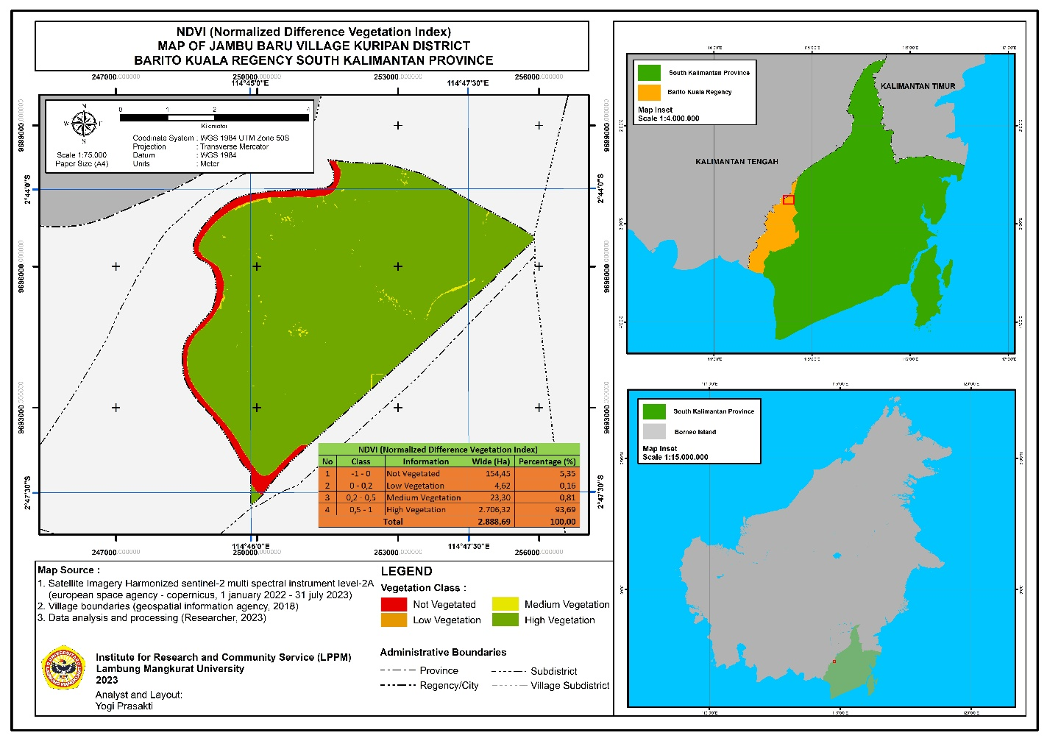
Figure 1. Research location map
(Caption should be written in Regular font, centered, size 10pt, resolution 300 dpi) Created in TeksBox)

  - Equation
Illustration of research data in the form of figure can be maps, photos, flow charts, garafik, or charts. Figure or tables can be placed in a text box placed at the top or bottom of the page. Data in tables are arranged logically so that the information delivered can be understood correctly. Tables are numbered sequentially with the title and number table above the table.
Equations must be numbered in parentheses as shown in Equation (1). Equations must be prepared using Equation (not in the image format). Equation numbers must be placed on the right side.

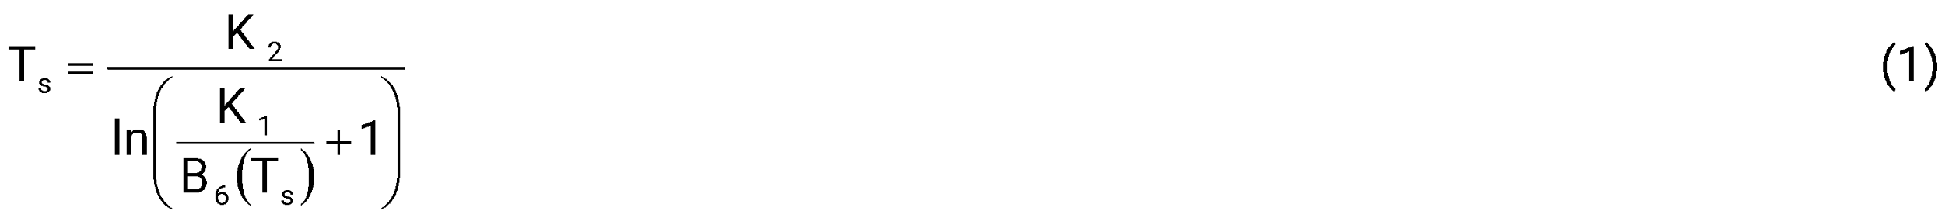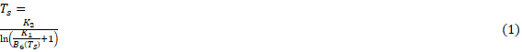

where: T_{s} is brightness temperature (K); B₆ (T_{s}) is radiasi balckbody (Wm⁻² sr⁻¹ µm⁻¹); K₁ and K₂ is konstanta radiasi first and second (Wm⁻² sr⁻¹ µm⁻¹).

Table 1. Class slope
(Information and Table in Regular, Center, Font 10pt )
Slopeª | Information | Class
Flat | 0% - 8% | 1
Sloping | 8% - 15% | 2
Rather Steep | 15% - 25% | 3
Steep | 25% - 45% | 4
Very Steep | > 45% | 5
Source: Analysis Results/Journals/Books/etc

- Results and Discussion

This section is the most critical part of your article. The following points should be carefully considered when writing the Results and Discussion section:

- The analysis or research findings must be presented clearly and concisely.
- The data presented should be processed data (not raw data) and reported in the form of narrative text, tables, or figures, accompanied by clear and easily understandable captions.
- It is essential to highlight the differences between your results or findings and those reported in previous publications by other researchers.
- The findings should be critically compared with relevant references to determine whether they are consistent with or contradictory to the results of previous studies, and whether they represent improvements or otherwise.
- The Discussion should clearly demonstrate the relationship between the obtained results and the underlying theoretical concepts.

The use of subheadings in the manuscript must conform to the style exemplified in the journal template.
The impact of the research conducted should also be described at the end of the discussion..
- Conclusion

Conclusion statements must be carried out carefully and carefully. In conclusion, the author must and only answer the problem and research objectives that have been formulated in the Introduction, and not as a summary of the results of the study. The Conclusion section should provide a description that directly addresses the research objectives stated at the end of the Introduction. The following points must be considered when writing the Conclusion:

- The conclusion should be clear and concise, written in a single paragraph.
- It must be supported by the research findings
- It should not contain any discussion elements.
- It may include research implications.
- The focus should be on the new findings, presented accurately and in sufficient depth.

- Acknowledgments

Include names or agencies that are instrumental in assisting the conduct of research. Also include the name of the research funding institution

Funding. statement if this publication received financial assistance (e.g This research received no external funding.)

Conflict of interest. statement that there is no conflict of interest between actors and others regarding this publication (e.g The authors declare no conflict of interest)

Data availability. statement of whether the data used in the published manuscript is accessible or not (e.g Not applicable.)

AI Use Declaration. e.g The authors used [Tool name, version] for [specific purpose: e.g., language editing / outlining / code assistance]. The authors reviewed and edited all AI-assisted output and are fully responsible for its content and any errors.

References
References section contains the bibliographic information of the sources used in the manuscript and is written in the format of the author's last name and the year of publication, arranged alphabetically based on the first letter of the first author's name. Primary sources (journals and patents) relevant to the research topic are preferred, with a maximum of sources published within the last 10 years, a minimum of 30 references, and 70% of journal article sources. not using web sources and Indonesian language article sources. Excessive self-citations should be avoided. It is recommended to use a reference manager application such as Mendeley. All citations in the manuscript must be included in the references section. The APA 7th edition citation style is used for all references, and each journal article reference must include a DOI/Article link
Journal: Author's name first followed by a period (.), Followed by years and given parentheses () and periods (.) The article title is written in normal print with capital letters at the beginning of each word unless the hyphen ends with a period (.), The name of the printed journal italicized and written in capital letters at the beginning of each word followed by a comma (,) italicized volume followed by a journal number with a closing bracket () sign (,) then the page number at the end of a period (.) followed by the address of the journal or doi site.

Arranged alphabetically

Abbe, A., & Brandon, S. E. (2014). Building and maintaining rapport in investigative interviews. Police Practice and Research, 15(3), 207–220. https://doi.org/10.1080/15614263.2013.827835
Afriansyah, A., Darmawan, A. R., & Pramudianto, A. (2022). Enforcing Law in Undelimited Maritime Areas: Indonesian Border Experience. The International Journal of Marine and Coastal Law, 37(2), 282–299. https://doi.org/10.1163/15718085-bja10092
Angne Alfaro, S., & Patel, T. (2021). Turning Space into a Sacred Place: A Study of a Cathedral in Motion. The International Journal of Religion and Spirituality in Society, 11(2), 151–168. https://doi.org/10.18848/2154-8633/CGP/v11i02/151-168
Das, D.M., Singh, R., Kumar, A., Mailapalli, D.R., Mishra, A., & Chatterjee, C. (2016). A multi-model ensemble approach for stream flow simulation. In Panigrahi, B. & Goyal, M.R. (Ed.), Modeling Methods and Practices in Soil and Water Engineering, 72-102. CRC Press.
DeVries, B. (2015). Monitoring Tropical Forest Dynamics Using Landsat Time Series And Community-Based Data. PhD Thesis, Laboratory of Geoinformation Science and Remote Sensing, Wageningen University.
Pratama, I., Purnomo, E. P., Mutiaran, D., Adrian, M. M., & Sundari, C. (2022). Creating Peatland Restoration Policy for Supporting in Indonesian Economic in a Sustainable Way. IOP Conference Series: Earth and Environmental Science, 1111(1), 012004. https://doi.org/10.1088/1755-1315/1111/1/012004
United States Geological Survey (15 October 2018). Science Application for Risk Reduction. Citing Internet sources URL https://www.usgs.gov/natural-hazards/science-application-risk-reduction.
Kerlinger, F. N. (1986). Foundations of behavioral research. New York: University Holt, Rinehart, and Winston Inc.

