  GRADES 1 to 12  DAILY LESSON LOG | School: | DepEdClub.com | Grade Level: | VI
 | Teacher: | File Created by Ma’am ANNALICE R. QUINAY | Learning Area: | MATHEMATICS
 | Teaching Dates and Time: | DECEMBER 5 - 9, 2022 (WEEK 5) | Quarter: | 2ND QUARTER

 | MONDAY |  |  | TUESDAY |  | WEDNESDAY | THURSDAY |  |  | FRIDAY
I. OBJECTIVES
- Content Standard | The learner demonstrate understanding of order of operations, ratio and proportion, percent, exponent, and integers
- Performance Standard | The learner is able to apply knowledge of order of operations, ratio and proportion, percent, exponent, and integers in mathematical problems and real-life situations
- Learning Competencies / Objectives | Solve word problems involving finding the percent of increase/ decrease on discounts, original price, rate of discount, sale price, and mark up price  M6NS-IIe- 144 |  | Solve word problems involving commission, rate of commission, total sales, and total income.  M6NS-IIe- 144 |  | Solve word problems involving sales tax, rate of sales tax, selling price  M6NS-IIe- 144 |  | Solve word problems involving simple interest, principal, rate, and time  M6NS-IIe- 144 |  | Create problems involving percentage with reasonable answers.  M6NS-IIe- 145
II. CONTENT | solving percent problems involving finding the percent of increase/ decrease on discounts, original price, rate of discount, sale price, and mark up price |  | Solving word problems in commission, rate of commission, total sales, total income |  | Solving word problems involving sales tax, selling price |  | Solving word problems involving simple interest, principal, rate, and time |  | Creating problems involving percentage with reasonable answers.
III. LEARNING RESOURCES
- References
- Teacher’s Guide pages | Lesson Guide in Elem. Mathematics Grade 6. 2012. pp. 316-328 |  | Lesson Guide in Elem. Mathematics Grade 6. 2012. pp. 316-328 |  | Lesson Guide in Elem. Mathematics Grade 6. 2012. pp. 316-328 |  | Lesson Guide in Elem. Mathematics Grade 6. 2012. pp. 344 |  | TG & LM in Math 5
- Learner’s Materials pages | Lesson Guide in Elem. Math Gr. 6 p.332, 336, 340, 344 2. DLP Gr. 6 Module 50, 51, 52
- Textbook pages
- Additional Materials from Learning Resource (LR) Portal
- Other Learning Resources | Power point presentation |  | Power point presentation |  | Power point presentation |  | Power point presentation |  | Power point presentation
IV. PROCEDURES
- Reviewing previous lesson or presenting the new lesson | Strategy 1: Completing the Table  Strategy 2: Role Play (Refer to TG)  Review  Do what is asked for:  1)What is 25% of 30? _______  2)Forty is what percent of 200?_______  3)18 is 30% of what number? _ |  | Mental Computation: Drill on finding the rate, base, or percentage  Strategy 1 Cross Number Puzzle  Strategy 2 – Completing the Table.  (Refer to TG) |  | Mental Computation: Drill on Finding the Rate, Base, or Percentage  a.Strategy 1: Role Play  b.Strategy 2: Searching the Lucky Team  (Refer to TG) |  |  | Mental Computation: Drill on finding the rate, base, or percentage  a. Activity 1 – Role Play  b. Activity 2 – Completing the Equation.  (Refer to TG) | Have a drill on solving routine and non-routine problems involving percentage using appropriate strategies and tools. The pupils may use different ways of solving the problems.  Review: Conduct a review on solving routine and non-routine problems involving percentage using appropriate strategies and tools
- Establishing a purpose for the lesson | The pupils of Lundagin Elementary School had an educational trip. One of the places they visited was Lukban, Quezon. While the group was going around the place the attention of some pupils was caught by the signs in one of the stalls. 15% off, 10% off, and 12% off. Can you tell what the signs mean? |  | What do you call the amount given to the sales agent after selling an item of the company aside from having a basic monthly salary? What does commission mean? |  | Every year, your parents pay an amount to the government. What do you call this amount paid to the government?  Why is there a need for us to pay our taxes? |  |  | Who has seen a bank book? What can you see in it? Does it have an interest? What about the principal? | What is your plan/ dream in the future? How do you plan to achieve it?  Ask: Is it important to make plan before doing any activity?  Ask: Does making a plan contribute in achieving one’s goal? Why? Why not?  Lead the pupils to appreciate planning ahead of time in any activity.
- Presenting Examples/Instances of new lesson | Activity 1 – Use of Compatible Numbers in the Problem  Aling Conching went to a factory outlet of garments to avail of low prices and a good profit. Underwear A was originally sold at 5 each. She asked herself the following:  a)If she was given 20% discount of the original price, how much was the sale price?  b) In case she will decide to sell underwear A with a 25% profit of the original price, how much will the mark up price be?  Guide the pupils to analyze and solve the problem.  a)Help the pairs of pupils find what the problem asks them to solve for.  (Refer to TG.) |  | Activity 1 – Use of Compatible Numbers  Bing, a teacher, is also a sales agent of her friend who owns an appliance store. She sells appliances with 5% commission. She asked herself the following:  a) If she sells a stand fan at 800, how much is her commission?  b) Is she sells 5 stand fans, how much is her total sales and total income?  c) If she sells a TV set at 32,000 and receives a commission of 3,200, what is the rate of her commission?  Let the pupils answer the questions about the problem  (Refer to TG) |  | Activity 1 – Use of Compatible Numbers in the Problem  Jetli needs to buy a book. He has 150 for a book. Is the money of Jetli enough to buy the book which costs 140.00 plus a sales tax of 6%?  His younger sister gives him 45 to buy a pencil case with a selling price of 30. What is the rate of sales tax if the sales tax is 0.90?  Let the pupils answer the questions about the problem  (Refer to TG) |  |  | Activity 1 – Use of Compatible Numbers  Rhoda has a deposit of 5,000 in a savings account for 2 years. If the bank pays simple interest at the rate of 6%, how much interest will she receive?  1)Answering the questions  a)Who has a savings account in a bank?  b)How much is her deposit?  c)If you were Rhoda will you open a savings account in the bank? Why?  Lead the pairs of pupils to analyze and solve the problem.  (Refer to TG)  Original File Submitted and Formatted by DepEd Club Member - visit depedclub.com for more | Present this problem to the class:  Ms. Losinio have 40 pupils. She decided to have a general cleaning of her room. She assigned 25% to sweep the floor, 20% to wipe the tables and blackboards, 40% to fix the books in the cabinet and 15% to arrange the chairs. How many pupils were assigned to arrange the chairs?  Guide the pupils in solving the problem. Refer to the questions.  What is asked in the problem?  What are given?  What is the operation to be used?  What is the number sentence?  What is the answer? Does it make sense?
- Discussing new concepts and practicing new skills #1 | Group Activity:  Activity 2 – Use of Challenging Life Situation Problems  Nancy was offered a house and lot with an original price of  3,500,000. The owner of the property wanted to sell it to raise funds for her daughter’s education. The data below was the basis for her decision to buy. (Refer to TG) |  | Group Activity:  Activity 2 – Use of Challenging Life Situation Problem  Sixto works as a sales agent in an appliance center with basic monthly salary of 12,000. He is given 8% commission on all items he sells above 50,000. At the end of the month he needs to know how much money he has. He prepares a table and solves. (Refer to TG) |  | Group Activity:  b.Activity 2 – Use of Challenging Life Situation Problems  Nena intends to buy a car. She thinks of the tax the government imposes. She makes a table showing the rate of sales tax imposed as shown below.  (Refer to TG) |  |  | Group Activity:  Activity 2 – Use of Challenging Life Situation Problem  The Sixth Grade Club had three rummage sales and was able to raise a good amount. The officers planned to deposit the money in a savings account with simple interest. Their president presented a table during their meeting and discussed as in:  (Refer to TG) | Divide the class into 5 groups. The task of the pupils is to help each other solve the problem. Give them enough time to perform the task.  After all the groups have finished, ask them to post their output on the board and let them discuss their solutions.
- Discussing new concepts and practicing new skills #2 | Pair-share  Activity 3 – Completing the Table  Find the missing data.  (Refer to TG) |  | Pair-share  Activity 3 – Completing the Table  Find the missing entries  (Refer to TG) |  | Pair-share  c.Activity 3 – Completing the Table  Look for the missing data.  (Refer to TG) |  |  | Pair-share  Activity 3 – Completing the Table  Fill in the needed data to complete the table of savings account of depositors  (Refer to TG) | Divide the class into four groups. Encourage the groups to create a problem similar to the one given.  (Refer to TG)
- Developing mastery  (Leads to Formative Assessment) | Individual Activity:  A.Find the missing entries.  B.Read, analyze and solve  (Refer to TG) |  | Individual Activity:  A. Find the missing data.  B. Read, analyze and solve. |  | Individual Activity:  A.Complete the table.  B.Read, analyze and solve |  |  | Individual Activity:  A.Complete the table.  B.Read, analyze and solve  (Refer to TG) | A. Discuss the presentation under Explore and Discover on LM  B. Ask pupils to create problems with the information given.
- Finding practical applications of concepts and skills in daily living | Solve the problem.  1) If the original price is 125 and the rate of discount is 25%, what is the amount of reduction? sale price?  (Refer to TG) |  | Solve the problems.  1) Jim, a sales agent, has an income of 30,000 and receives a commission of 5% on all sales above 75,000. If his basic salary is 13,500, what is his total sales?  2) Manuel, a sales agent, has a basic salary of 18,000 and a commission of 20% on all sales above 80,000. If his total sales is 290,000, how much is his total income? |  | Solve the problems.  1) Mr. Foronda bought a picture frame for 510 inclusive of 6% sales tax. How much is the tax? What is the selling price?  2) A sales tax for an item is 420 or 6%. How much is the total cost and the selling price of the item? |  |  | Solve the problems.  1) Three years ago, Ruby borrowed 12,000. If she paid back 15,200, what was the rate of simple interest?  2) Laura applied for a loan of 8,000 at a yearly interest of 10%. If she paid back the credit union 9,600, how many years was her loan? | Let the pupils answer Exercise A under Apply Your Skills on LM  Check the pupils’ answer after the given period of time.
- Making generalizations and abstractions about the lesson | How do you solve for percent problems involving increase/decrease? discounts? original price? rate of discount? sale price? mark up price? (Refer to TG) |  | How do you solve the commission? rate of commission? total sales? total income?  (Refer to TG) |  | How do you solve for the sales tax, rate of sales tax, and selling price?  (Refer to TG) |  |  | How do you solve for the simple interest? rate of interest? and time? | Lead the pupils to give the generalization by asking:  How do you create problems involving percentage with reasonable answers.
- Evaluating Learning | Find the missing entries.  (Refer to TG) |  | Fill in the data to complete the table.  (Refer to TG)  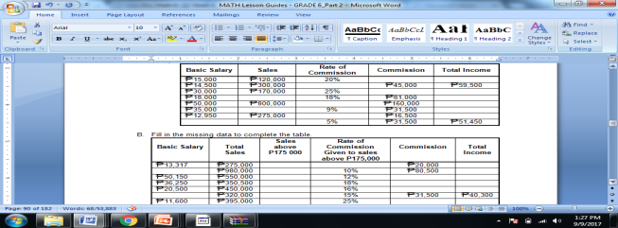 |  | Fill in the data to complete the table.  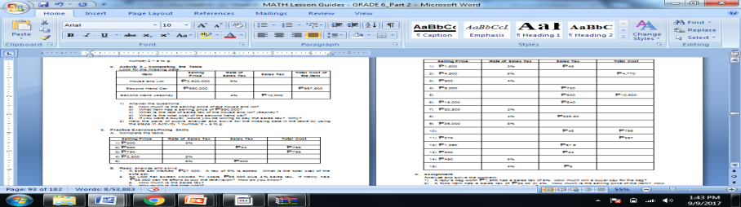 |  |  | 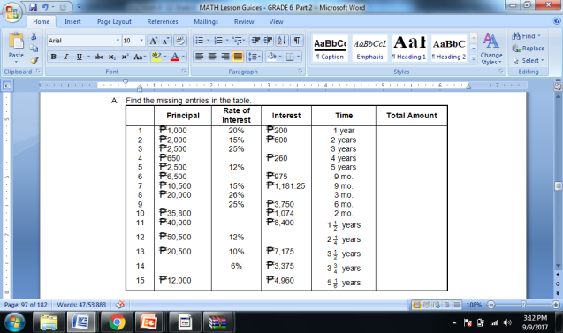  B.Analyze and solve the problems. | Directions: Create a problem using the given information.  1. 50 – numbers of pupils in Grade 5 – Jose Rizal  12% - failed in the quarter examination in Mathematics  (Refer to TG)
- Additional activities for application and remediation | Analyze and solve the problems. (Refer to TG) | Solve the problem.  1) A salesman sells a car for 860,000. If he receives a commission of 20%, how much will be his commission? (Refer to TG) |  |  | Analyze and solve the problem.  (Refer to TG) |  |  | A. Solve the problems  (Refer to TG) | A. Study the story problem given below. Complete the problem by creating a question for what is asked. Then solve the problem. (Refer to TG)
V. REMARKS
VI. REFLECTIONS
- No. of learners who earned 80% on the formative assessment
- No. of learners who require additional activities for remediation who scored below 80%
- Did the remedial lessons work? No. of learners who have caught up with the lesson
- No. of learners who continue to require remediation
- Which of my teaching strategies worked well? Why did this work?
- What difficulties did I encountered which my principal or supervisor can help me solve?
- What innovation or localized materials did I use/discover which I wish to share with other teachers?

