GRADES 1 to 12  DAILY LESSON LOG | School: | DepEdClub.com | Grade Level: | VI
 | Teacher: | File Created by Ma’am ANA LIZA DEGAMO SEBASTIAN | Learning Area: | MAPEH
 | Teaching Dates and Time: | DECEMBER 5 - 9, 2022 (WEEK 5) | Quarter: | 2ND QUARTER

 | MONDAY | TUESDAY | WEDNESDAY | THURSDAY | FRIDAY
I.OBJECTIVES
A.Content Standards | Understands the importance of keeping the school and community environments healthy | Demonstrates understanding of participation in and assessment of physical activities and physical fitness | Demonstrates the concept of melody by using intervals in the major scale and in the minor scale. | Demonstrates understanding of shapes, space, colors, and the principles of emphasis, harmony and contrast in digital painting and poster design using new technologies.
B.Performance Standards | Demonstrates practices for building and maintaining healthy school and community environments | Participates and assesses performance in physical activities.  Assesses physical fitness | Applies learned concepts of melody and other elements to composition and performance | Applies concepts on the use of software in creating digital paintings and graphics design.
C.Learning Competencies/  Objectives | Classifies different types of wastes  H6CMH-IIe-5 | Observes safety precautions  PE6GS-IIb-h-3  Executes the different skills involved in the game  PE6GS-IIc-h4  Explains the nature background of the game  PE6GS-IIb-1 | Demonstrates the ability to sing, read, and write simple musical notations in the key of G Major and its relative minor  MU6ME-IIa-1  Analyze the melodic patterns of songs in G major and its relative minor  MU6ME-IIa-2 | Realizes that art processes, elements and principles still apply even with the use of technologies  AGEL-IIe
II.CONTENT | Healthy School and Community Environment | Assessment of Physical Activities and Physical Fitness  Invasion Game:” Lawin at sisiw”/ “Agawang panyo” | Melody | Digital painting graphic Design
III.LEARNING RESOURCES
A.References
1.Teacher’s Guide pages | TG. p9 | PE6 Curriculum Guide, p.35
2.Learners’s Materials pages
3.Textbook pages | Enjoying life Through Music, Arts, Physical Education and Health 6 by Marissa C. Pascual, Irene Feliz S. Reyes, Ma. Elvira M. Garcia. Mignon C. Artuz pp.40-43 | The 21st Century MAPEH in Action | Enjoying life Through Music, Arts, Physical Education and Health 6 by Marissa C. Pascual, Irene Feliz S. Reyes, Ma. Elvira M. Garcia. Mignon C. Artuz pp.47-53  The 21st Century MAPEH in Action | Enjoying life Through Music, Arts, Physical Education and Health 6 by Marissa C. Pascual, Irene Feliz S. Reyes, Ma. Elvira M. Garcia. Mignon C. Artuz pp.44-53
4.Additional materials from learning resource (LR) portal | K to 12 Curriculum Guide 6
B.Other Learning Resource | Powerpoint, Activity card. | Laptop, Ppt Presentation  https://www.youtube.com/watch?v=piDObmOoDAY  https://www.youtube.com/watch?v=ZjBq-IF7KZk |  | Powerpoint, cellphones, computers, netbook
IV.PROCEDURES
A.Reviewing previous lesson or presenting the new lesson | Ask the pupils to identify wastes that can be found at home, in school and in the community | What game did you play last week?  What are the rules to follow in playing Sungka? How many shells are needed in all? Who will win in the game sungka? | What key signatures have we discussed last week? What musical symbols do you see in it?  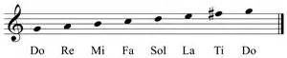 | Have you wondered just what digital paintings are? | Checking of pupils’ homework.  What are the different elements and principles of art?
B.Establishing a purpose for the lesson |  | Present some examples of invasion games and let them identify it.  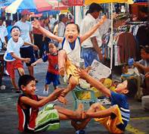  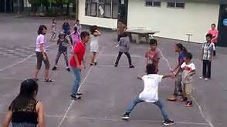  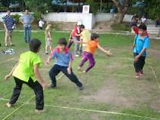  Today,We are going to assess our participation in physical activities based on the  Philippines physical activity pyramid through an invasion games. | Present the song” O Come, All ye faithful”key of G major  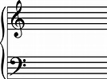  What do you notice at the fifth line of the staff? What do we call that symbol? What does it mean? Where can you find the Do?  Look at the second staff what do you observed?What does the sharp mean except from telling its key signatures?  Original File Submitted and Formatted by DepEd Club Member - visit depedclub.com for more | Showing the art work of Vincent Van Gogh, Amorsolo and Tadao Cern.  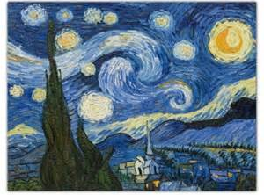  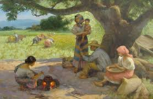  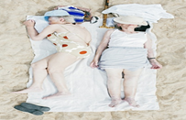 | Did you bring your gadgets children?  Who are your favourite artists? Why did you like them?
C.Presenting Examples/ instances of the new lesson | Activity1:  Biodegradable and Non-Biodegradable (Annex 1)  Direction: Classify the words below under the proper heading.  food waste rubber tires  DVD animal waste  metals radioactive materials  paper magazine  dead animals vegetables  BIODEGRADABLE NON-BIODEGRADABLE | What games have you played with your friends and classmates?  Have you tried the games shown on the pictures?  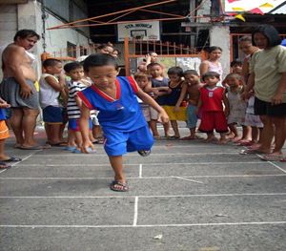  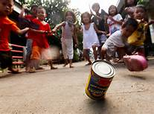  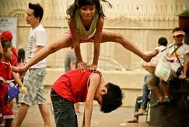 | Present the song” O Come, Emmanuel”Let them analyze the key of the song  What is the home tone of the song?  Is the song in major or minor mode?  On what line or space is the home tone located?  What is the name of the key of the song? | Allow the puplis toobserve and describe the works of Vincent Van Gogh, Amorsolo and Tadao cern | Teacher discuss the activities to de done by the pupils using their gadgets.  Direction:  Create your own digital painting similar with the masters  ( Van Gogh, Amorsolo, Tadao Cern, Etc)using GIMP
D.Discussing new concepts and practicing new skills #1 | Discuss and differentiate biodegradable and non-biodegradable materials  1.How will you know that waste is biodegradable?  non-biodegradable?  2. How can you lessen the amount of biodegradable and non-biodegradable waste at home? In school? In the community? | What are some reasons why most children don’t play traditional games anymore? | Allow the pupils tostudy the song “Away in a manger”  -clap the rhythmic pattern whiule reciting the syllables  -recite the words of the song in rhytmn  -Sing the pitches of the song  -Sing the words of the song in accurate pitch and rhytmn | What art processes are used by these artists in painting their artworks?  Are these processes be use /apply even with the use of technologies? Why?  Allow the pupils to view a video tutorial of GIMP’s Paint tools. | Hands On activity of the pupils.
E.Discussing new concepts and practicing new skills #2 | Activity2:  Classify other waste materials as: solid waste, water waste, hazardous waste, bio medical/health care waste, and reusable and recyclable materials. (Annex 2)  Direction: Classify the words below by matching Column A with that of Column B.  Column A Column B  Wood, boards, pet bottles, cartons, fragile bottles, plastic containers, scrap metals Solid Wastes  Spoiled foods, scrap parts of fruits and vegetables, animal bones, internal organs Hazardous Wastes | Do you know the game “Lawin at Sisiw”? How about the agawang panyo? How to play the game?  The teacher let the pupils to view the short video about “Agawang panyo and Lawin at Sisiw”  https://www.youtube.com/watch?v=piDObmOoDAY  https://www.youtube.com/watch?v=ZjBq-IF7KZk | Write out the melodies on the staff in the key of GMajor and e minor  so fa mi re  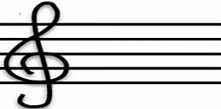  mi re do ti | Give some instructions to the pupils in creating a digital painting that shows  - Geometric shape  - Constrasting lines  - Two colors | Call on a pupil to say something about his/her output.  What motivates you to create your output?  Is using technology in your art work essential? Why?
F.Developing Mastery | The teacher will discuss other waste materials (solid waste, water waste, hazardous waste, bio medical/health care waste, and reusable or recyclable materials) 1. Why is it important to know the types of wastes? 2. How can this help you in maintaining a healthy school and community environment? | What should we remember before we play?  Play the game “Lawin at Sisiw”/ Agawang Panyo” | Analyze the melodic patterns of song in g major in e minor  “Away in a Manger”  Fiil the data being asked for in the table below  Away in the manger O Come, All ye faithful  Home Tone  Letter name where the home tone is  Mode  Name of the key | Study and discuss the outputs of the puplis | Contimuation of hands On Activity.
G.Finding Practical application of concepts and skills in daily living | How does classification and segregation of wastes help you at home?  In school?  In the community | Why should we not forget our Traditional Filipino games?
H.Making generalization and abstraction about the lesson | What are the different classifications of wastes? | What are the skills develop in the game?  Can you assess your physical fitness through this game? | - The sharp sign at the beginning of the staff serves as the key to be able to read the pitches on the staff  - The sharp sign raises the pitch by a half step  - The key of one sharp gives the key of G major and E minor  - G mnajor and E minor are relative keys because both of them use the same key signatures which is one sharp | GIMP is a powerful and versatile siftware that can be used to create a beautiful digital painting its various features can create lines, shapes and colors that when these elements are blended in a pleasing way, it shows harmony.  Arts elements and principles still apply with the use of technologies.
I.Evaluating learning | Classify the different type of wastes  Direction:  Write B if the example is biodegradable,NB if non biodegradable or H if it is haradous  Fruit peelings Seeds  Cans Used batteries  Pesticides Left over foods  bottles Expired medicines | 1. Did you enjoy the game?  2. Describe the skills involved in the game?  3. Did you observe safety precautions?  4. What are the rules in playing Agawang Panyo? Lawin at Sisiwi?  5. Do you feel proud being Filipino while playing the game? | True or false  1.The home tone or tonal center of songs in majoy keys is DO  2. The key of a piece is named after the letter name where the home tone is.  G major and D Minor are relative keys because they use the same key signatures. |  | Using Rubrics to evaluate the outputs of the pupils.  criteria Advanced 5 Proficient 3 Developing 1  Design Cam apply design elements with excellent skills Can apply design, elements with great skills Can apply design elements with fair skill  Creativity Can show excellent attention to detail the ideas/ material /methods are highly effective Can show great attention to details, ideas materials, methods are effective Can show good attention to detail. Imaginative touches are scattered throughtout the digital painting.
J.additional activities for application or remediation | Make a slogan about the importants of classifying wastes. | List down other invasion games with pictures then paste it in your portfolio |  | Bring your gadgets tomorrow | What is a poster?How can you create relevant posters?
V.MGA TALA
VI.PAGNINILAY
A.Bilang ng mag-aaral na nakauha ng 80% sa pagtatayao.
B.Bilang ng mag-aaralna nangangailangan ng iba pang Gawain para sa remediation
C.Nakatulong ba ang remedial? Bilang ng mag-aaral na nakaunawa sa aralin.
D.Bilang ng mag-aaral na magpapatuloy sa remediation
E.Alin sa mga estratehiyang pagtuturo ang nakatulong ng lubos?Paano ito nakatulong?
F.Anong sulioranin ang aking naranasan na solusyunansa tulong ng aking punungguro at superbisor?
G.Anong kagamitang panturo ang aking nadibuho nanais kong ibahagi sa kapwa ko guro?

