Name(s)_______________________________________________ Period ______ Date ___________________
 | Project Guide - Innovation Simulation | 

Project Description

Welcome to the Future School Convention! You have been chosen to attend this convention because you represent an important stakeholder in the broader school community. Together with a small group you will brainstorm and research computing innovations that you believe will have a positive impact on schools. At the end of the convention, your team will pitch your best idea to a panel of judges.

Deliverables
- Individual:
  - This completed project guide
  - A computing innovation proposal
- Group:
  - An artifact displaying your team members' innovations
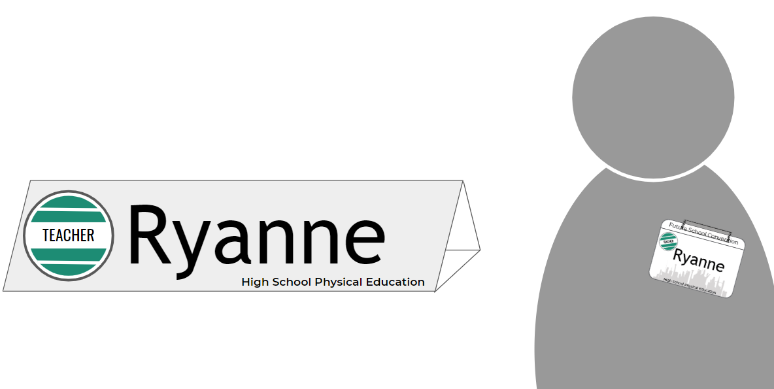
  - A presentation of the team's top innovation

Simulation
This project is a simulation where you and your classmates role play as delegates at a convention. There are times throughout this unit when you will be in simulation mode. Look for the red "Innovation Simulation" header at the top of slides as an indication of when the simulation is live. You should also wear your nametag and display your nameplate.

Step 1 - Reflection

My Character's Name
My Role
Consider what your character would want or need in a computing innovation for the Future School. Explain why.

Step 2 - Research
Choose three different computing innovations you would like to recommend for the Future School. These can be innovations that were brainstormed as a team, or new ones that you think of. Check with your team to make sure no one is researching the same innovations.

Computing Innovation #1
Name:
Purpose (why it exists): | Function (how it works):
Source(s) | What data is being collected?
My character would recommend this computing innovation because...

Computing Innovation #2
Name:
Purpose (why it exists): | Function (how it works):
Source(s) | What data is being collected?
My character would recommend this computing innovation because...

Computing Innovation #3
Name:
Purpose (why it exists): | Function (how it works):
Source(s) | What data is being collected?
My character would recommend this computing innovation because...

Step 3 - Feedback
In the space below record three pieces of feedback you gave to teammates about their proposed innovations and why you provided that feedback.

Innovation / Teammate | Feedback | Why You Gave It

Step 4 - One Pager
Based on the feedback you received, complete the one-pager on the next page for the innovation that best responds to your team’s feedback and aligns with a unifying group theme or vision for the Future School.

Innovation One-Pager


<Name of the Innovation>
Replace the text above with the name of your innovation
Replace the image to the right with an image of your innovation

Purpose and Benefits
Write a paragraph or bullets explaining the reason the innovation exists. You should include:
- The specific groups in the school community you believe would benefit
- The specific problems or challenge that group is facing
- The specific ways that group would benefit
- At least one specific reason your character would be interested in this innovation.

Function
Write a paragraph or bullets explaining how the innovation actually works. You should include:
- A high level description of how users interact with the innovation
- What data the innovation uses or collects
- How that data is processed and stored

Concerns
Write a paragraph or bullets explaining potential concerns or risks posed by this innovation. You should include
- At least one specific group that could potentially be harmed by the innovation and the way they could be harmed
- At least one specific privacy or security concern that arises from collecting the data needed to run your innovation.

Addressing Concerns
Write a paragraph or bullets explaining the ways you could address potential concerns about your innovation. You should include:
- Direct ties to the concerns raised in the previous paragraph
- At least one cybersecurity technique that could be used to make the innovation more secure
- Ways you would be willing to limit the innovation or alter its functionality to avoid the concerns

Sources
List all sources that you used in making this project using the format below. Make sure to cite the source of your image.

[1] Author’s Last name, First name. “Title of Web Page.” Title of Website, Publisher, Date, Permanent URL. Date retrieved.
[2] Author’s Last name, First name. “Title of Web Page.” Title of Website, Publisher, Date, Permanent URL. Date retrieved.
[3] ….

Step 5 - Preparing Your Group Presentation
In addition to each group member submitting an innovation one-pager, your group will need to create some kind of collective artifact or presentation that presents your vision for the Future School.

Convention Format
- Presentations - 20-30 minutes
  - Each group will get between 2 and 4 minutes to present their vision for the Future School
- Gallery Walk - 10-15 minutes
  - Groups will leave their presentation materials and Innovation 1-Pagers around the room
  - All convention attendees will circulate the room reviewing 1-Pagers that feel particularly interesting to your character
- Voting / Feedback - 5 minutes
  - Each attendee will vote for the Group Vision and individual innovation they believe is best
  - Attendees may not vote for themselves or their group members

Presentation Format: Your presentation can be in almost any format you want. You could make a poster or slides, but you’re also welcome to perform a skit, record a video, make a commercial, write a poem / song, or any other format that you think will be effective for communicating your vision. Aim for a presentation that is

- Coherent: Explains the theme that ties your different innovations together
- Compelling: Highlight the benefits of your vision and get the audience excited
- Creative: Choose the format that will best communicate your vision
- Clear: Make it clear specifically what you’re proposing
- Collaborative: Every group member has a role, and every innovation is briefly explained
- Concise: You’ll only have a couple minutes

Presentation Vision: What is the unifying theme of your group? What is the shared vision?

Step 2 - Your Innovation’s Connection to the Theme: Write down the connection between your innovation and the theme or vision your team has chosen.

Step 6 - Run the Convention
During the convention, every group will have a chance to present their vision and you’ll then review individual innovations.

Step 7 - Evaluate
Vote for the group vision and individual innovation your character believes is most compelling. You may not vote for yourself, your team, or other members of your team.

Best Innovation: __________________________________________________________

Best Overall Vision: ___________________________________________________________

Rubric

Category | Extensive Evidence | Convincing Evidence | Limited Evidence | No Evidence
Project Guide - Analyzing Innovations | Clear evidence of having fully considered three potential innovations. | Evidence of having considered two innovations or incompletely considering three. | Evidence of only having considered one potential innovation. | No record of evidence of having considered multiple innovations.
Project Guide - Benefits and Harms | Steps 1 and 3 indicates thorough consideration of multiple innovations from the perspective of the character. | Steps 1 and 3 are occasionally incomplete or include a small number of comments disconnected from the character profile. | Steps 1 and 3 are incomplete or often disconnected from the character profile assigned. | No response in steps 1 and 3
One Pager - Purpose and Benefits | Response clearly indicates the purpose of the innovation and the specific groups that would benefit from it. | The response occasionally lacks clarity on the purpose of the innovation or does not specifically indicate a group that would benefit. | The response does not clearly indicate the purpose of the innovation or the specific groups that would benefit. | No response is given
One Pager - Function | The response is clear, accurate, and highlights the way the innovation works, the data it uses, and how that data is used. | The response may occasionally lack clarity or detail on the way the innovation works or how it uses data. | The response lacks significant details or does not clearly indicate the way that the innovation works. | No response is given
One Pager - Concerns | The response clearly explains one or more valid privacy or security concerns as well as the specific groups that would be harmed. | The response includes some incomplete or inaccurate information about the concern or the specific groups harmed. | The response includes significant factual inaccuracies about the privacy / security concern or does not indicate a specific group that is harmed. | No response is given
One Pager - Addressing Concerns | Response indicates understanding of an actual cybersecurity technique that directly addresses the concerns listed. | Response indicates understanding of a cybersecurity technique but it may not directly address the concerns lists. | Response either includes incorrect information or does not directly address the concerns listed. | No response is given
One Pager - Sources | Multiple sources of information are completely cited | Multiple sources are cited though in some cases incompletely | Sources are incompletely cited or one source is used. | No sources are cited
Group Presentation - Coherent and Collaborative | Each group member has a role in the presentation and the overall vision clearly ties together the different innovations. | Most group members have a role in the presentation and there is a unifying vision tying most innovations together. | Some but not all group members have a role in the presentation. The vision may only connect some innovations. | Most group members do not participate in the presentation and there is no evidence of a unifying vision.
Group Presentation - Clear and Compelling | The presentation and overall vision was both clear, briefly explaining each innovation, and compelling, highlighting the benefits of the overall vision. | The presentation was compelling but occasionally lacked clarity on what specifically was being proposed. | The presentation may not have been compelling or clear. | The presentation did little to highlight the benefits of the overall vision or clearly explain what was being proposed.

