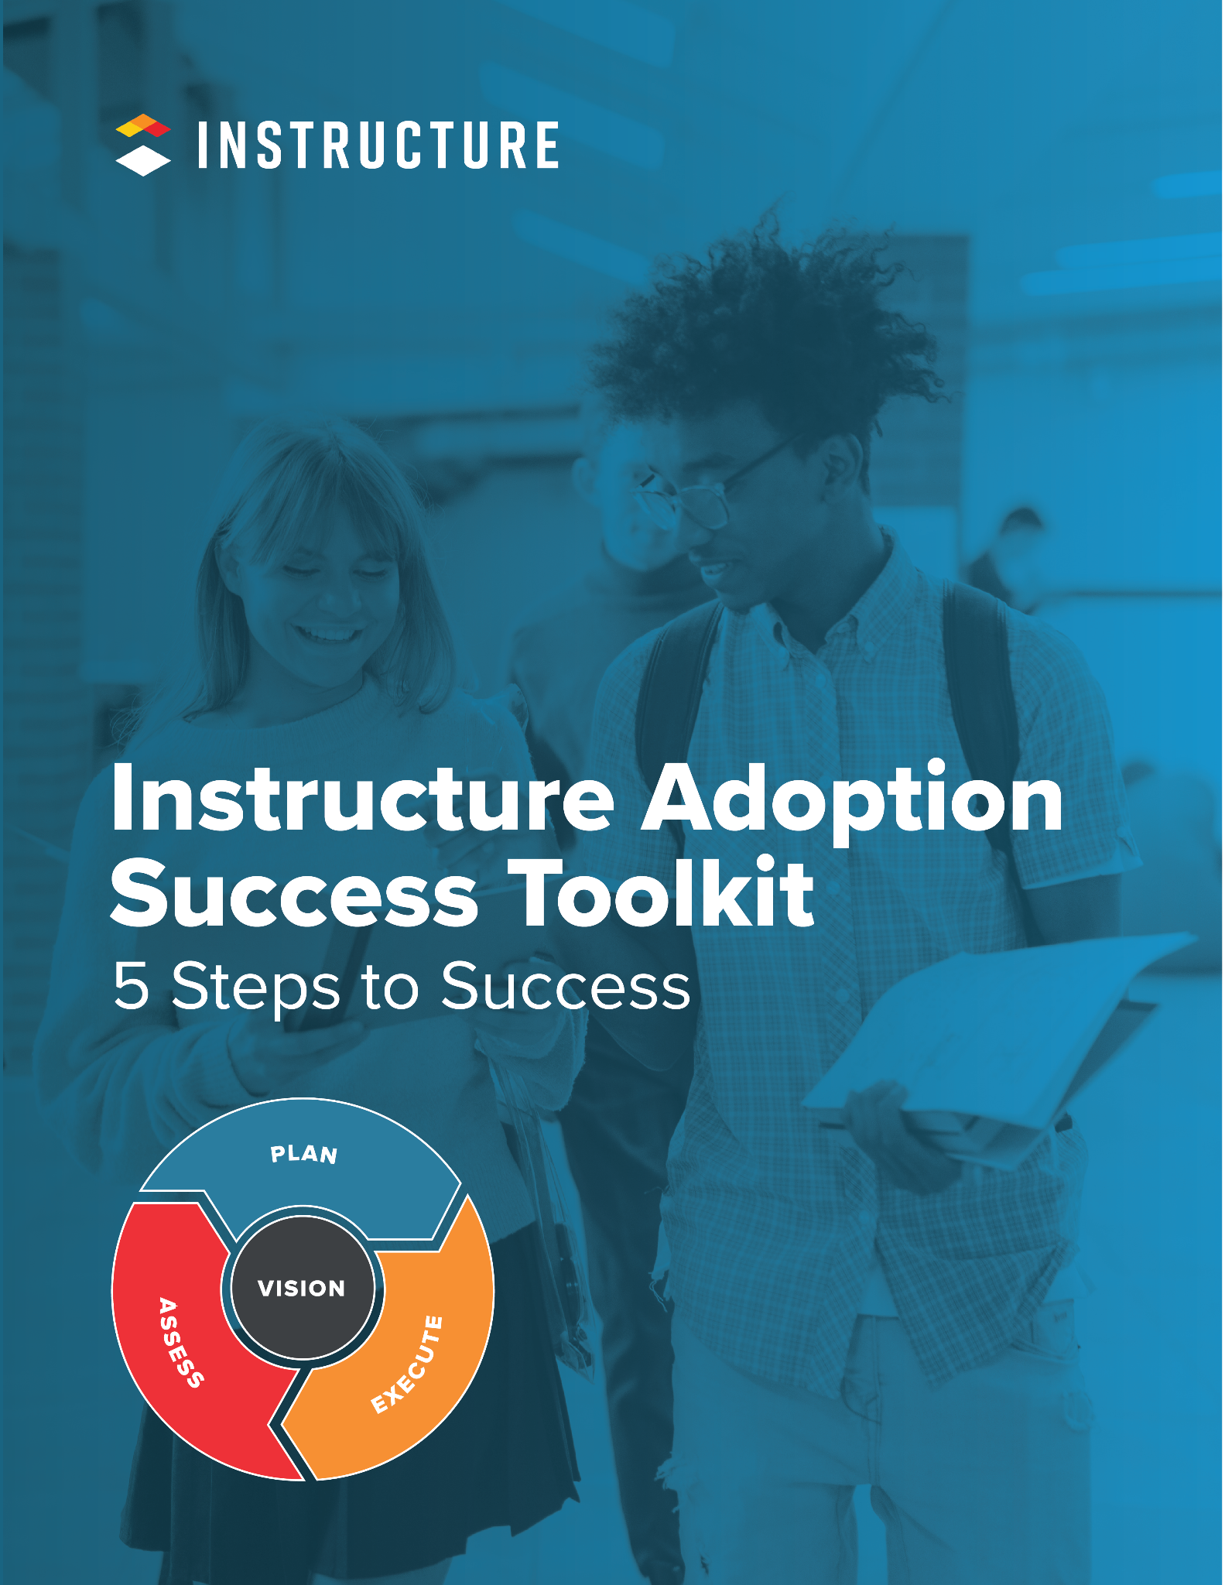

5 Steps to Success

1 | Bring the leaders of people together.
Form an Adoption Team with leaders and stakeholders within your organization to assess your current processes and begin planning for the future.

2 | Create and share the vision.
Start your visionary leadership journey and define the “why” to engage your organization in a shared vision of success.

3 | Plan for the short and long term.
Construct plans for communication, training, and engagement to prepare for challenges that will arise and empower leaders to support adoption.

4 | Execute and deepen experiences.
Implement plans with fidelity and flexibility to allow for responsive shifts that meet the needs of your stakeholders while honoring your vision.

5 | Assess progress and amplify wins.
Evaluate your adoption progress to share successes, set goals, and continue your evolution with the Instructure Learning platform.

Adoption Discovery | Self-Assessment
The shift to using the Instructure Learning Platform is a big change. There are many moving pieces with lots of people involved. This self-assessment is intended to help you identify and prioritize the key areas in which you can begin planning for your adoption of the Instructure Learning platform.
A close examination of institutions that have successfully launched and scaled their use of the Instructure Learning platform, has provided us with nine key areas of focus for LMS adoption. This self assessment will familiarize you with each, prompt you to reflect on where you are in the process, and identify a priority level.
KEY ADOPTION AREA: Vision, Goals, and Success Measures
Your vision is the most important part of your adoption success. A clear vision and measurable goals will help lay the foundation for your change strategy and give you clear direction. |  |  | Score Yourself
 | Does your institution have a defined vision, set of goals, and success measures for adopting the Instructure Learning platform? | - Just starting!  - Working on it!  - We’ve got this!

KEY ADOPTION AREA: Technical Needs
Adoption of the Instructure Learning Platform requires technical support. Your institution will need to identify who is responsible for the technical implementation and ongoing maintenance of tools to support data, users, and content. They will need to develop an understanding and process for provisioning data into the Instructure Learning platform and other data needs and operations, as well as the data fields, functionality, and capabilities. They will need to assess how the technology is configured to align with vision and whether you’ll need to establish new protocols or procedures. |  |  | Score Yourself
 | Does your institution have a plan to support the initial technical implementation and ongoing maintenance of the Instructure Learning platform, data, content, and users over time? | - Just starting!  - Working on it!  - We’ve got this!

KEY ADOPTION AREA: Teams of Support
A cross-departmental adoption team that includes representation from all groups directly involved in and impacted by adoption will provide the needed support to manage and maintain projects associated with adoption. A key contact, sponsor, or project leader who is ultimately responsible for the adoption decisions helps to oversee the project plan with clearly defined goals and milestones. Committees can be formed with members assigned roles and responsibilities to oversee the aspects of each project. |  |  | Score Yourself
 | Does your institution have an identified team of support that will lead and manage the adoption process? | - Just starting!  - Working on it!  - We’ve got this!

KEY ADOPTION AREA: Engagement
Planning for change and the challenges that naturally accompany change is a critical part of Instructure Learning platform adoption. An engagement plan aligned to your vision and responsive to the needs of your various stakeholder groups will empower your site-based leaders to reinforce and reward moving to the future state. |  |  | Score Yourself
 | Does your institution have a plan for engaging all stakeholders throughout the various phases of adoption? | - Just starting!  - Working on it!  - We’ve got this!

KEY ADOPTION AREA: Communication
Your communication plan will help drive awareness and increase desire to change. An effective communication plan should be timely, address various audiences, and contain key messages. You’ll need to determine content, delivery method, frequency and sender for each communication cycle. |  |  | Score Yourself
 | Does your institution have a comprehensive communication plan for the various stakeholders and phases of adoption? | - Just starting!  - Working on it!  - We’ve got this!

KEY ADOPTION AREA: Training
Your training plan will give users the knowledge and ability to change. An effective training plan should be tied to vision and address audience, needs, and timeline. Training will need to be ongoing, and differentiated as your adoption and utilization develops. |  |  | Score Yourself
 | Does your institution have a training plan for the various stakeholders and phases of adoption? | - Just starting!  - Working on it!  - We’ve got this!

KEY ADOPTION AREA: Usage
Understanding who is using Instructure products and when will provide key insights into your adoption plan. You’ll want to know which of your stakeholder groups are using and if they are using it consistently over time. This will inform how your engagement plan needs to evolve. Advanced usage looks like the majority of stakeholders using all tools in the Instructure Learning platform.. |  |  | Score Yourself
 | Has your institution developed usage goals for various stakeholders and phases of adoption? | - Just starting!  - Working on it!  - We’ve got this!

KEY ADOPTION AREA: Utilization
How your stakeholders use the different features of the platform tells you about the quality of how your adoption is progressing. Utilization can include the basic features for content creation and management, engagement, communication, feedback, assessment, and the sharing of content. Utilization data has the potential to inform your engagement, training, and communication plans as you target specific goals aligned to vision. For example, to increase student engagement, you might set a utilization goal for Discussions. Advanced utilization looks like demonstrated best practice and fluency with most aspects of the platform for teaching and learning. |  |  | Score Yourself
 | Does your organization have a plan for how it will connect Instructure products to teaching and learning priorities? | - Just starting!  - Working on it!  - We’ve got this!

KEY ADOPTION AREA: Relationships
Instructure strives to partner with you as you work toward advanced adoption. Let’s work together as a team! Actively involving us in your challenges and successes and getting to know our products and services is an effective and collaborative way to approach adoption. |  |  | Score Yourself
 | Has your organization developed goals for establishing a strong relationship with Instructure, its services and products? | - Just starting!  - Working on it!  - We’ve got this!

PRIORITIZING KEY ADOPTION AREAS [Rank 1-9 with 1 = Highest Priority]

Take a look at your results. Which ones would you prioritize as you move through the adoption toolkit and adoption process? Although they are all important to successful adoption, we recommend focusing on two or three key adoption areas to begin with.
As you build more capacity, consider adding on the others.
Vision, Goals, and Success Measures
Technical Needs
Teams of Support
Engagement
Communication
Training
Usage
Utilization
Relationships

