SUMMATIVE TEST NO. 1
Objectives | CODE | Percentage | No. of Items | Item Placement
recognize rhyming words in nursery rhymes, poem , songs heard | (EN1PA – III – e – 2.2) | 33.33% | 5 | 1-5
recognize sentences and non-sentences; | EN1PA-IIIa-e2.6 | 33.33 | 5 | 6-10
recognize telling and asking sentences. | EN1PA-IIIa-e2.6 | 33.33 | 5 | 11-15
Total |  | 100 | 15 | 1 – 15
GRADE I – ENGLISH
SKAI KRU

SUMMATIVE TEST NO.1
GRADE I – ENGLISH
SKAI KRU

Name :_____________________________________ Grade and Section:_________

I. Draw a line to match each picture on the left with its rhyming partner on the right.
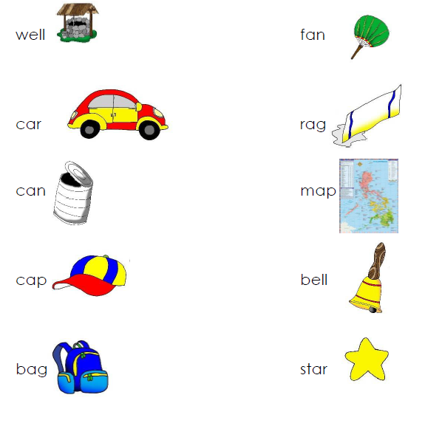

II. A. Write S in the box if the statement is a sentence and N if the statement is a non-sentence.
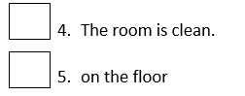

B. Write TS in the box for telling sentence and AS for asking sentence and add the correct punctuation mark at the end of the sentence.

6. I love watching movies _____

7. What is your favorite fruit _____

8. The trees are tall _____

9. I have a new dress _____

10. Where did he go _____

SUMMATIVE TEST 1 ANSWER KEY:
II.
A.
6. S
7. S
8. N
9. S
10. N
B.
11. TS
12. AS
13. TS
14. TS
15. AS
I.
1. WELL-BELL
2. CAR-STAR
3. CAN-FAN
4. CAP-MAP
5. BAG-RAG

