Darknet Diaries #54 - NotPetya

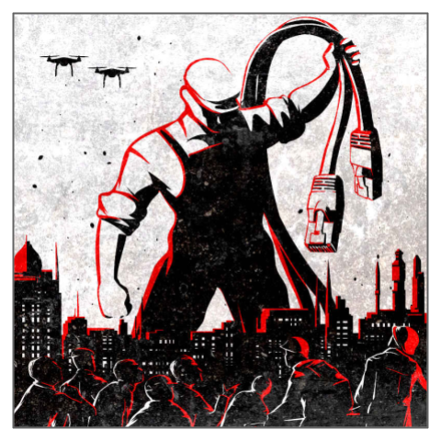
BACKGROUND
“This is the story of NotPetya. Which seems to be the first time we’ve seen what a cyber war looks like. In the summer of 2017 Ukraine suffered a serious and catastrophic cyber attack on their whole country. Hear how it went down, what got hit, and who was responsible.”
In this exercise, you will listen to a riveting podcast episode from the podcast the Darknet Diaries and then craft a response to it.

REQUIREMENTS
A web browser and internet connection.

PART I: Listen to the podcast
- If you have a podcast app, you can subscribe to the Darknet Diaries (it’s free!) and find Episode 54 - NotPetya. Alternatively, you can listen to the episode online here. A transcript is available here. By the way, you should totally subscribe to this podcast - it is reliably one of the finest podcasts today.
- Craft a response to the podcast. Address the following:
List three things that are AWESOME. Things you were surprised by, amazed by, or something new you learned.

List two things that you will ADVOCATE with your family, friends, and co-workers. What are things that you should tell them to help them understand the importance of information security?

List one thing that is ACTIONABLE. After listening to this podcast, what is one thing you will do? Is there a quick thing you can do to be safer? Is there something you can do to change your behavior?

SUBMIT A LINK TO THIS DOCUMENT IN BLACKBOARD.

