5.04 Human Impact on Marine Life Lab
Instructions: In the Human Impact on Marine Life Lab, you will help rehabilitate a rescued sea lion by making sure she is eating enough food to sustain her energy levels. Fill in the blue boxes of this lab report as you complete the virtual lab on the last page of the lesson. Carefully read all instructions and background information. This information can also be found in Appendix A. You will submit your completed lab report.

Name and Title (1 point)
Include your name, your teacher’s name, the date, and the name of the lab.

Objective(s) (2 points)
In your own words, what is the purpose of this lab?

Hypothesis (2 points)

Choose a hypothesis:
To get her back to her goal weight, Snappy should eat ____ percent (%) of her body weight per day.

Procedure
Snappy is a rescued sea lion who was found tangled in some fishing nets. She was brought to Marine Sanctuary Inc., and needs to heal and gain weight before being released back into the ocean. In this lab, you will help her recover by determining how much food she should eat and collecting data on her weight and length each week.

Data (10 points)
Use the virtual lab on the last page of the lesson to collect your data. Complete the tables below or provide screenshots of your data tables from the virtual lab.

If you are unable to use the virtual lab to collect your data, you can use the sample data here: 5.04 Data

Data Table 1. Length and Weight of Snappy during recovery at a Rehabilitation Center
Week | Daily Diet (kg) | Snappy’s Length (m) | Snappy’s Weight (kg)
1
2
3
4
5
6 (if needed)
7 (if needed)

Conclusion (15 points)
Use complete sentences to answer the questions below.

- What is Snappy’s trophic level on the food web? What does that mean in terms of her eating habits?

- By the time that energy from the sun has reached Snappy and the food she eats, how much of that original energy is still available to her?

- From what you have observed: what impact did human actions have on Snappy, both in the wild and in the rehabilitation center?

- How did you determine how much food to feed Snappy each week? Using Data Table 1, describe how the amount of food Snappy was fed each week impacted her weight gain.

- What are some things that you can do to reduce our human impact on animals like Snappy?

Save This Google Doc
A copy of this Google Doc will automatically be saved to your Google Drive. You may edit this Google Doc online at any time and also access it through the Google Doc app on your smartphone or tablet. However, to obtain credit for this assignment, you must save this completed document to your computer and submit it online within your marine science class. See instructions on how to save a Google Doc as a .pdf here: How to Save a Google Doc as a PDF.jpg

Next Steps
After completing this document, please open your marine science “Assessments” tab and click on “05.04 Human Impact on Marine Life” assignment. Please upload your .pdf and submit for assignment credit. Note that a link to your Google Doc will not be accepted for credit.

Appendix A

Purpose
In this lab, you will be volunteering at Marine Sanctuary Inc., which rescues and rehabilitates marine animals. They’ve just rescued a sea lion from some fishing nets at a nearby beach, brought her to the facility, and named her Snappy. In this lab, you will help determine how much Snappy weighs and how much she needs to eat in order to regain her health and ultimately be released back into the wild.

Who Is Snappy?
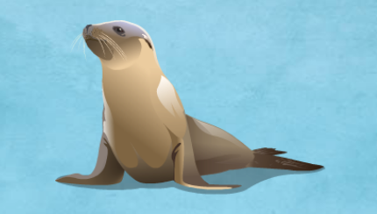
Figure 1. Snappy, the sea lion that you will be taking care of during this lab.

Snappy is a tertiary consumer. She feeds on both primary and secondary consumers (See Figure 2). Primary consumers feed on plants and phytoplankton, which are the producers. Secondary consumers feed on primary consumers. When organisms die, decomposers break down the organic matter and recycle it back into the environment.

A normal, healthy California sea lion that is 1.4 meters in length would weigh between 88 and 92 kg. California sea lions eat about 5% to 10% of their body weight per day just to cover their energy requirements. Sea lions generally gain weight within a range of 1 – 3 kg per week.

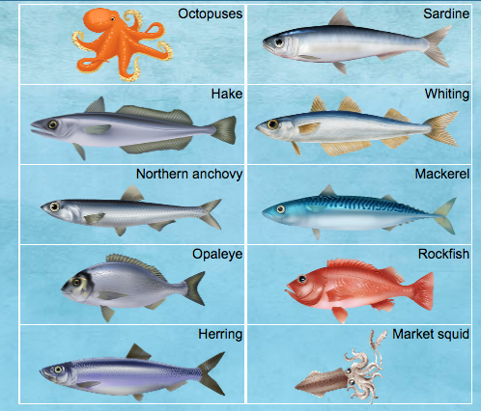
Figure 2: Some organisms that sea lions eat.

