  GRADES 1 to 12  DAILY LESSON LOG | School: | DepEdClub.com | Grade Level: | VI
 | Teacher: | File created by Ma’am NERISSA P. BRATO | Learning Area: | MAPEH
 | Teaching Dates and Time: | NOVEMBER 7 - 11, 2022 (WEEK 1) | Quarter: | 2ND QUARTER

 | MONDAY |  | TUESDAY | WEDNESDAY | THURSDAY | FRIDAY
I. OBJECTIVE/S
- Content Standard | demonstrates the concept of melody by using intervals in the major scales and in the minor scales |  | demonstrates the concept of melody by using intervals in the major scales and in the minor scales | demonstrates the concept of melody by using intervals in the major scales and in the minor scales | demonstrates the concept of melody by using intervals in the major scales and in the minor scales | Weekly Test
- Performance  Standard | applies learned concepts of melody and other elements to composition and performance |  | applies learned concepts of melody and other elements to composition and performance | applies learned concepts of melody and other elements to composition and performance | applies learned concepts of melody and other elements to composition and performance | Be able to answer questions given
- Learning  Competencies  (write the LC Code) | demonstrates the ability to sing, read, and write simple musical notations in the:  Key of C Major  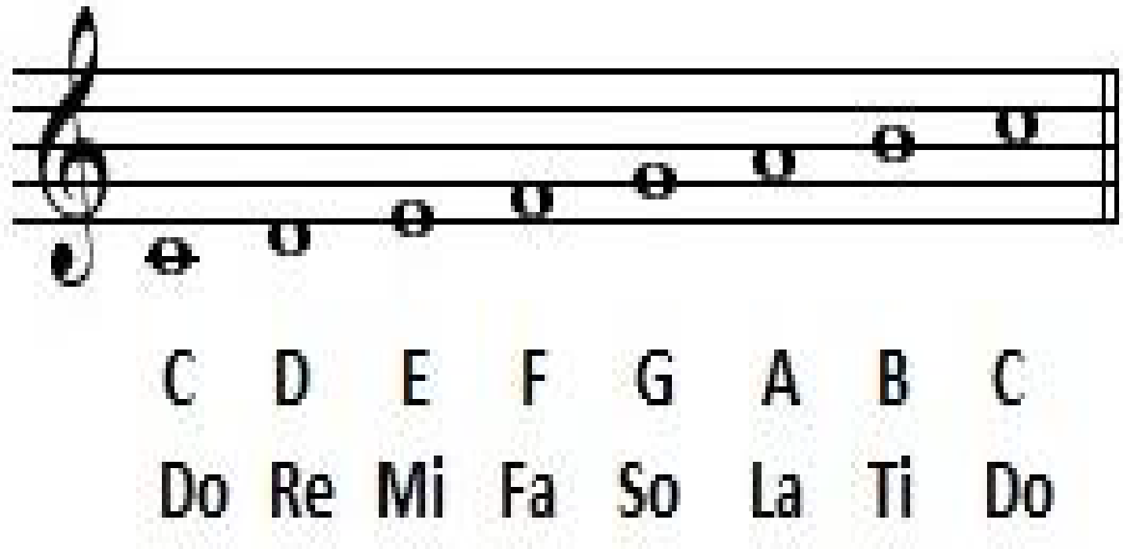  MU6ME-IIa-1 |  | demonstrates the ability to sing, read, and write simple musical notations in the  Key of F Major  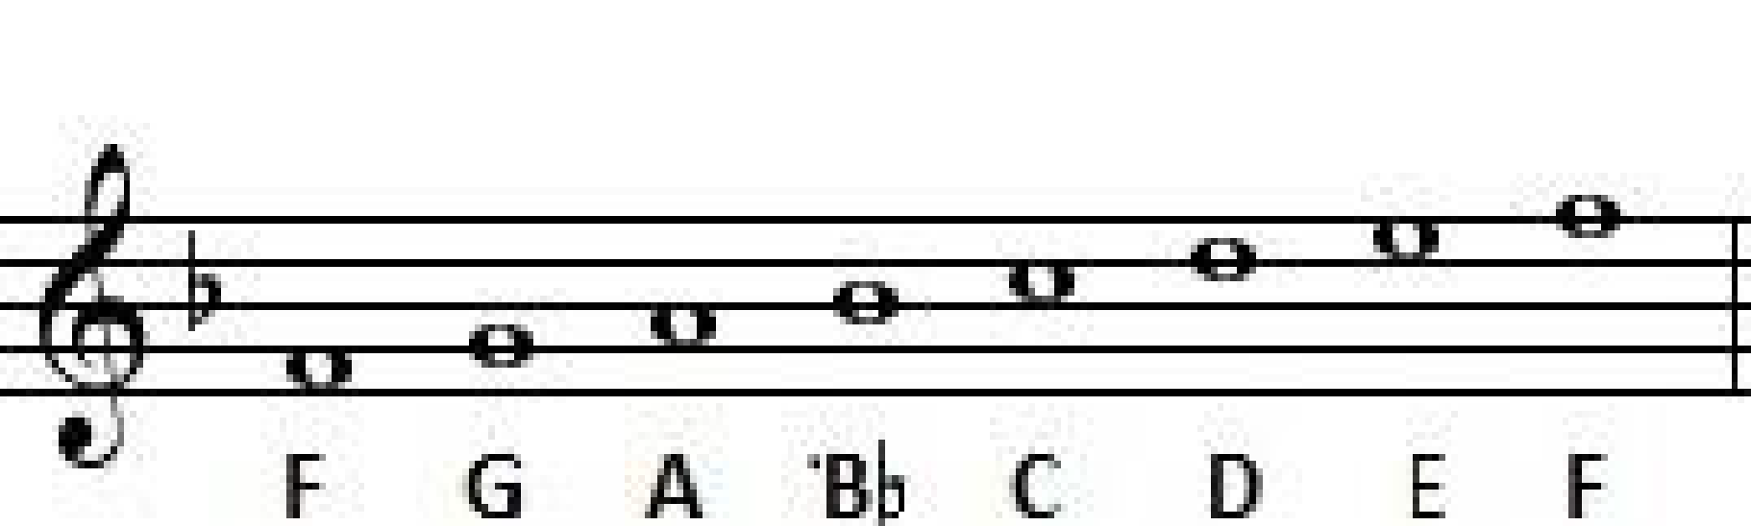  MU6ME-IIa-1 | analyzes the melodic patterns of songs in C Major, G major, and F Major keys  sings and plays solo or with group, melodies/songs in C Major, G Major, and F Major  MU6ME-IIa-2-3 | creates simple melodies in:  4.1 C Major,  4.2 G Major, and  4.3 and F Major scales  sings self-composed melodies in C Major, G major, and F Major key  MU6ME-IIa-3-4 | applies learned concepts of melody and other elements to composition and performance
II. CONTENT | An Enhanced Understanding of Melody |  | An Enhanced Understanding of Melody | An Enhanced Understanding of Melody | An Enhanced Understanding of Melody
III. LEARNING RESOURCES
- References
- TG/CG pages | CG pp. 34-35 | CG pp. 34-35 |  | CG pp. 34-35 | CG pp. 34-35
- Learner’s Materials pages | MISOSA4-modules13,14  • MISOSA6-module5,6 | MISOSA4-modules13,14  • MISOSA6-module5,6 |  | MISOSA4-modules13,14  • MISOSA6-module5,6 | MISOSA4-modules13,14  • MISOSA6-module5,6
- Textbook pages | The 21st Century MAPEH in Action | The 21st Century MAPEH in Action |  | The 21st Century MAPEH in Action | The 21st Century MAPEH in Action | .
- Materials downloaded from LRMDS
- Other Learning Materials | Musical score, Illustration chart of C Major Scale | Musical score, Illustration chart of F Major Scale |  | Musical score, Illustration chart of F Major Scale | Musical score, Illustration chart of F Major Scale
IV. PROCEDURES
- Reviewing previous lesson and presenting new lesson | Reviewing previous lesson:  Do you still remember when you were a baby, your mother used to sing a lullaby in order for you to sleep? | Reviewing previous lesson  The C Major Scale |  | Reviewing the past lesson  Of the F Major scale | Reviewing the past lesson  A song in the C Major scale,  F Major scale, and G Major Scale
- Establishing a purpose for the lesson | The reason why you have a favorite song is not just the lyrics/words of a song but you like the tune. | Today we are going to learn another song with the F Major scale |  | Today, we are going to sing a new song in a G major Scale | Today, we will be having a group activities.  Find your group, and follow directions.
- Presenting examples/instances of the lesson | Listen to the song “With a Little Help from My Friend”  With your classmates, sing the famous song entitled “With a Little Help from my Friend”  Find out what is in the melody of this song that makes this popular tune.  Ask:  - What is Melody?  - Why are melodies important?  - What is interval?  - What are tonal Movements? | Ask the pupils:  Do you know or hear the song “May Pulis sa Ilalim ng Tulay”?  Teach the song.  Original File Submitted and Formatted by DepEd Club Member - visit depedclub.com for more |  | Teach the song.  “Leron Leron Sinta in a G major Scale”” | With your group,  You are going to create a simple melody of the different Major scale:  - C Major Scale  - F major Scale and  - G major scale song. | written test
- Discussing new concepts and practicing new skills #1 | Tell: There are two kinds of diatonic scales  - The major scale and the minor scale  - The major scale uses WS-WS-HS-WS-WS-WS-HS  - Key of C – does not have any sharp or flat signature  - WS-Whole step  - HS-Half step | The F Major scale utilizes one flat (b) in order to maintain the sonic interval pattern of a major scale  F(WS) G(WS) A(HS) B(WS) C(WS) D(WS) E(HS) F |  | Discussion:  Major scale that utilizes sharp (#) is the key of G Major  G (WS) A (WS) B (HS) C(WS) D(WS)  E(HS) F(WS) | Discuss on what to do:  sings self-composed melodies in C Major, G major, and F Major key
 | MONDAY | TUESDAY |  | WEDNESDAY | THURSDAY | FRIDAY
- Discussing new concepts and practicing new skills #2 | An example of folk song in the scale of C Major  “ Kung Dai Si Abanico” in the tune of “Lubi Lubi”  See p. 29-the 21st Century MAPEH IN ACTION | Present the musical score of the song “May Pulis sa Ilalim ng Tulay “  Help the pupils identify the  F Major Scale tune. |  | Present the musical score of the song “Leron Leron Sinta“  Help the pupils identify the  G Major Scale tune. | Let the pupils have time to practice their song selected
- Developing mastery (lead to formative assessment 3) | Present this musical score  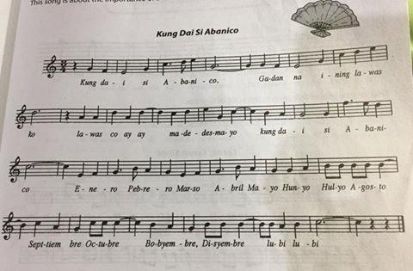 | Present this musical score  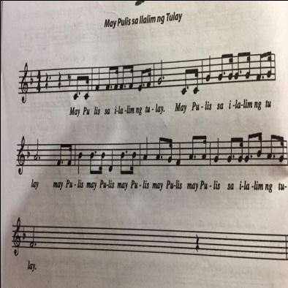 |  | Present this musical score  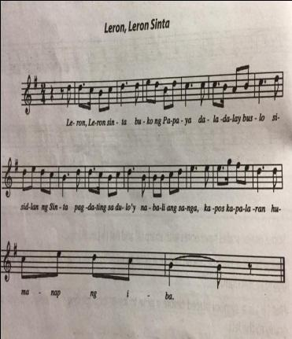 | Group Presentation/  Performance by group
- Finding practical application of concepts and skills in daily living | Teach The song to the pupils and let them sing with you.  This song is about the importance of a fan to Bicolanos throughout the year | Teach the song to the pupils in the  F Major scale. |  | Teach the song to the pupils in the  G Major scale. | Sing again the different songs in the different Major scale.
- Making generalization and abstractions about the lesson | Tell the pupils:  Some major scales have notes with sharp (#) and flat (b) markings. | Tell:  F Major scale that utilizes flat (b) in order to maintain the sonic interval pattern of a major scale |  | Discussion:  Major scale that utilizes sharps (#) is the key of  G Major – it utilizes one sharp (#)
- Evaluating learning | LET US Sing again the song “Kung Dai Si Abanico” | Identify the flat (b) in the major F scale of the song “May Pulis sa Ilalim ng Tulay” |  | Identify the flat (b) in the major F scale of the song “Leron Leron Sinta” | Identify the scales and the different signs that is used in the different songs. found in the song
- Additional activities for application or remediation | Memorize the song | Memorize the song |  | Memorize the song | Memorize the song
V. REMARKS
VI. REFLECTION | Assessing yourself as a teacher and analyzing the students’ progress this week.
- No. of learners who earned 80% in the evaluation
- No. of learners who acquired additional activities for remediation who scored below 80%
- Did the remedial lessons work? No. of learners who have caught up with the lesson.
- No. of learners who continue to require remediation.
- Which of my teaching strategies worked well? Why did these work?
- What difficulties did I encountered which my principal can help me solve?
- What innovation or localized materials did I used/discover which I wish to share with other teachers?

