

Resume example
Hello Valued Applicant,
Creating a standout resume has never been easier! Our resumes feature clean, modern designs tailored to make a lasting impression. Crafted by certified resume writers and optimized for ATS compatibility, they’re built to help you succeed in today’s competitive job market.

Here’s how we can help you:
Build Your Resume – Our simple tool makes creating a standout resume quick and stress-free.
Browse Resume Templates – Choose from modern, eye-catching designs tailored to impress.
Explore Resume Examples – Get inspired by samples made for every industry and role.
Write the Perfect Cover Letter – Complete your application with a compelling cover letter that wins interviews.
Job Search – Visit our blog for expert tips and strategies to help you land your dream job.
Take the guesswork out of job applications and start creating your future today. We’ll make sure you’re ready to seize every opportunity with confidence!
Your next chapter starts here – let’s get started.

Warm regards,
The Resume Example Team

How to Write a Student Resume
1. Header (Personal Information)
✔ Ensure your header is clear and well-structured.
✔ Include name, student status (e.g., College Student, High School Graduate), email, phone number, and LinkedIn (if applicable).
✔ Use a professional email address (avoid informal ones like gamerboy123@gmail.com).
✔ Avoid including photos, home addresses, or unnecessary personal details.
2. Resume Title
✔ Use a relevant and attention-grabbing title (e.g., "College Student | Aspiring Marketing Specialist").
✔ Customize it based on the position or career field you're targeting.
3. Summary or Objective Statement
✔ If you have some experience, write a resume summary:
- Highlight key skills, academic achievements, and relevant projects or internships.
- Example: "Motivated Business Administration student with strong analytical and problem-solving skills. Experience in market research and digital marketing strategies through coursework and internships."
✔ If you lack experience, write a resume objective:
- Focus on enthusiasm, relevant coursework, and career aspirations.
- Example: "Dedicated Computer Science student with a passion for AI and software development. Seeking an internship to apply Python and data analysis skills in a real-world setting."
4. Education (Reverse Chronological Order)
✔ Place education before experience if you have limited work history.
✔ Include:
- Degree or Major (e.g., "Bachelor of Science in Computer Science")
- University/College Name
- Graduation Year (or expected graduation date)
- Relevant coursework, academic achievements, or GPA (if above 3.5).
5. Work & Internship Experience
✔ Use reverse chronological order (most recent first).
✔ Include:
- Job/Internship Title
- Company Name & Location
- Dates of Work
- Key responsibilities & achievements (use bullet points).
✔ Use action verbs and quantify results (e.g., "Developed a social media campaign that increased engagement by 40%").
✔ If you lack professional experience, highlight volunteer work, extracurricular activities, freelance work, or academic projects.
6. Skills Section (Hard & Soft Skills)
✔ Hard Skills (Technical & Industry-Specific)
- Data Analysis (Python, SQL, Excel)
- Graphic Design (Adobe Photoshop, Canva)
- Coding (Java, HTML/CSS, JavaScript)
- Social Media Marketing (SEO, Google Analytics)
✔ Soft Skills (Transferable & Interpersonal)
- Time Management
- Communication & Teamwork
- Problem-Solving
- Leadership & Adaptability
✔ Match your skills with job descriptions to improve ATS compatibility.
7. Additional Sections (Optional but Recommended)
✔ Certifications – Include online courses or certifications (e.g., "Google Analytics Certified").
✔ Languages – Mention proficiency levels (e.g., "Fluent in Spanish, Basic German").
✔ Extracurricular Activities – Sports, clubs, leadership roles, hackathons.
✔ Personal Projects – Websites, blogs, coding projects, case studies.
8. Formatting & ATS Optimization
✔ Keep formatting simple & clean (avoid columns, tables, graphics).
✔ Use bullet points for easy readability.
✔ Choose professional fonts (Arial, Calibri, Times New Roman).
✔ Optimize with job-relevant keywords to pass ATS scanning.
✔ Save your resume as PDF or Word (.docx) format.
9. Cover Letter (Highly Recommended)
✔ Tailor it to each job application.
✔ Start with a strong introduction and explain why you're interested.
✔ Highlight relevant skills, coursework, or projects that align with the role.
✔ End with a call-to-action (e.g., “I look forward to the opportunity to discuss my application further.”).

Student Resume Example

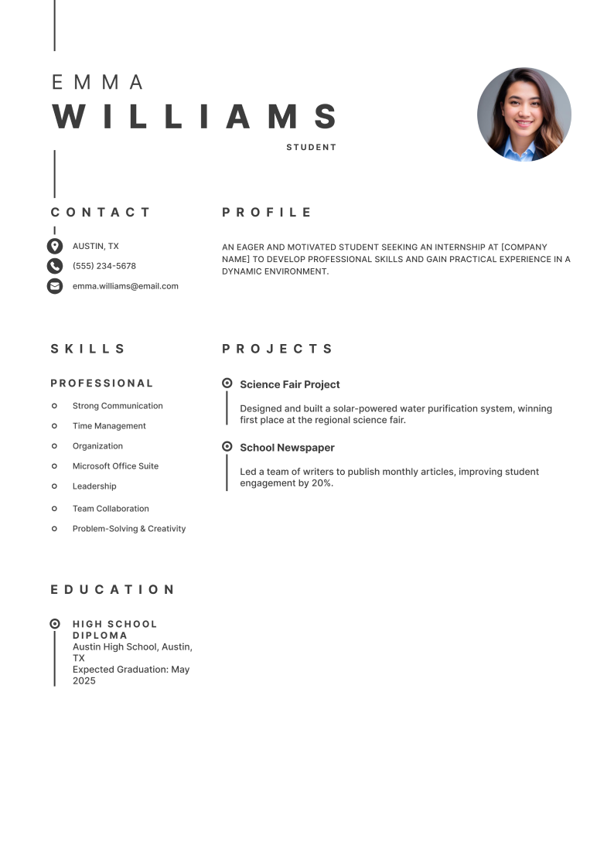

Student Resume Checklist

Check your student resume to see if it has all the critical elements:

✅ Header includes name, contact info, LinkedIn, and a professional email address.
✅ Resume title is relevant and aligns with the job or internship position.
✅ Summary/objective highlights skills, education, and career goals.
✅ Education is listed with degree, school name, graduation year, and relevant coursework.
✅ Experience section includes internships, volunteer work, school projects, or freelance work.
✅ Skills section contains both hard skills (technical) and soft skills (interpersonal).
✅ Additional sections include certifications, languages, extracurricular activities, and personal projects.
✅ ATS-friendly formatting with bullet points, keywords, and professional fonts.
✅ Resume is tailored to each application (keywords match the job description).
✅ Cover letter is included to strengthen the application.

If you're unsure about writing your resume or want to save time, we're here to help.
Use our resume builder to create a professional, ATS-friendly resume in minutes—boosting your chances of landing an interview and securing your dream job.

Good Luck!

