
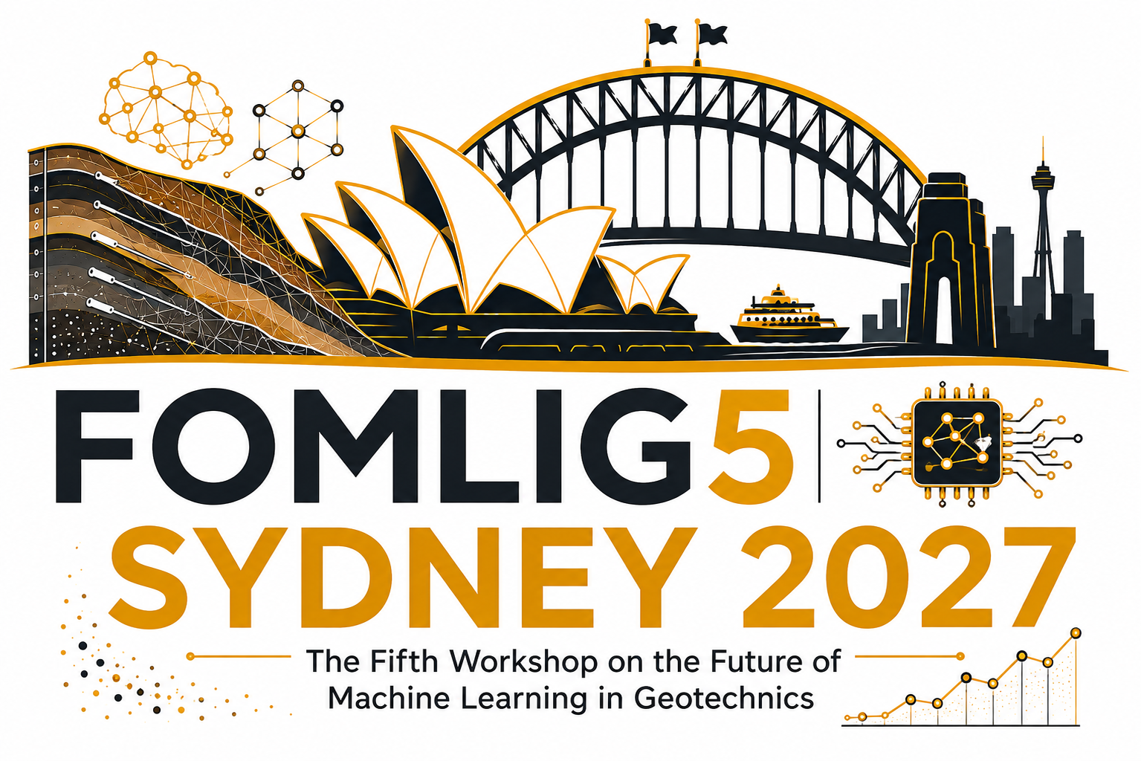
FOMLIG 2027
The Fifth International Workshop on the Future of
Machine Learning in Geotechnics

INVITATION FOR PROPOSALS
Pre-Workshop Short Courses
Tuesday, 12 October 2027 | FOMLIG 2027, Sydney
DATE  12 October 2027 | FORMAT  In-person | DURATION  Half-day or full-day

Invitation
FOMLIG 2027 invites proposals for pre-workshop short courses that provide practical, focused and up-to-date learning opportunities relevant to machine learning, artificial intelligence, data-driven methods and digital technologies in geotechnical engineering and engineering geology.
Proposals are welcome from academics, industry practitioners, consultants, technology providers and multidisciplinary teams. Courses that help bridge research advances with engineering practice are particularly encouraged.

A short course may include
- Practical methods, tools, software demonstrations, worked examples or case studies.
- Emerging AI and machine-learning approaches with clear relevance to geotechnical practice.
- Hands-on activities, data analysis or interactive exercises where appropriate.
- Research-to-practice lessons, implementation challenges and examples of successful application.
Recognition for organisers. The lead organiser and approved co-instructors of selected short courses will receive discounted FOMLIG 2027 registration as a token of appreciation.

The FOMLIG 2027 organisers will review all proposals received and get back to proposers regarding the outcome.

Please Visti our website for more information about submission: Click Here
For general information about conference: Click here

FOMLIG 2027 - PRE-WORKSHOP SHORT COURSE PROPOSAL
SHORT COURSE PROPOSAL FORM
Proposed title | Enter the proposed short course title.
Lead organiser | Name, title, affiliation and email.
Co-instructor(s) | Name, affiliation and email, if applicable.
Course summary | Briefly describe the proposed short course and its relevance to FOMLIG 2027 (approximately 150-200 words).
Main topics | List the main topics or modules to be covered.
Objectives | What should participants understand or be able to do after completing the course?
Target audience | Who is the course intended for?
Preferred duration | ☐ Half-day ☐ Full-day ☐ Either
Keywords | Provide 4-6 keywords.
Submission deadline and submission method are available in the FOMLIG 2027 website.

