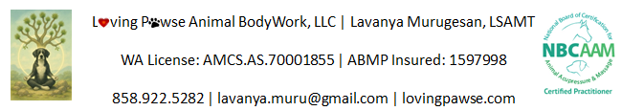

Animal Health Intake

Date: Click here to enter a date.
Dog Information
Dog Name: Click here to enter text.
Dog Gender: Male ☐ Female ☐
Surgical Sterilization: Spayed ☐ Neutered ☐ Intact ☐
Dog Age: Click here to enter text.
Dog Breed/Color: Click here to enter text.

Guardian Information
Guardians Name: Click here to enter text.
Guardians Address: Click here to enter text.
Guardians contacts (Phone and email): Click here to enter text.

Veterinarian Information
Veterinarian Name: Click here to enter text.
Veterinarian Address: Click here to enter text.
Veterinarian contacts (Phone): Click here to enter text.
Do I have permission to talk to the Vet if it is applicable? Yes ☐ No ☐

Medical History
Immunization (Current /up-to-date?): Choose an item.
Surgeries (date, type of surgery): Click here to enter text.
Injuries (date, type of injury): Click here to enter text.
Any known/preexisting conditions (date, diagnosis): Click here to enter text.
Current Medication (name, dosage, frequency): Click here to enter text.
Is your pet receiving ongoing care for any diagnoses medical conditions/allergies/post-surgery care, etc.? Yes ☐ No ☐
If yes, please clarify: Click here to enter text.

Dog Nutrition
Diet (name, quantity, frequency): Click here to enter text.
Supplements (dosage, frequency): Click here to enter text.
Does your pet have any known allergies?: Yes ☐ No ☐
If yes, please clarify (food name, environmental, etc.): Click here to enter text.

Dog Activities
Exercise (frequency and level of activity): Click here to enter text.

Dog Background
Behaviors (general behavior, handling sensitivity, sleep habits, season preferences, anything else?) : Click here to enter text.
Has your dog had body work done previously (e.g. massage, chiropractic, and acupuncture)?: Yes ☐ No ☐
If yes, please specify body work type, date and provide any documentation if available: Click here to enter text.
Reason for choosing massage/acupressure and any goals you have?: Click here to enter text.
Any concerns or anything else to report/request?: Click here to enter text.

Signature
Reference: Click here to enter text.

Bodywork is not a replacement for veterinary care. Canine Massage Therapists cannot diagnose and/or treat illness, injury or lameness. Massage Therapy as provided by Lavanya Murugesan includes a variety of complementary modalities, all within a licensed SAMT’s scope of practice, which support the health and well-being of the client physically and emotionally. I understand that I have to give at least 24 hours’ notice if I have to reschedule or cancel an appointment. I do not expect a reminder call prior to my appointment unless I request one.

☐ I understand

Signature (name, date, time): Click here to enter text.

