';--have i been pwned?

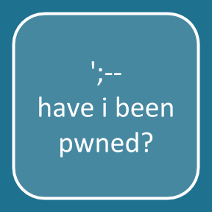
Background:
Troy Hunt is an Australian web security expert known for public education and outreach on security topics. He created Have I Been Pwned?, a data breach search website that allows non-technical users to see if their personal information has been compromised.
His site catalogs known data breaches and will check your credentials to see if they have been compromised. We will leverage his site to see if our credentials have been discovered in some of these breaches.

Requirements:
A web browser.

PART I: Find out if your email address has been pwned.
- Go to www.haveibeenpwned.com and enter your email
- If you have been pwned, scroll down through the list and note the sites where your email address has been discovered.
- Take a screenshot of your results and paste them below.

EVIDENCE #1
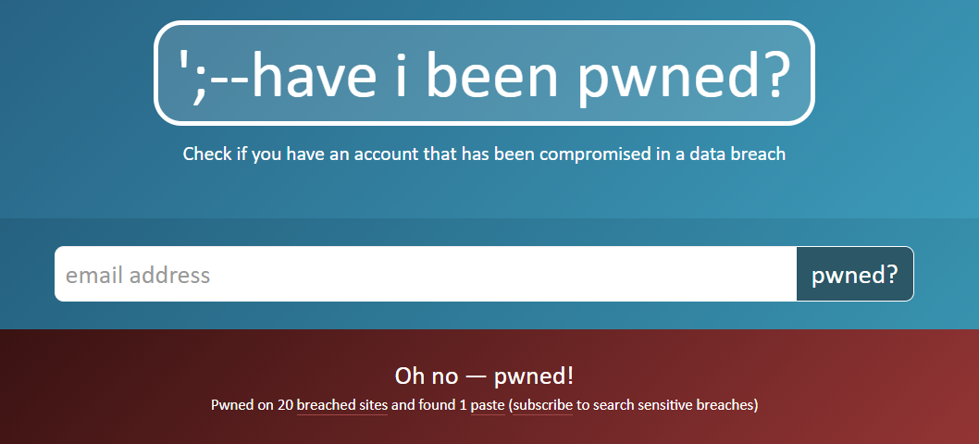

PASTE THE IMAGE OF YOUR EMAIL PWNAGE RESULTS

PART II: Find out if your password has been pwned.
- Go to www.haveibeenpwned.com/Passwords (or just click on the “Passwords” tab at the top of the website) and enter a password you may have used in the past.
- Look at the results and take a screenshot of them.

EVIDENCE #2
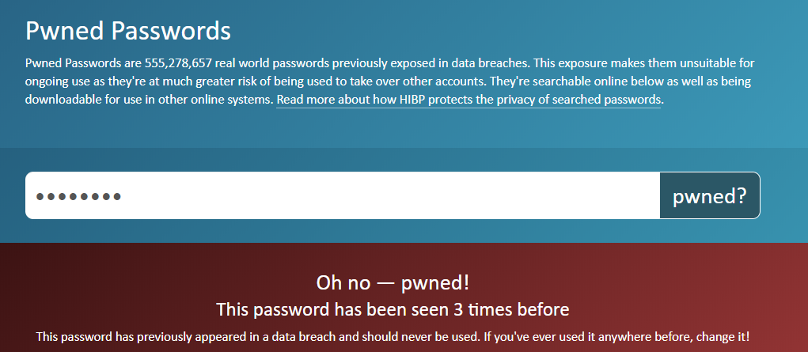
PASTE THE IMAGE YOUR PASSWORD PWNAGE

Wikipedia - Troy Hunt

