

Manajerial:
Jurnal Manajemen dan Sistem Informasi
Journal homepage: https://ejournal.upi.edu/index.php/manajerial
Manajerial: Jurnal Manajemen dan Sistem Informasi xx(x) (202x) x - xx

Article titles should be no Longer than 14 words and use the Constantia Font in 16 pt.
Author¹, Author², Author³
Author Affiliation¹
Author Affiliation²
*Correspondence: E-mail: *example@upi.edu
A B S T R A C T |  | A R T I C L E I N F O
The abstract must be written in standard English, ranging from 150 to 250 words in length, using the Calibri font in 12 pt and 1.0 line spacing. The entire abstract should be organized into a single paragraph that presents a brief background along with the research objectives, the methods used, the main findings or results, and the conclusions and their implications. Authors are prohibited from including citations, references to tables or figures, or uncommon abbreviations.  List keywords in the format “Keywords:” followed by 3 to a maximum of 5 keywords separated by commas.  © 2026 Kantor Jurnal dan Publikasi UPI |  | Article History: (filled in by the editor)  Submitted/Received xx Month 202x  First Revised xx Month 202x  Accepted xx Month 202x  First Available online xx Month 202x  Publication Date xx Month 202x  __________________  Keywords:  Keyword1, Keyword2, Keyword3, Keyword4, Keyword5

1. INTRODUCTION
The body of the article is typed with 1.15 line spacing, no spacing between paragraphs (before and after 0 pt), and a 12-pt Calibri font with left-and right-aligned (justified) paragraph formatting. The first paragraph is written without indentation, while subsequent paragraphs use a first-line indent of 1 cm.
The manuscript should be 10 to 20 pages in total (including the references section).
2. LITERATURE REVIEW
2.1. Example of Numbering for the Second Subsection
Example of Third-Level Subchapter Numbering
Chapters and subsections are written in 12-point Calibri font. First-level subsections are numbered using main numbering (e.g., 1. INTRODUCTION) and written in all capital letters. Second-level subsections use hierarchical numbering (e.g., 1.2.) with the first letter of each word capitalized. Meanwhile, third-level subsections are written in bold without numbering.
3. RESEARCH METHOD
3.1. Figure Guidelines
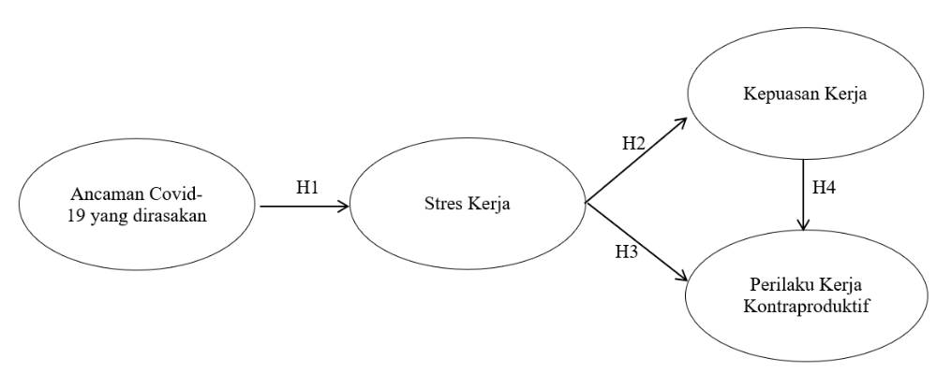
Referring to Figure 1, figures should be centered on the page and have a clear resolution. Figure captions should be placed below the figure, in bold, and numbered sequentially. Every figure included must be referenced or explained within the text.
Figure 1. Conceptual Framework
4. RESULT AND DISCUSSION
4.1 Table Guidelines
Tables are centered on the page with the number and title at the top. The table format must use an open style (with horizontal lines at the top, bottom, and headers, without vertical lines). Source citations should be listed below the table, centered, and each table presented must be cited within the text.
Table 1. Heading Format Rules
Heading Level | Example | Font & Style
Title (center) | ARTICLE TITLE | 16, bold
1st-level heading | 1. INTRODUCTION | 12, bold
2nd-level heading | 2.1 Sub-literature Review | 12, bold
3rd-level heading | Respondent Characteristics | 12, bold
Source: For secondary data only (year)

5. CONCLUSION AND RECOMMENDATIONS
The conclusion presents a clear and concise synthesis of the answers to the research objectives, without repeating the descriptions in the results and discussion sections. The recommendations include practical suggestions and input for future research based on the limitations identified. This entire section is organized in the form of narrative paragraphs, numbered lists, or bullet points.
6. ACKNOWLEDGMENTS
Acknowledgments can be included in this section.
7. REFERENCES
(The References or Bibliography section is arranged alphabetically according to APA Style (7th Edition). The references must consist of at least 20 scholarly sources, with at least 80% comprising research articles published within the last 10 years. Each entry must be typed using single spacing with a 1 cm hanging indent. Authors must include an active DOI (Digital Object Identifier) link for all references that have one.)
Basani, A., & Wardhana, I. (2025). Barriers and facilitators of personal health record adoption in Indonesia. International Journal of Medical Informatics. https://doi.org/10.1016/j.ijmedinf.2022.104878
Baskara, I., & Sukaatmadja, I. (2016). Pengaruh online trust dan perceived enjoyment terhadap online shopping satisfaction dan repurchase intention Lazada Indonesia. E-Jurnal Manajemen Universitas Udayana, 5(11). https://doi.org/10.24843/ejmunud.2016.v05.i11.p07
Giatman, M. (2011). Ekonomi teknik. Raja Grafindo Persada.
Yin, R. K. (2018). Case study research and applications: Design and methods (6th ed.). SAGE Publications.

