Geologic Time Scale Activity

Introduction
Understanding geologic time is critical to relating events in Earth’s history to those of today. Scientists use several forms of the geologic time scale to classify the age of objects to become familiar with other events occurring simultaneously. Choose one of the options listed in the procedures below to complete this assignment.
Materials
If you would like to create your geologic time scale by hand, you will need the materials listed below.
Note: There are alternative procedures that do not require these materials.
- Adding machine paper, or pieces of paper taped together to form a continues line
- ruler or meter stick
- tape
- colored pencils, crayons, or markers
- digital camera, mobile device, or laptop camera to take a photograph of your time scale
Procedures:
Option 1 Procedures with materials
- Cut a piece of adding machine tape approximately 4.6 meters long or attach pieces in a continuous line using tape so it is approximately 4.6 meters long.
- Tape the ends of your paper onto your table so it is easier to measure and label.
- label your paper “Geologic Time Scale” at the top left.
- At the top right of your paper, include the following scale:

1 meter | 1 billion geologic years (1 bya)
1 centimeter | 10 million geologic years (10 mya)
1 millimeter | 1 million geologic years (1 mya)

- Starting from the left side of the paper, measure 5 centimeters to the right and draw a vertical line. Label the line “today”.
- Plot each era, period, and important event on the paper using the scale provided and Table 1 below.
When you have completed your geologic time scale model, take an image of it and place it onto this document for your instructor to view.
Option 2: Procedures without materials
There are many different types of models. A timeline is one way to represent the geologic time scale, but there are other ways as well.
- Below Table 1, you have been provided with the geological time scale. The time scale is an approximation and is not to scale.
- You will need to complete the scale by recording the significant biological and geological events. You will need to identify at least two biological and two geological events for each period. You may need to perform additional research to gather your information to complete the time scale.
- After you have completed the time scale answer the Reflection Questions.

Reflection Questions
Do not answer until you have completed the time scale located on the pages following Table 1.
- How long (in centimeters and years) was the Precambrian period compared to the rest of the scale?
- How many years and “centimeters” of time separated the dinosaurs and humans on Earth?
- How many years and centimeters of time passed before life appeared on Earth?
- For how many years of geologic time have humans existed?
- Did dinosaurs exist at the same time as mammals? Explain your answer using the geologic time scale.
Table 1
Complete the total time column for the table below to assist with answering the reflection questions. The first one has been completed for you.
- bya=billion years ago
- mya=million years ago
- 1cm=10 million years ago

 | Time Span | Scale | Total Time
Hadean Eon  (Precambrian Time) | 4.6 bya – 3.8 bya | 460 cm – 380 cm | .8 billion years
Archaean Eon  (Precambrian Time) | 3.8 bya – 2.5 bya | 380 cm – 250 cm
Proterozoic Eon  (Precambrian Time)  Cambrian Period  Ordovician Period  Silurian Period  Devonian Period | 2500 mya – 543 mya | 250 cm – 54.3 cm
 | 543 mya – 490 mya | 54.0 cm – 44.0 cm
 | 490 mya – 443 mya | 49.0 cm – 44.3 cm
 | 443 mya – 417 mya | 44.3 cm – 41.7 cm
 | 417 mya – 354 mya | 41.7 cm – 35.4 cm
Carboniferous Period | 354 mya – 290 mya | 35.4 cm – 29.0 cm
Permian Period | 290 mya – 245 mya | 29.0 cm – 24.5 cm
Triassic Period  Jurassic Period  Cretaceous Period | 245 mya – 206 mya | 24.5 cm – 20.6 cm
 | 206 mya – 144 mya | 20.6 cm – 14.4 cm
 | 144 mya – 65 mya | 14.4 cm – 6.5 cm
Tertiary Period  Quarternary Period | 65 mya – 1.8 mya | 6.5 cm – .18 cm
 | 1.8 mya – Today | .18 cm – 0.00 cm
The Present | Today | 0 cm

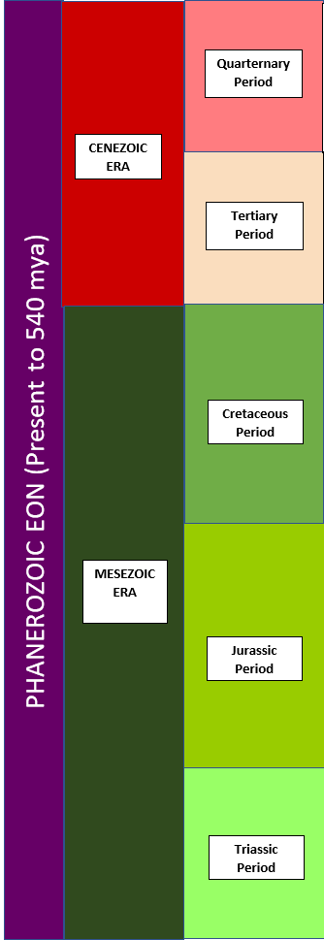

Biological Events
1.
2.
Geological Events
1.
2.

Biological Events
1.
2.
Geological Events
1.
2.

Biological Events
1.
2.

Geological Events
1.
2.

Biological Events
1.
2.S
Geological Events
1.
2.

Biological Events
1.
2.
Geological Events
1.
2.

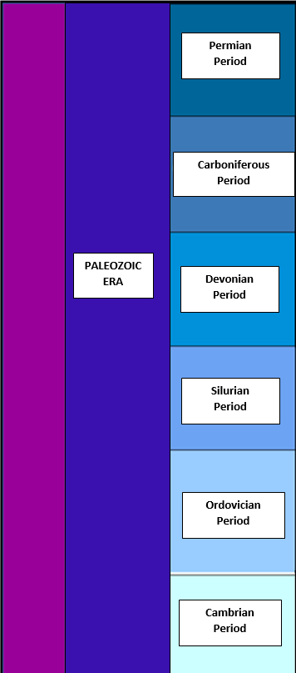
PHANEROZOIC EON (Present to 540 mya)
Biological Events
1.
2.
Geological Events
1.
2.

Biological Events
1.
2.
Geological Events
1.
2.

Biological Events
1.
2.
Geological Events
1.
2.

Biological Events
1.
2.
Geological Events
1.
2.

Biological Events
1.
2.
Geological Events
1.
2.

Biological Events
1.
2.
Geological Events
1.
2.

Biological Events
1.
2.
Geological Events
1.
2.

Biological Events
1.
2.
Geological Events
1.
2.

ARCHAEAN
EON
HADEAN
EON

