TERG 3000
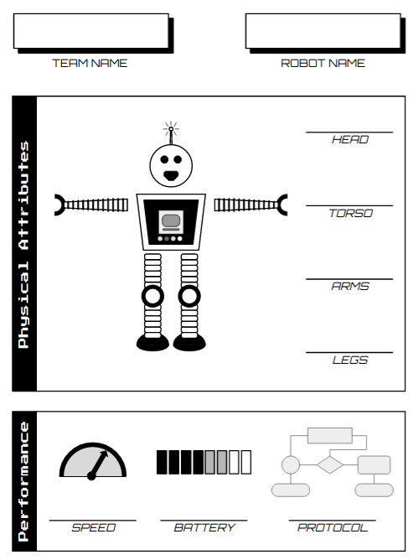
The players are tasked with assembling a robot to represent their team in a robot competition.

OVERVIEW
In the first phase of the game, each team freely explores the playable area, earning RoboCredits by participating in challenges at stations they encounter. The RoboCredits are then used to purchase components (head, torso, arms, legs) and attributes (battery, speed, and protocol) for their robot. The components are actually costume pieces, and by the end of this phase each team has a sheet indicating the components for the complete robot costume.
In the second phase (possibly held on another day), all teams convene at a performance area. Each team outfits a staff member in the components they have collected, thereby assembling their robot. The costumed staff members then compete for their teams by performing randomly selected task (for example, break-dancing, juggling, singing a pop song in robot voice) for the crowd. A panel of judges awards points based on the success and entertainment value of the performance. Prizes can be given for best performance, worst performance, most impressive, funniest, and so on.

INTRODUCTION & RULES
Players are divided into teams. With all players in attendance, the GameRunner explains the premise of the game and answers questions. The GameRunner emphasizes the following:
- Explore the playable area, looking for stations
- Teams must stay together
- Teams will earn RoboCredits for completing tasks at stations
- RoboCredits are used to buy robot parts at vendors; each team needs to buy:
- Robot Components:
  - Head
  - Torso
  - Arms
  - Legs
- Robot Attributes
  - Battery
  - Speed
  - Protocol
Explaining the game in robot-costume is a plus. During this time, staff members will report to their stations. The players are then dismissed and the game begins.

PHASE 1: Stations
There are ten stations, distributed across the playable area. Staff at each station will welcome teams, explain the challenge, and award RoboCredits when the challenge is completed. Unless otherwise stated in the station description, all games have a minimum award of 10 RoboCredits and a maximum of 40 (depending on the effort of the team, and within the discretion of the station attendant). Detailed suggestions for each station are included in the Assets Package

COLLECT THE BALL BEARINGS
Traditionally, this challenge uses a “Plinko” or “Galston Distribution” game [see Carnival Games].
Use the cup to catch the falling ball; it is up to the person running the event to determine how many points each team will receive. The recommendation is that every person in the team attempts to catch the ball 2 or 3 times.

SEND INFORMATION VIA LASER
Needs to be done in a low-light environment, so indoors is preferable. A smoke machine is an option.
Connect the three nodes to the target by shining a laser such that it glances off of a mirror at each node. Players can move and adjust the mirrors as long as they remain situated inside their nodes. The laser can be shined from anywhere. Lesser credit may be awarded for connecting two nodes together or one node to the sign. For added effect, use the smoke machine so that the beam is visible! Obviously, do not allow the laser to be shined into anyone’s eyes.

ROBOT CONSTRUCTION
Needs a modified version of the popular Milton Bradley game “Operation.” Create a template of a robot to place over the patient. Have an artistic staff member draw the insides of a robot on the template, and affix it to the cardboard of the original game.
The intention here is for all pieces to be placed into the robot. Using the modified version of “Operation,” players must take turns inserting the pieces (for example, the first player should insert one piece, hand the robo-tweezers to the next player, who will insert another piece, and so on).

RECOVER THE INTEGRATED CIRCUITS
Create circuit boards and other robotic-looking paraphernalia by hot gluing copper wire, dead batteries, and some random metal pieces onto a piece of wood spray painted green.
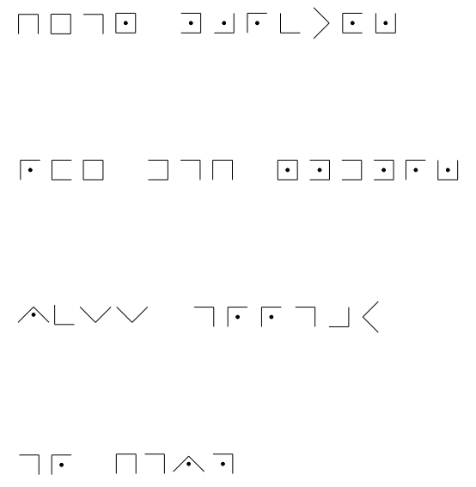
There are four different pieces that need to be recovered. The recovery game should be very similar to “Steal the Bacon.” The station attendant may call two or three people at a time. Players compete against staff members, who should adjust their level of competition accordingly.

DECODE THE MESSAGE
Using the included Pig-Pen cipher, have each group try and decode the encryption.
The station attendant gives the team the message, and has them decode it. Typically, it is revealed that the first word is “Dear.” If the team is still struggling, more hints can be given.

DELIVER FUEL
Uses the element “Nitro Crossing” typically found in a Low Ropes Course.
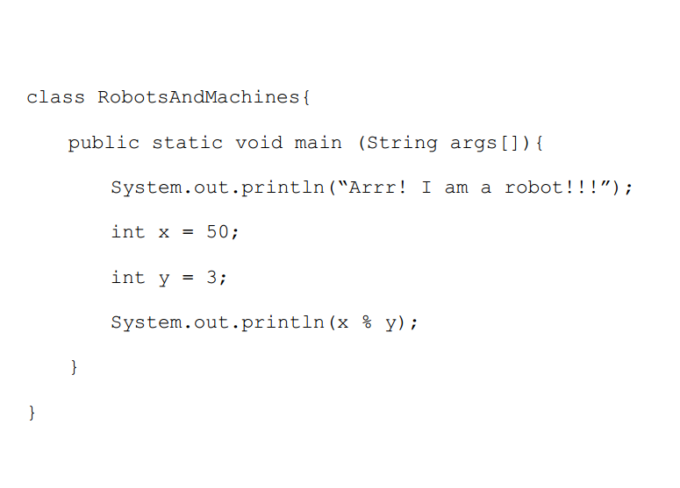
Players must attempt to swing, one-by-one, from one platform to another. They may not touch the ground, and must also transport a small container of fuel (water) without spilling. A team succeeds when all players have successfully landed on the other platform. Although the minimum reward is typically 10 credits, no credits can be given for poor attempts or no attempt at all.

PROGRAM CODE
Uses an old typewriter, typically found in garage sales, secondhand stores, or eBay. Also requires the model code segment, included.
Each player on the team re-types the code segment on the old typewriter verbatim.

ALGORITHM MARCH
Supplies as determined by staff member in charge of this station. Typically, athletic supplies are used for small obstacle courses.
The station attendant will create an obstacle course with challenges. One player is blindfolded. His team members will verbally guide him through the field, telling him where to turn and how to avoid obstacles to complete the course. The goal is to traverse the course without touching any of the obstacles.

OIL A ROBOT
Needs an oil can.
An oil can needs to be retrieved by the team. Two staff members are involved; one is the person who “cries and enlists the help of the kids” and the other is the “old curmudgeon who has the only oil can around” (on the porch of a nearby building). The first staff member will send the players to the second staff member, who will, in turn, make the team perform a series of amusing tasks (sing a song, collect a four-leaf clover, something out of the ordinary).

TRANSPORT VOLATILE BIOMASS TO THE INCINERATOR
This station needs a large, flat, smooth area (such as a basketball court). Also needs a hose attached to a water supply and a soccer ball.
There will be a hose (attached to a faucet) that will be used to propel the biomass (soccer ball) from a starting destination to an ending destination. Depending on the skill of the team, the station attendant can hurl objects at the soccer ball in an attempt to disrupt its trajectory.

VENDORS
The vendors are located in the Robo-Mall. Each vendor will display a catalog of products for the teams to look at, and will be able to negotiate prices (catalogs, signs, and price lists are included in the Assets Package). Vendors will indicate - on the sheet for each team - the item that the team has purchased with RoboCredits.

PHASE 2: The Robots Compete
All players convene at a performance area to watch the robots perform. Each team’s “robot” is actually a staff member who will don the costume the team has assembled.
Robots are called one at a time to the stage and asked to perform randomly selected tasks (see Task List for Final Performance). These tasks are designed to be of high entertainment value by being difficult to perform in a robot costume. A panel of judges rates each performance. For every 50 RoboCredits a robot is worth, one point is added to the performance. Note that the performance and adjudicating should (roughly) be commensurate with the value of the robot.

CHARACTERS, PROPS & LOCATIONS

CHARACTERS
- Old Curmudgeon
- Staff to run nine stations
- Vendors to run the stores that sell robot pieces and characteristics
- Panel of judges (only needed to participate at the end)
- Emcee for the Robot Competition

PROPS
- RoboCredits (included in Assets Package)
- There are a lot of props for this game. In addition to the robot costumes, the Challenge Stations will require props as well. Consult the Assets Package for detailed instructions on building the props.
- The best way to get robot costume pieces is to go to a hardware store and buy cool looking things.
  - Things like shiny silver insulation tape, some thin sheet metal, some foam insulation sheets, and some flexible hosing
  - The 4” black drainage tubes used in landscaping are cheap and look great
  - 3” circular vents for roofs make great mouths for robots, and rectangular vents are almost as cheap and make great robot pieces
  - Chest protectors and shoulder pads from second hand sports stores look amazing when spray painted silver
  - PVC tubing is cheap and look pretty good without being painted
  - Battery powered LEDs are cheap, available, and enhance any robot prop or costume
  - The Maintenance Director typically has a trove of odd objects that can be used as robot props
- Feel free to change the vendor shops to names that reflect the staff at your camp

LOCATIONS
- Challenge Stations
  - Catch the Ball Bearing
  - Send Information Via Lasers
  - Robot Construction
  - Recover the Integrated Circuit
  - Decoding the Message
  - Deliver Fuel
  - Program Code
  - Algorithm March
  - Oil a Robot
  - Transport a Volatile Biomass
- Vendor Mall
  - Amanda’s Arm Dealer (sign included in Assets Package)
  - Tina’s Torso Haven (sign included in Assets Package)
  - Lyman’s Leg Bodega (sign included in Assets Package)
  - Hayne’s Head Emporium (sign included in Assets Package)
  - Bo’s Battery Depot (sign included in Assets Package)
  - Sam’s Speed Shack (sign included in Assets Package)
  - Peter’s Protocol Repository (sign included in Assets Package)

TIPS & TRICKS
- This game works best in two different phases.
  - The Stations Phase can take between 60 and 90 minutes. If teams cannot earn enough RoboCredits to buy all their pieces in that amount of time, the vendors may be willing to barter or donate pieces
  - Depending on the number of teams, the Robot Competition Phase can be another 60 minutes (this works well at all-camp gatherings such as campfires)

