Name(s)_______________________________________________ Period _______ Date _____________________

Project Guide - Final Personal Website

Overview
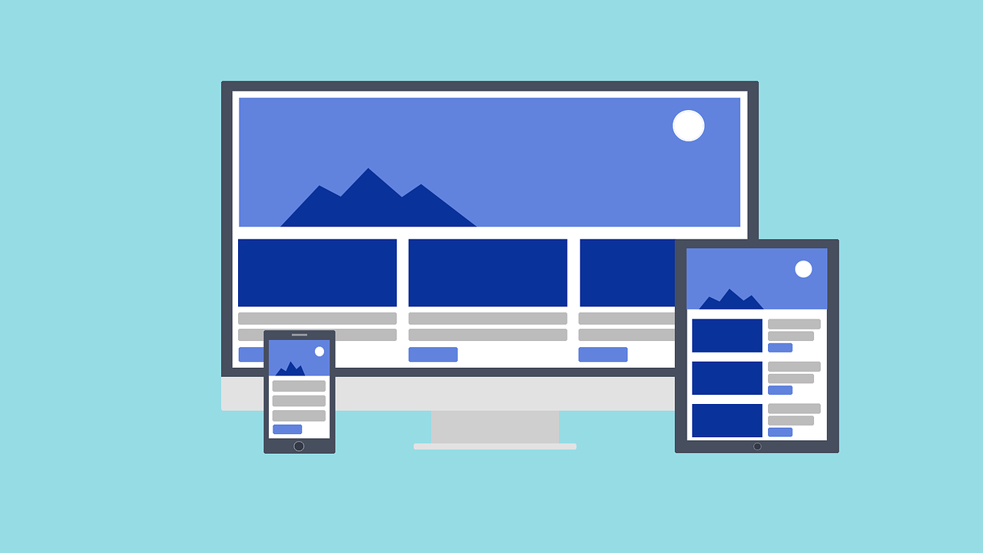
Web design is a powerful tool for self expression, sharing information, and building a business. During this project you will get to finalize the website that expresses your personal style and shares some of the work you have done in this class. You have already done most of the work in creating this site, so this is your chance to add your finishing touches and celebrate everything that you have done in this unit.

You will…
- Learn HTML and CSS
- Create a multi-page website

You will submit...
- Screenshots of the progress of your home page
- Your final website
- Your personal reflection

Project Process
- Finalize the content of all website pages
- Style your entire website pages using a single stylesheet
- Put finishing touches on your site
- Check your website against the rubric
- Reflect on what you have accomplished

Step 1: Finalize Content

Identify any content that is left to create on your website. Your site should have the following files:

- Home Page - This is the first page that people will see when coming to your site. It’s the page you started off with at the beginning of the unit.
- Lists Page - This page has at least one ordered or unordered list. It could be a recipe, a top ten list, or something else of your choice.
- Third Page with content of your choice.
- Style Sheet - This is the css file that you used to create the styles on your website.
- Images - These are the images that you will show on your website. You should have at least three of them.

Spend time reading back through pages that you made earlier in the unit to make sure you’re still happy with them. Consider revising pages to make them more compelling to your reader.

Step 2: Style Your Site

Using a single stylesheet that is linked to from all of your pages to give your entire website a consistent style. Use the space below to plan out which styles you will apply to each element.

Element or Class | Style
Body
Paragraph
Headers 1-6
Ordered List
Unordered List
Image

Step 3: Finishing Touches

There are probably multiple things you still want to get done on your website but you have limited time to get them done. When this is the case it is a good idea to start with the most important ones. Consider the additions or changes you would most like to make to your site, including new pages, better styling, incorporating new tags or styles, or anything else that would make your site better.

List the five most important things to get done in order. Depending on your time available, you may not get to all of these finishing touches.

- ____________________________________________________________________________________

- ____________________________________________________________________________________

- ____________________________________________________________________________________

- ____________________________________________________________________________________

- ____________________________________________________________________________________

Step 4: Check Your Website

Check your website to make sure it has everything it needs.

Step 5: Reflect

What part of your project are you most proud of? ____________________________________________________

Why? _______________________________________________________________________________________

_____________________________________________________________________________________________

If you had more time, what improvement would you make to your website?

_____________________________________________________________________________________________

_____________________________________________________________________________________________

