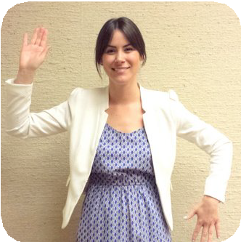

|  |  | 3 | **Clap** | **Clap Clap** | |  |
| --- | --- | --- | --- | --- | --- | --- |
|  | 2 | **Behind Head Waist** | | **Behind Head Waist** | |
| Repeat this part **3** times! | 3 | **Clap** | **Clap Clap** | |  |
|  | 2 | **Left Up Right Up** | | **Left Up Right Up** | |
|  | 3 | **Clap** | **Clap Clap** | |  |
| Then do this! |  |  | **Belly Laugh** |  |  |  |