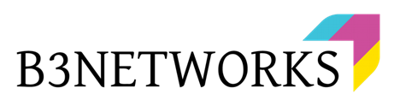

B3Networks
Product Specification for CPaaS Robocall

Document Control Versioning

Document History
Date | Version | Applicable BMOs | Author | Comments
26 Oct 2022 | Version 1.0 | All | Kevin/Wulan | Creation
27 Oct 2022 | Version 1.1 | All | Mahnoor | Amendment
3 Nov 2022 | Version 1.2 | All | Kevin | Amendment

Table of Contents

Product Summary 3
Product Features 4
Product License Requirements 4
CPaaS License Requirements 4
Functional Specs 5
Elements 5
● CPaaS Communication Campaign 5
● CPaaS Developer Programmable Flow 6
Workflow 6
Web Interface 6
Banking 7
Hospital 7
Restaurant 8

Product Summary
Robocall is an automated outbound call that utilizes a computerized auto dialer to deliver a pre-recorded text-to-speech or mp3 (audio file) message, generated by a robot, with or without DTMF interaction.
Robocall is a part of an automated telephone solution created to assist companies/partners in sending mass information over messages to the entire customer contact list and expanding reach to customers quickly by removing the need to directly speak to customers and therefore, reducing agents’ call activity.
Robocall is an effective tool as it can be used to sell a product, which reduces the need for human resources and therefore saves costs. For example, a company wants to make automatic calls for the purpose of increasing agent productivity by eliminating the time used to input customer dial numbers. Similarly, a company that has a system to send reminders/verification continuously within 24 hours is capable of making many calls simultaneously without involving many people. With the use of Robocalls, product sales can be carried out optimally by spending least cost. Robocall can assist in making multiple simultaneous calls to customers digitally.

Product Features
Feature Name | Description
Support play text to speed | Flexibility to adjust the play text to speed
Support upload MP3 file | Flexibility to adjust MP3 file
Campaign Management | Ability to make outbound campaigns and schedule campaigns
Support DTMF | Ability to capture the DTMF response from the caller
Support multiple layer | Provide a flow of calls to ask or explain something in single call
Verification or Validation | Option available for verification or validation during the call
Voice mail recording | Option available to leave a Voice Message
Custom integration using API | Flexibility to integrate into other systems or customers

Product License Requirements

SKU Name | SKU Type | Unit Of Measure
Developer | Basic License | Per organization per month
Developer Concurrent Call | Addon License | Per concurrent call per month
Number | Addon License | Per number per month

Functional Specs
Robocall comprises the following elements that work together to give a unique Robocall solution:

Elements

CPaaS Communication Campaign
Robocall provides a personalized outgoing call attribution that supports an automatic outgoing call option that allows outgoing calls to multiple destinations with a single click and other features to optimize and schedule calls.

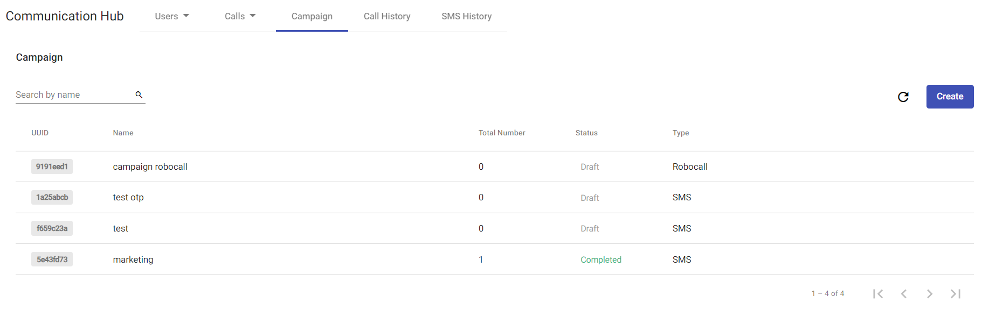

CPaaS Developer Programmable Flow
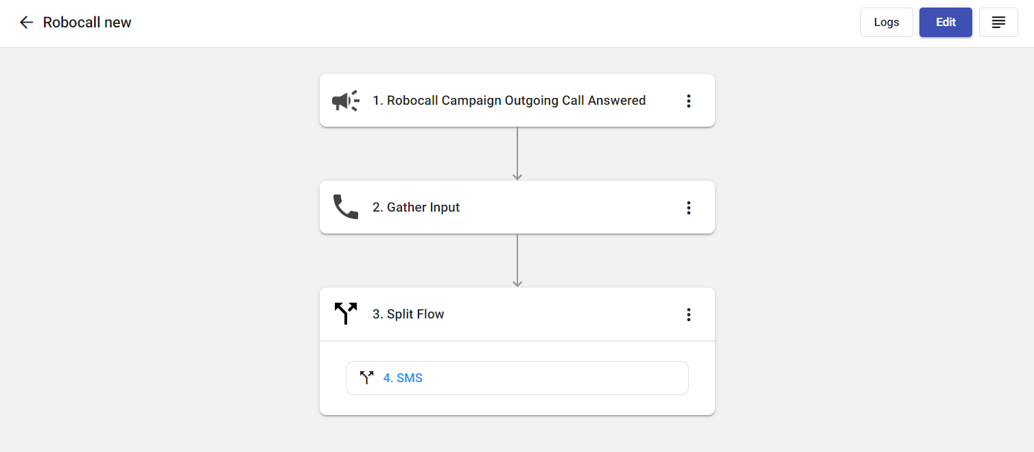
Robocall creates automated workflows by pooling resources and performing actions on a diverse set of services. These flows are used to integrate with third party systems required to pull and transmit data.

Workflow

Start/Schedule Campaign
Customer picks up call
Automated message plays
Robocall starts calling customers
Customer creates a Robocall campaign

Using API

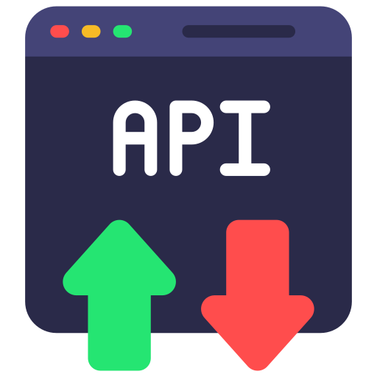
Customer picks up
Automated message plays
Robocall System starts calling customers
Customer uses
our Voice API

Use Cases In Various Industries
Robocall serves as a solution, as it makes it easier to deal with customers and provide them with detailed information. Robocall is quite flexible and suitable for use in multiple industries engaged in various fields.

Banking
In the banking industry, robocall can make automatic calls to remind customers of bill payments before the due date.

Customers pick up the call
Remind customers of bills
Robocall makes outgoing calls

Hospital
Robocall is a service that allows the hospitals to do the reminders and get confirmation of the customer attendance for the various schedules such as appointments, check-ups and doctor's schedules, etc.

Restaurant

A restaurant wants to make an offer to the customers about the discounts through automatic robocalls and customers can directly make reservations at the restaurant.

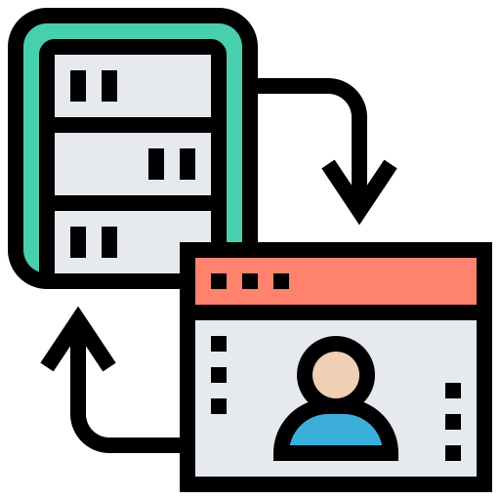
Customer picks up the call
Robocall makes outgoing calls
Booking completed
Greeting message
Customers decide to make reservations
Integrations with Restaurant’s internal system

