Introduction
More information on ORCID and signing up for an account can be found on the teaching labs website.
The following will show how to add a publication of crystallographic data from the CCDC, specifically DOI: 10.5517/ccdc.csd.cc2n7806

Adding Works
After signing into ORCID you will be presented with your profile page, this is what is used to manage personal information including employment and educational background as well as professional activities and publications.
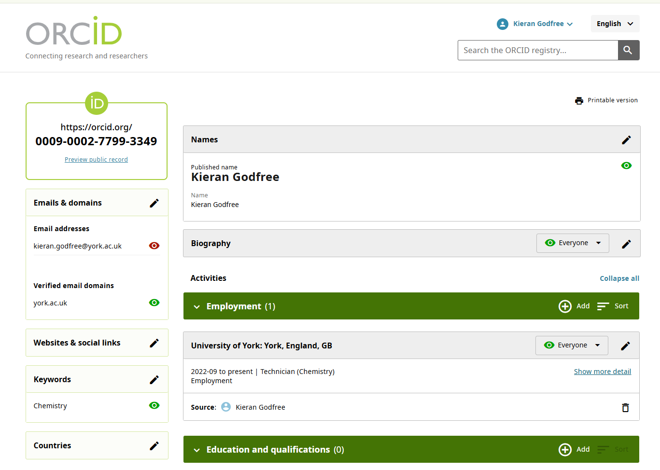
To add a publication to your profile scroll to the bottom to the works section and press add you will then be given options of different methods to add, in this example we will be using DOI, hence select the Add DOI option.
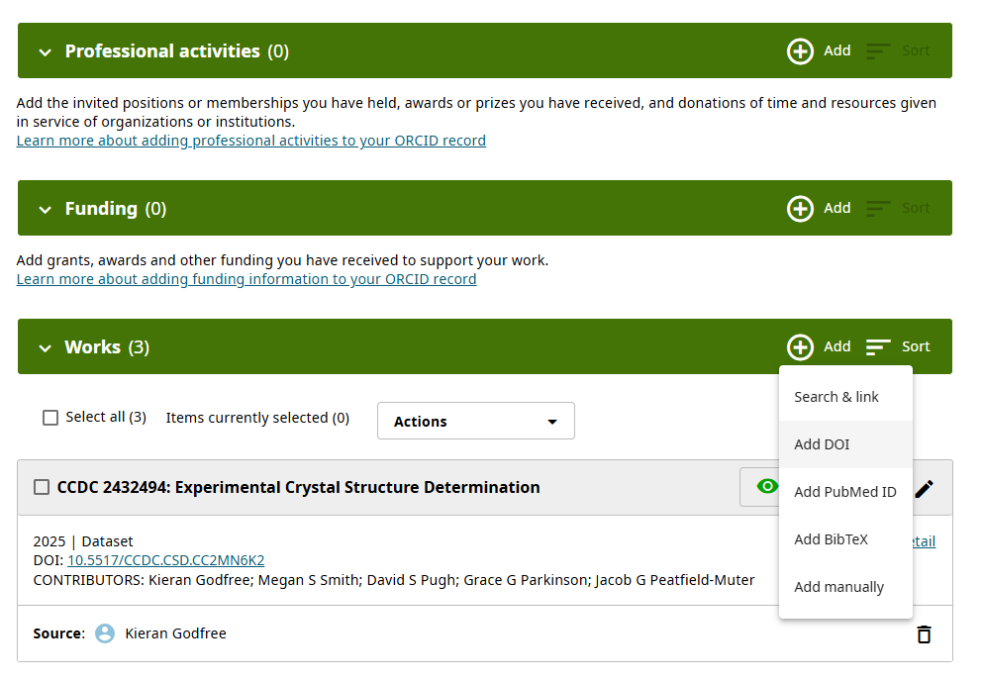
Copy and paste the DOI from the data listing you are trying to add this will be in the general format of 10.number/example. ORCID will then fetch the publications information and prefill some of the details for you.
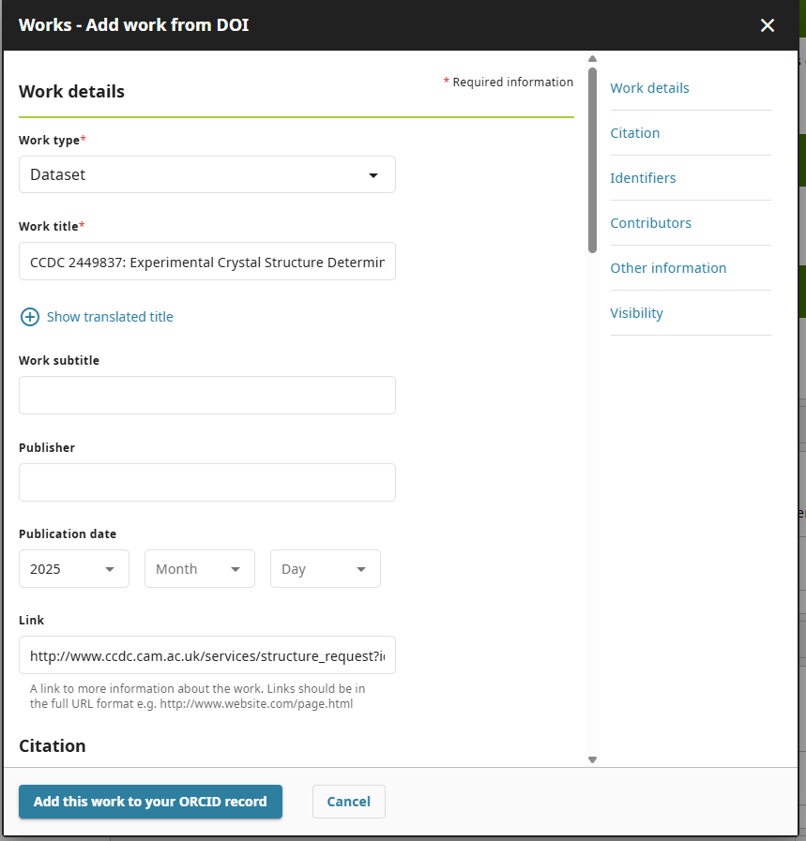
Information such as publication data can then be added here too. ORCID is sometimes unable to extract authors' names when importing from the CCDC so these will need adding manually. First start by deleting the generic author information from the list by pressing the trash icon next to each entry.
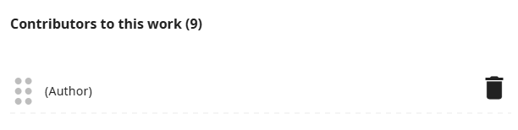
Once all the authors are removed press the add yourself as a contributor link, then add your fellow authors by pressing add other contributors and entering their names manually, the role can be left blank or specified. Once all the contributors are added you can then press the “add this work to your ORCID record” button and this will then be added to your profile for others to view.
