

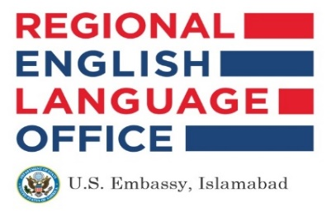
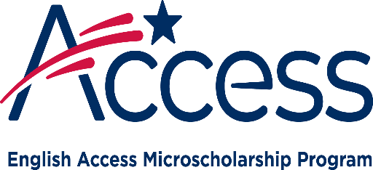

ABDUL WALI KHAN UNIVERSITY MARDAN
ENGLISH ACCESS SCHOLARSHIP PROGRAM
Student Registration Form
Program Duration |  | Paste 2 recent  passport size  attested photos here  (White or Blue  background)
Program Timings
Program Venue | Garden Campus,  Abdul Wali Khan University Mardan
Applicant Details
Full Name
(in block letters)
Father Name
(in block letters)
Date of Birth
(DD/MM/YY)
CNIC/Form-B
Residential Address
Permanent Address
Contact No.
(Mobile/Landline)
Email Address
Class presently studying
Name of your School/College
Address of your School/College
Contact No. of your School/College
Parent/Guardian Occupation
Name of Institute (in case the parent/ guardian is a government or private employee)
Guardian’s relation to student
Contact No. of Parent/Guardian
Parent/ Guardian’s Monthly Income
Number of Dependent Family Members
Are you currently availing any other scholarship? |  |  | □ YES | □ NO
If yes, which one:
Have you been registered in any English language course? |  |  | □ YES | □ NO
If yes, provide details:
Do you go for any tuition after school? |  |  | □ YES | □ NO
Do you have a computer at school? |  |  | □ YES | □ NO
Do you have laptop at home? |  |  | □ YES | □ NO
Do you have access to internet? |  |  | □ YES | □ NO
Do you have smartphone? |  |  | □ YES | □ NO
Do you participate in extracurricular activities at school/college? |  |  | □ YES | □ NO
If yes, which ones?
List your hobbies and interests:
Declaration of Student
I hereby declare that the information given above is correct and to the best of my knowledge. I shall abide by the terms and conditions for sanction of this scholarship, and I undertake, that if at any stage, it is found to the satisfaction of the sanctioning authority that the information given by me is false or if I violate the terms and conditions of the program, the scholarship sanctioned to me, may be cancelled.

Date:
Signature (Student)

Declaration of Parent/Guardian
I _____________________________ (Father/Guardian) of _________________________ who is studying in ______________________________hereby consent that my child/ward shall be enrolled in English Access Microscholarship Program, Abdul Wali Khan University Mardan, and solemnly declare that my monthly income from all sources is Rs._____________. If at any stage, it is found that this information is false/not true, all benefits given to the student under Access program could be withdrawn and legal action as deemed fit, may be taken against me or my ward.

Date:
Signature (Parent/Guardian)
List of Documents to be attached
1 | 2 passport size attested photos
2 | Copy of CNIC/Birth certificate/NADRA Form-B
3 | Father/Guardian’s CNIC copy
4 | Father/Guardian’s salary slip (if employee), or income certificate (if not an employee)
5 | Certificate from head of the school/college where the student is presently enrolled
Submit your Application and Document to:
Dr. Mujahid Shah, Program Coordinator, English Access Scholarship Program, AWKUM
Email: access@awkum.edu.pk
Contact No: 0937-920863/0345-9334045

