PCG 341 - Drugs of Biological Origin II

ALKALOIDS
Alkaloids are biosynthetically derived from amino acids. The name ‘alkaloid’ derives from the word ‘alkaline’, which means a water soluble base. They are chemically, heterogeneous group of compounds having a basic character and containing at least one nitrogen in a heterocyclic ring.
Properties
They are spread wide in nature and often toxic found in many medicinal plants.
Most alkaloids are crystalline solids and are bitter in taste.
Since they are basic in nature, they form water soluble salts with mineral acids
Many alkaloids isolated from plants include morphine, nicotine, cocaine etc. They are highly potent medicament and possess curative properties no matter how trace they may occur in plants. Some medicinal uses of alkaloids include analgesic (e.g. Morphine), anti-malaria (e.g. Quinine), and anti-tumors (e.g. Vincristine).
Classification
Alkaloids are often classified according to the nature of the nitrogen-containing structure (e.g. pyrrolidine, piperidine, quinoline, isoquinoline, indole).
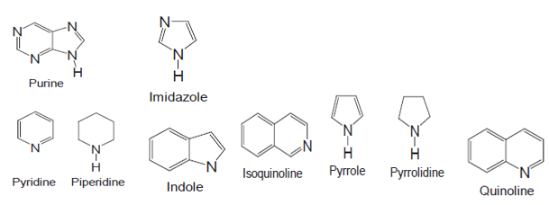

Pyridine and piperidine alkaloids e.g. piperine, coniine, and nicotine possess a pyridine or modified pyridine heterocyclic ring system (e.g. piperidine ring).
Piperine, molecular formula C₁₇H₁₉NO₃, a component of black pepper (Piper nigrum), has been used in various traditional medicine preparations, and also as an insecticide
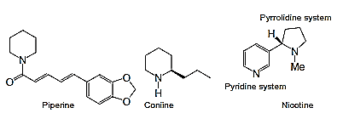
Nicotine, molecular formula C₁₀H₁₄N₂, is the major pharmacologically active component of tobacco, Nicotiana tabacum, and is also found extensively in other species of the family Solanaceae, e.g. tomato, potato and green pepper. Nicotine is a potent nerve poison and is included in many insecticide preparations. In lower concentrations, nicotine is a stimulant, i.e. it increases activity, alertness and memory, and this is one of the main factors that contribute to the dependence-forming properties of tobacco smoking. Nicotine increases heart-rate and blood pressure and reduces appetite. In higher doses, nicotine acts as a depressant
Coniine Coniine or (S)-2-propylpiperidine, molecular formula C₈H₁₇N, is a poisonous alkaloid found in the hemlock poison and the ‘yellow pitcher plant’ (Sarracenia flava). Coniine contributes to the foul smell of hemlock. It is a neurotoxin, causes respiratory paralysis and is toxic to all classes of livestock and humans. In 399 BC, Socrates was put to death by this poison.
Pyrrole and pyrrolidine alkaloids e.g. nicotine and hygrine. These alkaloids are also found in many drug preparations, e.g. procyclidine hydrochloride, which is mainly used for the treatment of drug-induced Parkinsonism.
Hygrine, molecular formula C₈H15NO, is found mainly in coca leaves (Erythroxylum coca). It is a thick yellow oil, having a pungent taste and odour.
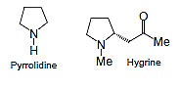
Quinoline alkaloids e.g Quinine and Quinidine.
Quinine, molecular formula C₂₀H₂₄N₂O₂, is a white crystalline quinoline alkaloid, isolated from Cinchona bark (Cinchona succirubra), and is well known as an antimalarial drug. Quinine is extremely bitter, and also possesses antipyretic, analgesic and anti-inflammatory properties. It can also be used to treat nocturnal leg cramps and arthritis.
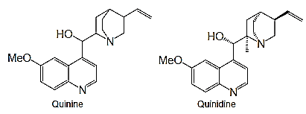
Quinine is an extremely basic compound, and is available in its salt forms, e.g. sulphate, hydrochloride and gluconate. Non-medicinal uses of quinine include its uses as a flavouring agent in tonic water and bitter lemon.
Quinidine Quinidine, molecular formula C₂₀H₂₄N₂O₂, is a stereoisomer of quinine found in Cinchona bark. It is used as a Class 1 anti-arrhythmic agent. Intravenous injection of quinidine is also used in the treatment of P. falciparum malaria.
Isoquinoline alkaloids
Any alkaloids that possess an isoquinoline skeleton are known as isoquinoline alkaloids, e.g. papaverine and morphine and codeine. The isoquinoline backbone is biosynthesized from the aromatic amino acid tyrosine. A number of these alkaloids are available as drugs.
Papaverine Papaverine, molecular formula C₂₀H₂₁NO₄, is an isoquinoline alkaloid isolated from poppy seeds (Papaver somniferum, family Papaveraceae). This alkaloid is used mainly in the treatment of spasms and of erectile dysfunction. It is also used as a cerebral and coronary vasodilator. Papaverine may be used as a smooth muscle relaxant in microsurgery. In pharmaceutical preparations, papaverine is used in its salt form, e.g. hydrochloride, codecarboxylate, adenylate and teprosylate.
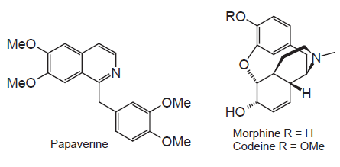
Purine alkaloids: Alkaloids that contain a purine skeleton are commonly known as purine alkaloids, e.g. caffeine and theobromine
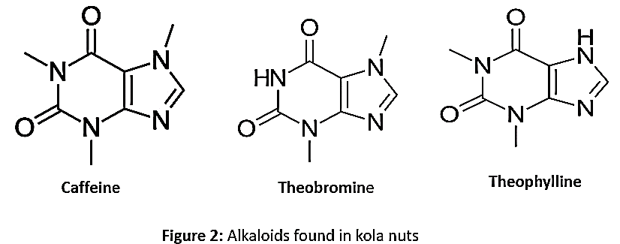
Caffeine molecular formula C₈H₁₀N₄O₂, is a xanthine (purine) alkaloid, found mainly in tea leaves (Camellia sinensis), kola nuts and coffee beans (Coffea arabica). Caffeine is found in a number of other plants, where it acts as a natural pesticide. It is odourless white needles or powder. It is also an ingredient of a number of soft drinks. Caffeine is a potent CNS and metabolic stimulant and is used both recreationally and medically to reduce physical fatigue, and to restore mental alertness.
Indole alkaloids: This is one of the major groups of naturally occurring bioactive alkaloids and can be classified into three main categories: tryptamine and its derivatives, ergoline and its derivatives, and β-carboline and its derivatives.
Tryptamine derivatives Tryptamine, chemically known as 3-(2-aminoethyl)indole, is widespread in plants, fungi and animals. Biosynthetically, tryptamine derives from the amino acid tryptophan. Tryptamine acts as the precursor of many other indole alkaloids. Substitutions to the tryptamine skeleton give rise to a group of compounds collectively known as tryptamines: e.g. serotonin, an important neurotransmitter, is the 5- hydroxy derivative of tryptamine; melatonin, a hormone found in all living creatures, is 5-methoxy-N-acetyltryptamine.
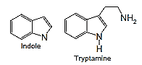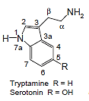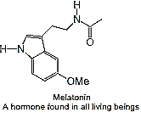
Test for Alkaloids
Wagner’s reagent, Hager’s reagent, Dragendorff’s reagent and Meyer’s reagent
Meyer's Reagent test : To about 3mL of extract a few drops of Meyer's reagent (prepared by dissolving 1.36g of Mercuric chloride and 5g of potassium iodide in 100 ml of water) were added along sides of the test tube. Cream coloured precipitate indicates the presence of alkaloid.

