Standard Operating Procedure (SOP)
-Designing Bonus and Incentives Plan



Validated for use by

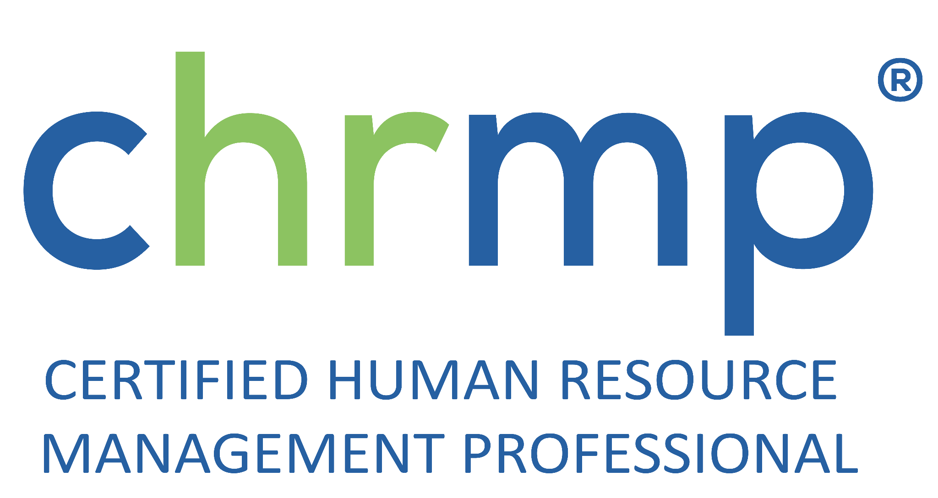

Purpose:
The purpose of this Standard Operating Procedure (SOP) is to establish a systematic approach for designing bonus and incentive plans for employees, which is aligned with the company's overall business strategy and objectives.
Introduction:
A well-designed bonus and incentive plan can be an effective tool to motivate and retain employees, increase productivity, and achieve business goals. However, an improperly designed plan may lead to unintended consequences and have negative effects on employee morale, job satisfaction, and company culture. This SOP aims to provide guidance for designing an effective bonus and incentive plan that benefits both employees and the company.
Scope:
This SOP applies to all employees and departments within the company. It covers all types of bonus and incentive plans, including but not limited to individual, team, and company-wide plans.
Definitions:
- Bonus: A one-time payment made to an employee in addition to their regular salary or wages, usually as a reward for achieving specific goals or exceptional performance.
- Incentive: A reward offered to an employee to motivate them to achieve specific targets or objectives, usually tied to performance metrics or other criteria.
- Key Performance Indicators (KPIs): Quantifiable measures used to evaluate the success or progress of an employee, team, or the company as a whole.

Responsibilities:
- HR department: responsible for developing and implementing the bonus and incentive plan, in collaboration with the management team and other relevant stakeholders.
- Management team: responsible for communicating the plan to employees, setting clear goals and targets, and evaluating employee performance.
- Employees: responsible for meeting the targets and objectives set forth in the plan, and adhering to the company's policies and procedures.
Best practices:
- Align the bonus and incentive plan with the company's overall business strategy and objectives.
- Set clear, specific, and measurable goals and targets for employees.
- Ensure the plan is fair, transparent, and consistent across all departments and levels of the organization.
- Consider the company's budget and financial resources when designing the plan.
- Communicate the plan and its objectives clearly to all employees, and provide regular updates on progress and performance.
- Evaluate the plan regularly to ensure its effectiveness and make any necessary adjustments.
Steps:
- Define the business objectives and goals that the bonus and incentive plan will support.
- Identify the key performance indicators (KPIs) that will be used to evaluate employee performance.
- Determine the target audience for the plan, whether it will be individual employees, teams, or the entire company.
- Decide on the type of incentive plan that best fits the target audience and company objectives (e.g. cash bonuses, stock options, paid time off, etc.).
- Set clear and specific goals and targets for the plan, and establish a timeline for achieving them.
- Develop a communication plan to inform employees about the plan, its objectives, and how it works.
- Monitor employee performance and progress towards the goals and targets, and provide regular feedback and coaching.
- Evaluate the plan periodically to determine its effectiveness and make any necessary adjustments.
Risks:
- Inadequate planning and communication may lead to confusion, misunderstanding, or dissatisfaction among employees.
- Poorly designed plans may incentivize negative behavior or encourage employees to focus on short-term goals at the expense of long-term success.
- Unintended consequences, such as the exclusion of certain employees or departments from the plan, may lead to resentment or disengagement.
Disclaimer: This SOP is intended to provide general guidance and recommendations for designing bonus and incentive plans, but it does not constitute legal, financial, or professional advice. Companies should consult with their legal, financial, and HR professionals to ensure that their bonus and incentive plans comply with all relevant laws, regulations, and industry standards.

