Istanbul Conference on Economics and Society

24-26 September 2025

**THE Title OF SHORT PAPER FOR ISTCES-2025**

**(12 pt Arial ‘all caps’, bold, centered)**

*1* First Name Last Name, 2 First Name Last Name, 3 First Name Last Name (9 pt Arial, centered, Italic)*

1Affiliation (e.g., University, Faculty, Department), Address, City, Country (9 pt Arial, centered)

2 Affiliation (e.g., University, Faculty, Department), Address, City, Country

3 Affiliation (e.g., University, Faculty, Department), Address, City, Country

*Corresponding author e-mail: [mail@example.edu](mailto:mail@example.edu) (9 pt Arial, centered)

**ABSTRACT (Section HEADING: 10 pt Arial ‘all caps’, bold, justified)**

Please carefully follow the guidelines in the current template and prepare your short paper in MS Word. The abstracts should be submitted via Microsoft’s Conference Management Toolkit (CMT). Please create a user account on the submission site. Make sure that your paper is free of technical, grammatical and typographical errors. Please ensure using a plagiarism software that the similarity index is less than 20% with no more than 1% from any source (excluding the references). The abstract (maximum 200 words) should briefly state the content, methods, and results only. (BODY TEXT: 10 pt Arial, justified).

***Keywords:*** Keyword 1, Keyword 2, Keyword 3 (Max. 5 keywords, Separate with commas. 10 pt Arial, Aligned Left)

**INTRODUCTION**

Each paper, including figures and tables, should be limited to 4 pages. The authors must follow the formatting instructed in this text. The paper should be typed as a single columned text. You may put page numbers. The whole document should be typed with single line spacing. The abbreviations and acronyms should be defined the first time they are used. Authors may prepare a nomenclature if it is preferred. Text font and size of the main text should be Arial 10 pt. The paper size should be ‘Letter’. The margins of the paper should be defined according to Fig. 1. The main text should be justified.

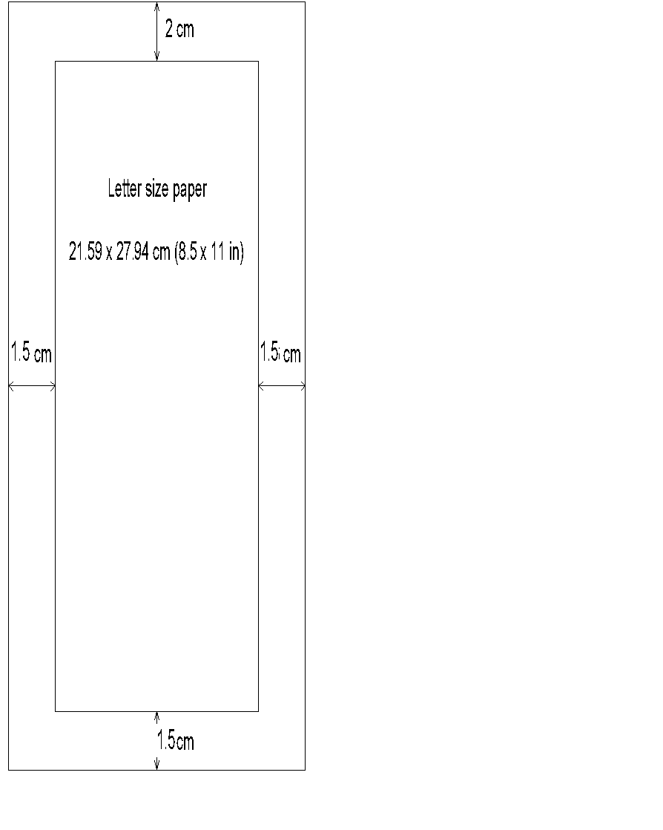

Fig. 1. Page size and margins

Authors should use sections and subsections to outline their study clearly. In the introduction section, the authors should include some background information; highlight the importance of the work; present an up-to-date literature review; state the specific objectives and explain how their work differs from others done in the literature. Please omit trivial information and avoid very long paragraphs.

**MATERIALS AND METHODS**

Describe the problem and methodology.

***Structure of the Paper*** ***(Arial, 10 pt, italic, bold)***

Papers should have the following structure: Title, Author names and their affiliation, Abstract, Keywords, Main Text, Conclusions, Acknowledgements (if appropriate), Nomenclature (if appropriate), and References.

***Units and Equations***

Align each equation left and the Equation number to the right. Allow single spacing above and below equations, as:

(1)



***Tables, Figures, and Photographs***

Briefly and descriptively entitle each table and caption each figure. Place the table title above the table and the figure caption below the figure. Each table and figure should be cited in the text (e.g., Fig. 1, Table 1); and placed as close as possible to the text to which they refer. Allow single spacing between the table or figure and the adjacent text, and there should be no space between the table title and table (or between figure caption and figure). Tables and figures should be numbered consecutively with Arabic numerals. Do not reduce figures or tables to a size that is difficult to read. Please make sure there is no copyright issue with the photos/figures.

Table 1. Summary of ISTCES 2025 formatting details

|  | **Font and Style** | **Line and Paragraph Spacing** |
| --- | --- | --- |
| **Title** | Font: Arial, 12 pt, ‘All Caps’, bold  Template Style: ‘Title_ISTCES’ | Justification: centered  Line spacing: Single, 0 pt before, 6 pt after |
| **Author(s) and Affiliation(s)** | Font: Arial, 9 pt  Template Style: ‘Authors and Affiliations_ISTCES’ | Justification: centered  Line spacing: Single, 0 pt before, 6 pt after (no spacing between paragraph of same style) |
| **Section Headings** | Font: Arial, 10 pt, ‘All Caps’, bold  Template Style: ‘SectionHeadings_ISTCES’ | Justification: justified  Line spacing: Single, 0 pt before, 6 pt after |
| **Sub-Section Headings** | Font: Arial, 10 pt, italic, bold  Template Style: ‘Sub-SectionHeading_ISTCES’ | Justification: justified  Line spacing: Single, 0 pt before, 6 pt after |
| **Body text** | Font: Arial, 10 pt  Template Style: ‘Normal_ISTCES’ | Justification: justified  Line spacing: Single, 0 pt before, 6 pt after |
| **Table captions** | Font: Arial, 9 pt  Template Style: ‘Table Caption_ISTCES’ | Justification: justified  Line spacing: Single, 0 pt before, 0 pt after |
| **Table text** | Font: Arial, 9 pt  Template Style: ‘Table Text_ISTCES’ | Justification: left or centered  Line spacing: Single, 2.5 pt before, 2.5 pt after |
| **Figure captions** | Font: Arial, 9 pt  Template Style: ‘FigureCaption_ISTCES’ | Justification: centered  Line spacing: Single, 0 pt before, 6 pt after |

**RESULTS AND DISCUSSION**

All the results obtained should be discussed.

**CONCLUSIONS**

State the main findings in brief.

After preparing your short paper according to ISTCES 2025 format, please submit your abstract online following the instructions at <https://istces.ihu.edu.tr/en/submission-68427c792b31c>. You can see the status of your paper on the Author Console at <https://cmt3.research.microsoft.com/ISTCES2025/Submission/Index>. Once a decision is made on your short paper, you will receive an email from the ISTCES Secretariat regarding this decision.

* If you are asked to revise your short paper, you have to do it according to the reviewer/s comments within 2 weeks of your decision email. Please do not include any response sheet.
* Once the reviewer/s is/are satisfied with your submission, you will be notified so that you can proceed with registration.

**Acknowledgement** (*Optional*)

Acknowledgement comes here.

**REFERENCES**

The numbered reference style should be used in short papers that are submitted to ISTCES 2025. Please place numbers inside square brackets, e.g., [1], in the text while citing a reference. Citations should be numbered sequentially. Please list the reference in the order of appearance in the text. Text font and size of the reference list should be Arial 9 pt. The reference list should be prepared according to the following style.