|  | Financial Aid: Part 1Student Worksheet - Sample Aid Letters |
| --- | --- |

**Background:**

* When a college admits you, the admissions department will send you an acceptance letter (by email or postal mail). Usually, a few weeks later, the financial aid department will send you a separate “financial aid award letter” detailing your award package.
* The following are six award letters found on the internet from three different colleges. The goal of this exercise is to familiarize yourself with what these award letters will look like and to learn how to “read” them for the key information.
* Since this lesson is focused on the TYPES of financial aid, your goal is to identify how much each college is offering the student in scholarships & grants (free money), work-study (must work to earn it), and loans (must repay it later, with interest).
  + Bonus points for figuring out how much you STILL need to pay the college per year (assuming you take out 100% of the loans, which you don’t always have to)!

### 

| Want to find and apply to scholarships? [Sign up for Going Merry!](https://app.goingmerry.com/sign-up?utm_source=sendgrid&utm_medium=email&utm_campaign=worksheet&utm_term=counselor-referral#students) Scan the QR code to [sign up for a free Going Merry account.](https://app.goingmerry.com/sign-up?utm_source=sendgrid&utm_medium=email&utm_campaign=worksheet&utm_term=counselor-referral#students) |
| --- |

Fill out these two tables:

|  | **Georgia Institute of Technology** | **Whitman College** | **UC Davis** |
| --- | --- | --- | --- |
| Scholarships and grants  (“free money”) |  |  |  |
| Work-study |  |  |  |
| Loans |  |  |  |
| How much do you still need to pay the college per year?  *(assuming you accept all loans offered to you)* |  |  |  |

|  | New York University (NYU) | University of Illinois at Chicago (UIC) |
| --- | --- | --- |
| Scholarships and grants  (“free money”) |  |  |
| Work-study |  |  |
| Loans |  |  |
| How much do you still need to pay the college per year?  *(assuming you accept all loans offered to you)* |  |  |

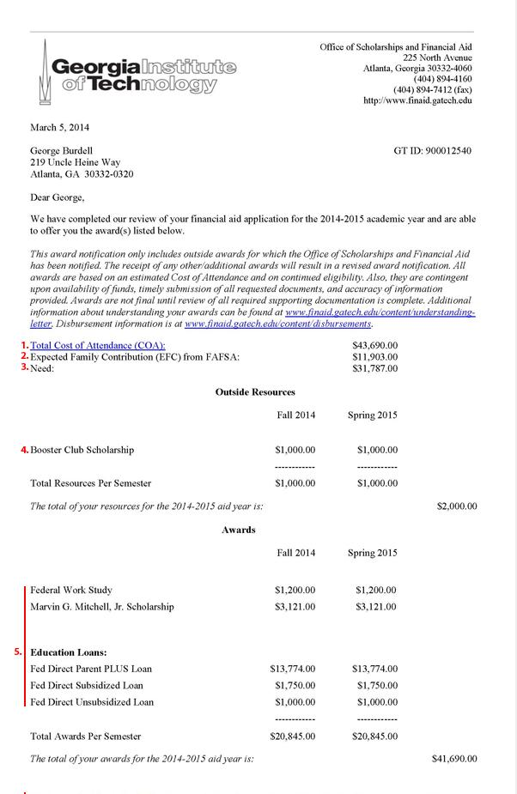

Whitman College:

