LJ Institute of Media & Communications


Event Report: Movie Screening of ‘Paanchika(Five Pebbles)’

Date: January 20, 2024(Saturday)
Time: 10:00 am - 12:00 pm
Venue: Architecture Auditorium, LJ University

Introduction
The LJ Institute of Media & Communications hosted an enriching short film screening of ‘Paanchika (Five Pebbles),’ directed by Ankit Kothari. This event offered students and film enthusiasts a captivating opportunity to explore the art of cinematic storytelling in depth.

Objectives:
- Present a distinguished cinematic creation, ‘Paanchika (Five Pebbles),’ acclaimed both nationally and internationally.
- Enhance understanding of storytelling through film among budding writers and film enthusiasts.
- Provide attendees with an opportunity to engage with a thought-provoking cinematic narrative and gain insights into the art of storytelling through film.
- Enable students to gain practical knowledge and learn key insights about the intricacies of filmmaking.

Welcome and Introduction:
The event commenced with a distinguished introduction of our esteemed guest, Ankit Kothari, the Director of the movie, by our student anchors, setting the stage for an enlightening session ahead. Dr. Divya Soni, Director of LJIMC, extended a gracious welcome to Mr. Kothari, presenting him with a symbolic tulsi pot and LJIMC memento as tokens of appreciation for his esteemed presence.

Guest Speaker:
Ankit Kothari, a National Award-winning director, is renowned for his multifaceted talents as a filmmaker, scriptwriter, and Brand Storyteller. His acclaimed short film ‘Paanchika (Five Pebbles)’ has been showcased at prestigious festivals including the New York Indian Film Festival (NYIFF) and the International Short Film Festival Oberhausen in Germany. Kothari's exceptional talent was recognized with the National Award for Best Director for ‘Paanchika (Five Pebbles).’ With credits as assistant director on notable films like ‘Oye Lucky Lucky Oye’, and ‘Shanghai’, along with serving as First Assistant Director on ‘Tumbbad’ , Kothari brings a wealth of experience to his craft.
In addition to his directorial achievements, Ankit Kothari mentors aspiring scriptwriters through professional masterclasses online, with over 3000+ attendees already benefited from his guidance.

Event Details:
‘Paanchika (Five Pebbles),’ the 69th National Film Award-winning short film for Best Short Film, premiered at the New York Indian Film Festival (NYIFF) and screened at the International Short Film Festival in Oberhausen, Germany, has garnered international recognition for its artistic merit and thematic depth. Set against the backdrop of the Little Rann of Kutch, the film masterfully explores friendship and human connection. Attendees were captivated by its compelling narrative and impactful portrayal of social issues, directed by Ankit Kothari.
The screening was further followed by an interactive Q&A session with the guest speaker, allowing attendees to delve deeper into the creative process behind the film.

Audience Q&A
During the Q&A session, attendees including students, especially the budding story writers engaged in a dynamic discussion with Ankit Kothari, gaining valuable insights into various aspects of storytelling and filmmaking. Here's a summary of the main topics addressed during the session :

Understanding Storytelling Techniques:
Ankit Kothari explored the art of effective storytelling, focusing on character development, plot progression, and thematic resonance. Attendees learned practical tips for creating engaging narratives that resonate with audiences. Kothari emphasised the importance of multi-dimensional characters, compelling story arcs, and visual storytelling techniques to enhance narrative impact.

Film Analysis:
Ankit Kothari provided a comprehensive analysis of ‘Paanchika (Five Pebbles),’ delving into the film's themes, character motivations, and the creative decisions behind its production. Attendees gained a deeper appreciation for the film's artistic merits and gained insights into the challenges and triumphs of independent filmmaking.

Behind-the-Scenes Insights:
Ankit Kothari offered behind-the-scenes insights into the making of ‘Paanchika (Five Pebbles),’ sharing anecdotes, challenges faced during production, and memorable moments from the set. Attendees gained a rare glimpse into the creative process behind the film and learned about the collaborative nature of filmmaking.

Career Guidance:
Drawing from his extensive experience in the film industry, Ankit Kothari offered practical career advice to aspiring filmmakers. He discussed various career paths in the film industry, shared tips for navigating the industry landscape, and highlighted the importance of persistence and passion in pursuing one's creative endeavours.

Attendees:
The audience comprised students from various departments of LJ University who attended the screening after prior online registrations. A total of 100 plus students participated in the event, including 70 plus with prior online registrations and an additional 30 students on the spot registrations.

Enclosure:
- Participation Attendance:
  - Total Students Registered: 76
  - Total Present with Registration: 20
  - Total Present without Registration: 49
  - LJIMC Students: 29
  - Students Present: 98

- Name of Colleges:
  - LJ Institute of Computer Application
  - LJ Institute of Management Studies
  - New LJ Commerce College
  - LJ Institute of Integrated M.B.A
  - LJ Institute of Applied Science
  - LJ Institute of Engineering and Technology
  - LJ School of Architecture

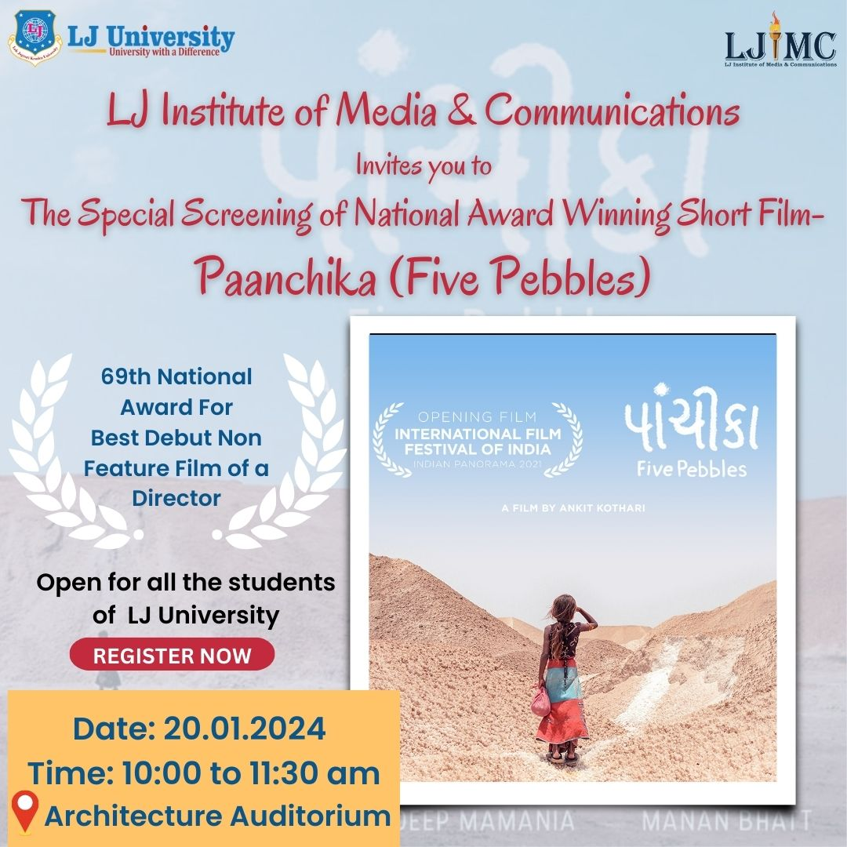

- The above creative was floated on social media platforms for making students aware regarding the movie screening.

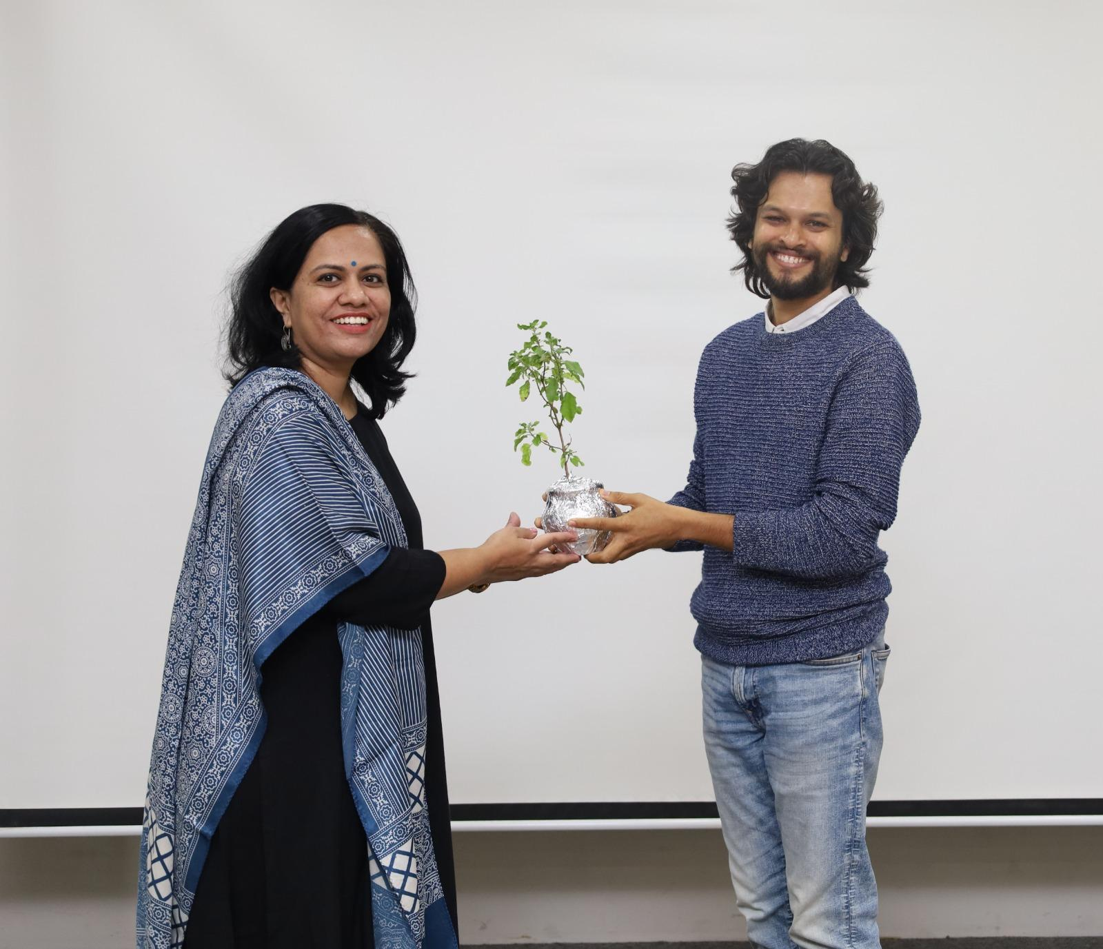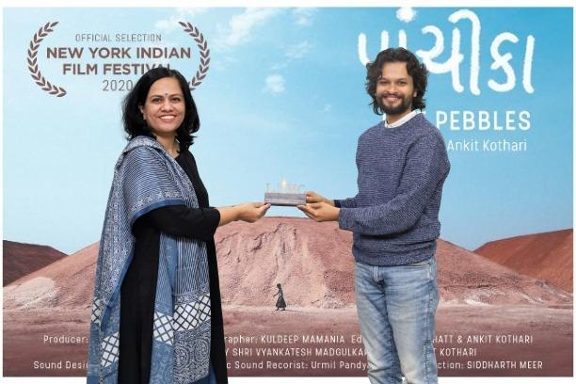
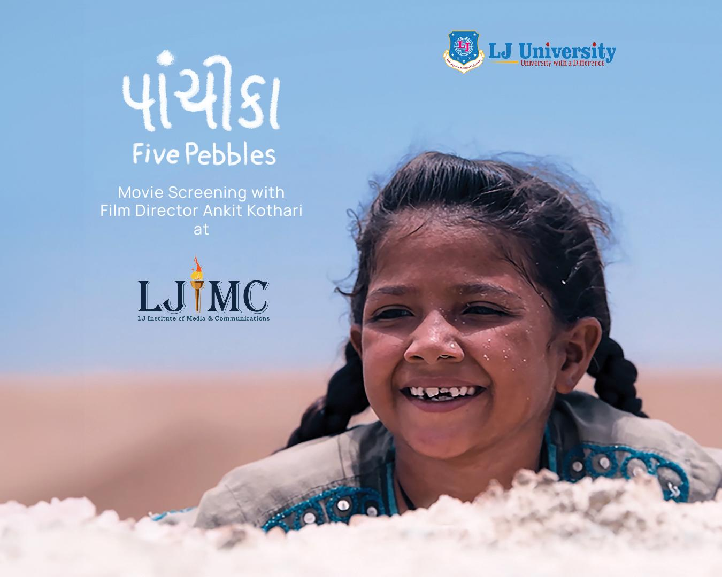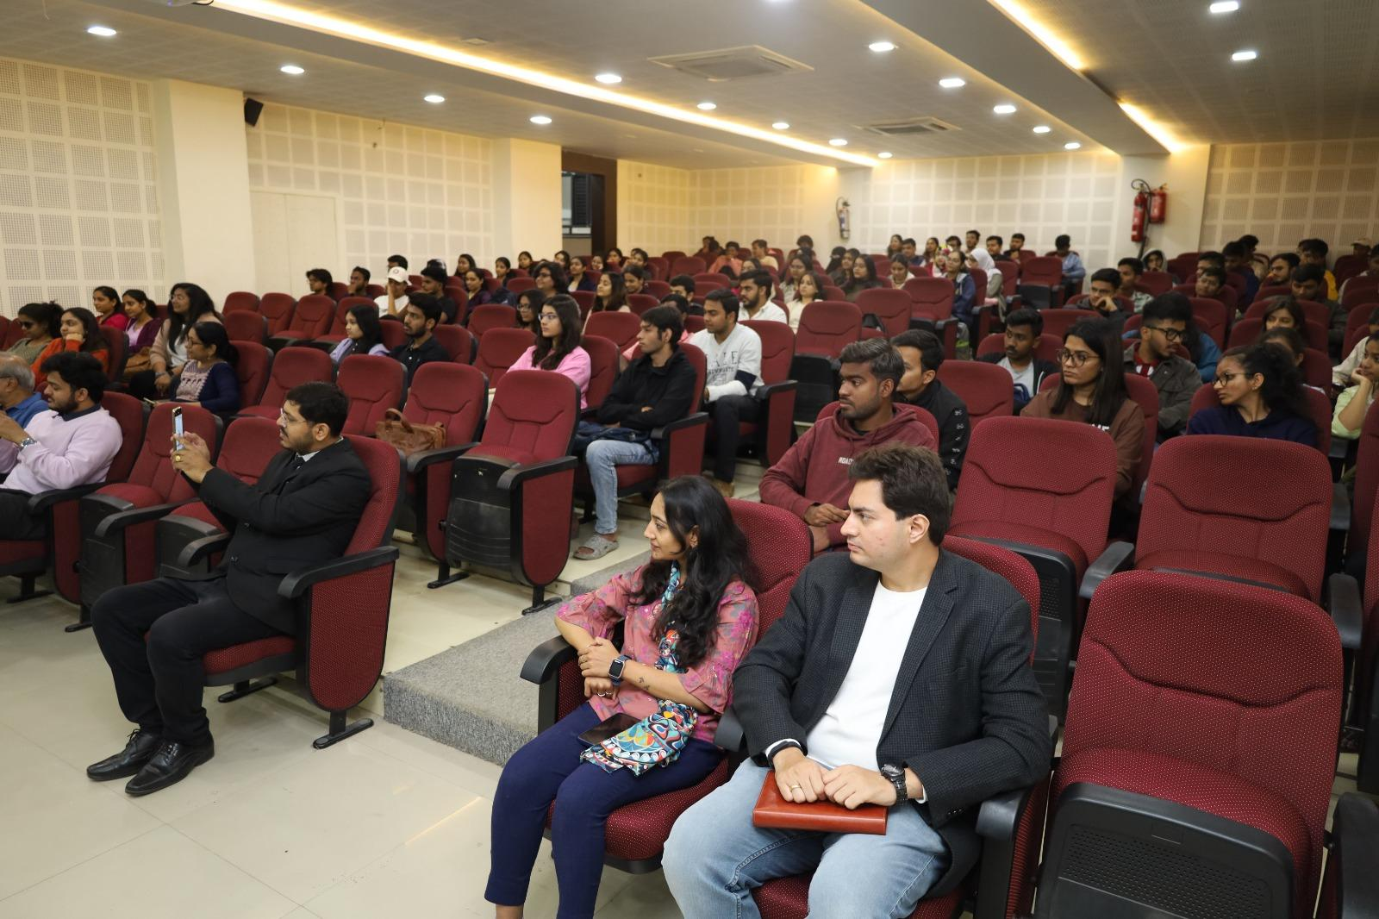
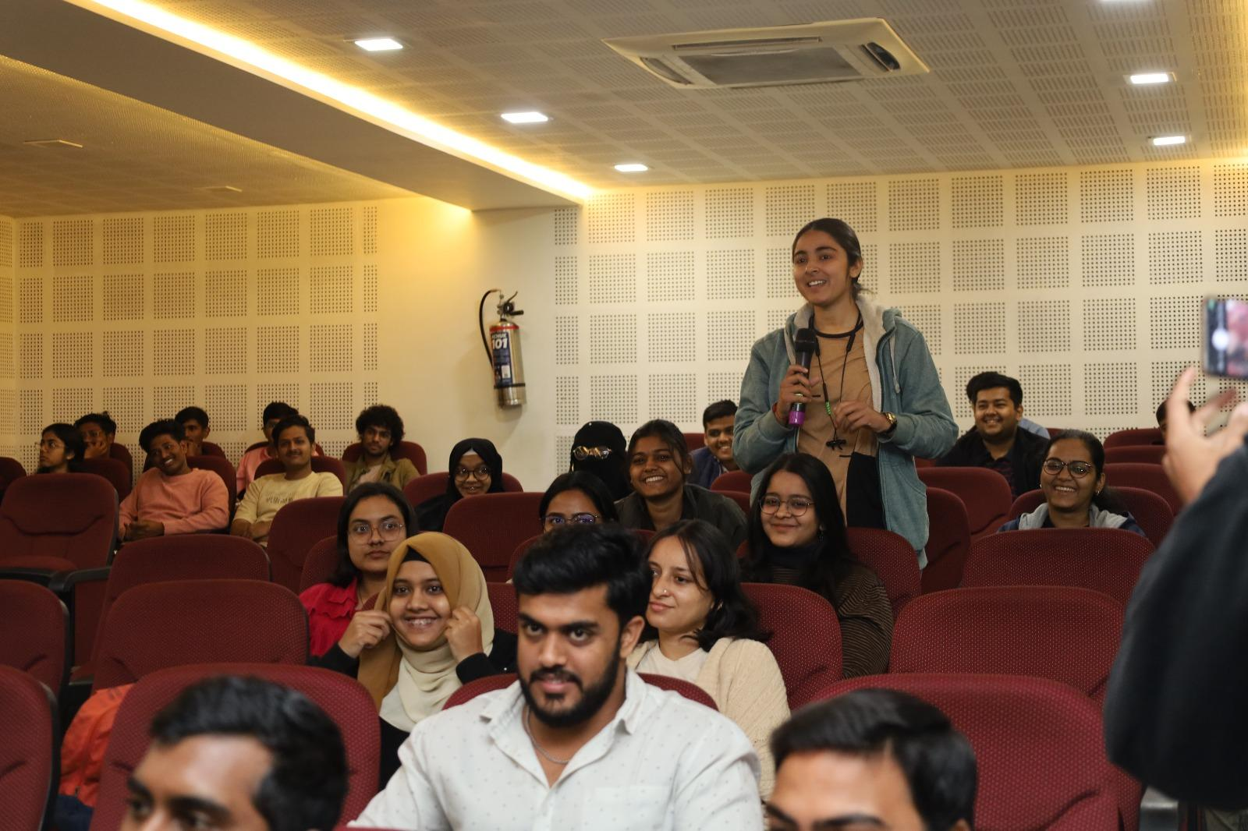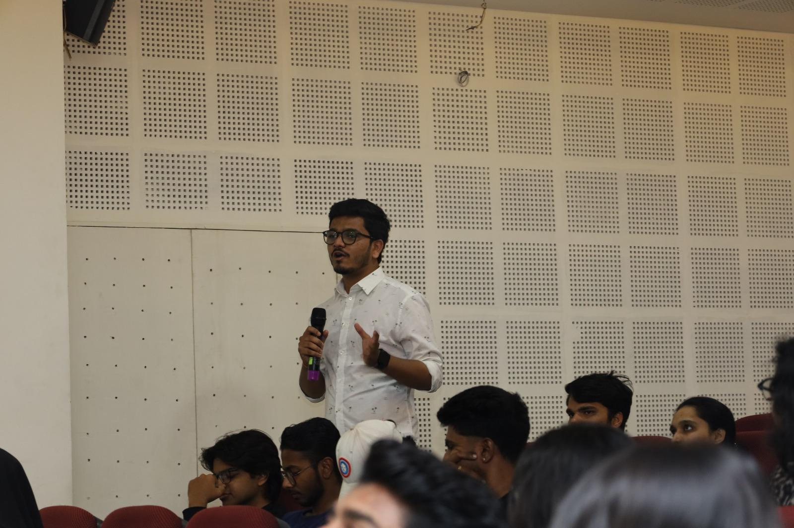
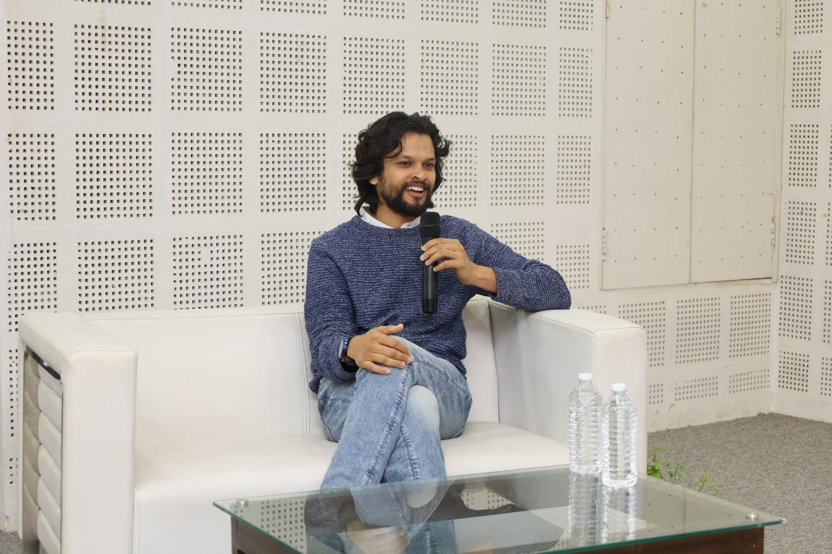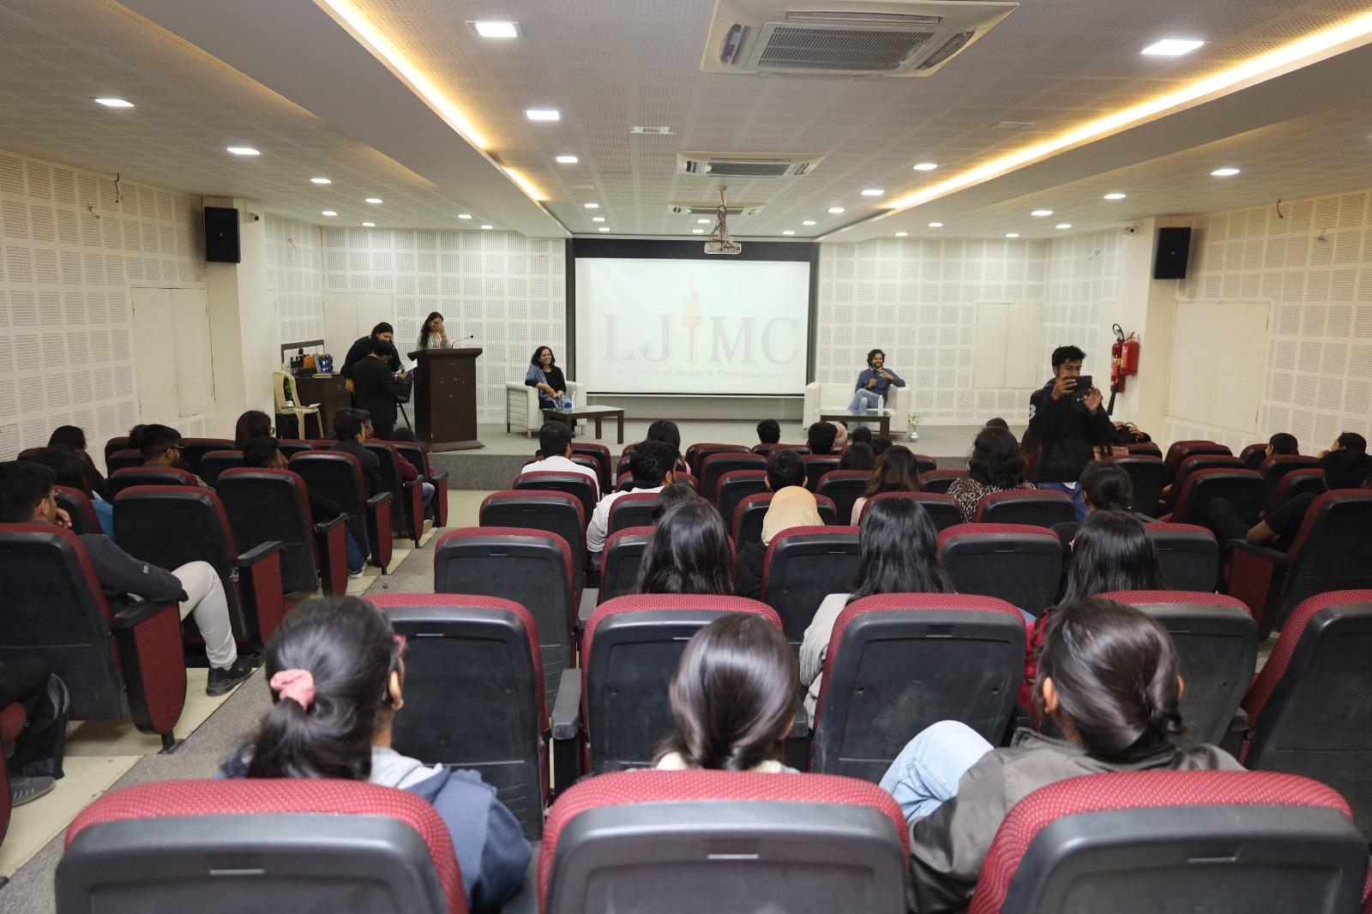

Conclusion:
The Movie Screening of ‘Paanchika (Five Pebbles)’ not only showcased the brilliance of the award-winning short film but also provided students and other attendees with a unique opportunity to engage with the filmmaker, Ankit Kothari. The insightful interaction session allowed attendees to delve deeper into the artistic process and the nuances of storytelling in cinema.

Feedback:
Attendees praised the event for its insightful discussion with Ankit Kothari and the selection of ‘Paanchika (Five Pebbles)’ for its compelling storytelling. Many found the event enriching and inspiring, appreciating the opportunity to gain firsthand knowledge from a seasoned filmmaker. The inclusive atmosphere fostered meaningful connections and dialogue among participants, reflecting the event's success in engaging and empowering the audience to explore the world of filmmaking.

Guest Speaker's Reflection:
Ankit Kothari shared his reflections on the event, expressing gratitude for the opportunity to engage with students and share his insights into the filmmaking process by discussing the art of storytelling through ‘Paanchika (Five Pebbles).’
He highlighted the enthusiasm and passion displayed by the audience, emphasising the importance of fostering a supportive and creative environment for aspiring filmmakers. Kothari expressed his hope that the event would inspire attendees to pursue their artistic ambitions with confidence and dedication.

Media Coverage:
Media coverage of the event, spotlighting its impact on aspiring filmmakers and the university community, can be found on: https://divya-b.in/DBMs6Zo9wGb

