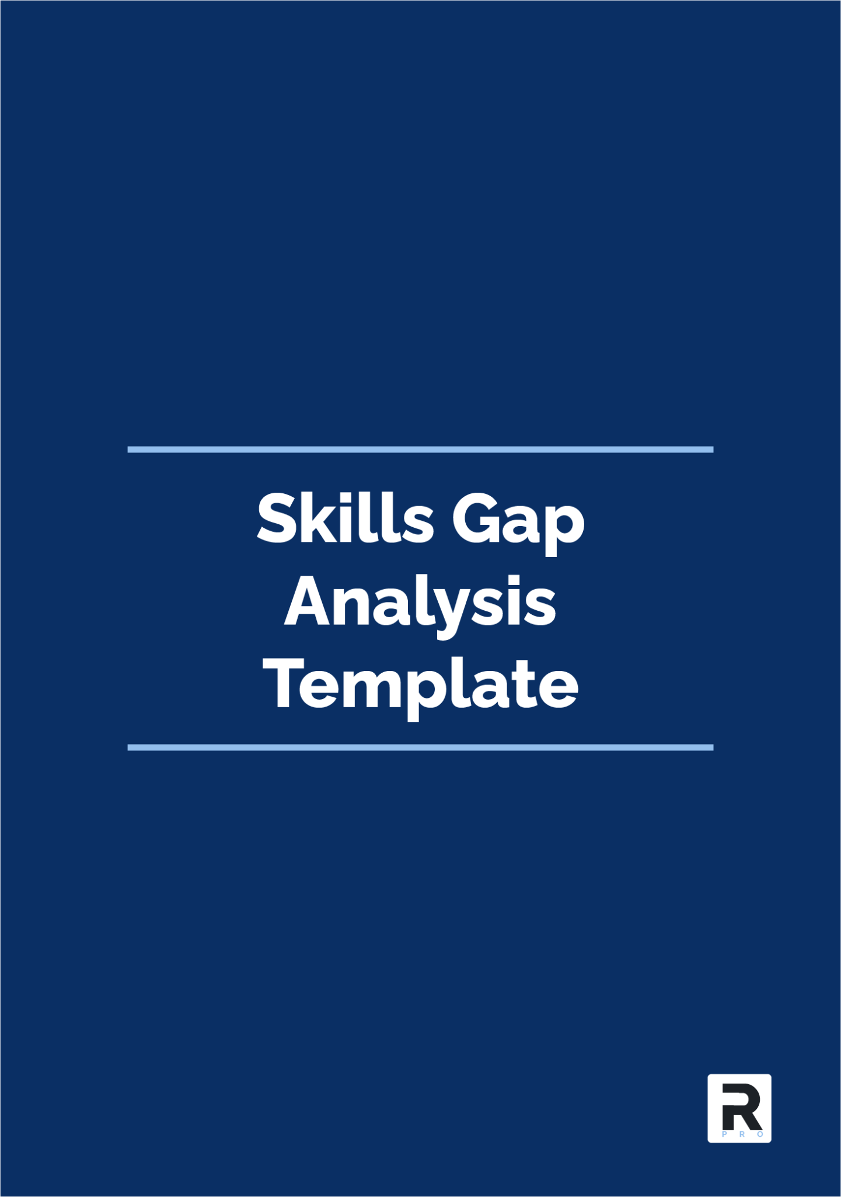

**Version Control**

| **Date** | **Version** | **Change** |
| --- | --- | --- |
| 12 March 25 | 1.0 | Publication |
|  |  |  |
|  |  |  |

**Template Customisation and Usage Guide [DELETE WHEN READY] 4**

**Employee Gap Analysis Form 4**

Employee Details 5

Job Description 6

Skills Overview 7

Training Requirements 8

Assessment Review 10

Additional Notes: 10

Completion Details 11

## 

## 

# Template Customisation and Usage Guide [DELETE WHEN READY]

**Customising Your Template**

This template is a guideline and must be customised to reflect your organisation’s operations, regulatory obligations, and internal controls. Replace all placeholder text with business-specific information to align with your processes, risk framework, and compliance structure.

**\*\*\*This guidance and footer graphic should be removed from the final saved version\*\*\***

**Using This Template**

This template provides a comprehensive framework to help your organisation develop a policy that meets regulatory requirements and industry best practices. While structured to align with FCA expectations, you must review and adjust the content to reflect your organisation’s compliance framework, sector-specific risks, and operational procedures.

If your organisation has policies related to this document, ensure that relevant cross-references are included. Some referenced policies are available separately or as part of bundled compliance toolkits.

**Licence and Usage Terms**

**This template is provided for use only within the purchasing organisation. Without prior written consent, redistribution, resale, or transfer of this document in any form is strictly prohibited.**

For usage rights and licensing details, refer to the Instructions document included with your purchase.

**Disclaimer**

This template supports regulatory compliance and governance, but does not constitute legal or professional advice. While designed for accuracy and relevance, your organisation ensures compliance with FCA regulations, industry standards, and legal requirements.

Customise this document to reflect your business model, risk exposure, and internal policies. If unsure of your regulatory or legal obligations, seek professional advice before finalising.

**Use of this template assumes no liability for loss, damage, or regulatory action.**

# **Employee Gap Analysis Form**

## 

## Employee Details

Provide the following information:

| **Detail** | **Info** |
| --- | --- |
| Name |  |
| Department |  |
| Position |  |
| Phone Number |  |
| Manager/Supervisor |  |

## 

## Job Description

Provide a brief overview of the role and its purpose within the organisation.

**Job Description Summary:**

*[Provide a detailed job description of the advertised role.]*

**Purpose of the Position:**

*[Explain why this role exists within the firm and how it contributes to the overall operational function.]*

## Skills Overview

**Required Skills**

Identify the skills necessary to fulfil the job role effectively, including mandatory, business, role-specific, and optional skills.

| **Skill Category** | **Examples** |
| --- | --- |
| *Regulatory Requirements* | *Conduct rules knowledge, Data Protection Impact Assessment skills* |
| *Business Requirements* | *Computer literacy, Microsoft Office knowledge* |
| *Role/Duties Requirements* | *Compliance officer awareness, Interview skills* |
| *Optional Requirements* | *Communication skills, Shorthand* |
|  |  |
|  |  |
|  |  |
|  |  |

## 

**Existing Skills**

List the current skills and knowledge the employee possesses.

| **Skill Category** | **Examples** |
| --- | --- |
| *Regulatory Skills* | *Conduct rules knowledge, CF10 experience* |
| *Business Skills* | *Computer literacy, Customer service diploma* |
| *Role/Duties Skills* | *Interview skills, Train the Trainer award* |
| *Additional Skills* | *Touch typing, Fluent in Spanish* |
|  |  |
|  |  |
|  |  |
|  |  |

**Skills Gap Analysis**

Compare the required skills with existing skills to identify gaps.

| **Identified Skills Gap** | **Skill Type** | **Skill Description** | **Priority** |
| --- | --- | --- | --- |
| *Completing Data Protection Impact Assessments* | *Legal* | *Legal requirement by the ICO to complete DPIAs for high-risk data processing activities* | *High* |
| *Microsoft Office knowledge* | *Business* | *Employees are required to use Word, Outlook, and Excel daily* | *Intermediate* |
| *Compliance officer awareness* | *Job role* | *The role involves deputising for the Compliance Officer in their absence* | *Intermediate* |
|  |  |  |  |
|  |  |  |  |
|  |  |  |  |
|  |  |  |  |
|  |  |  |  |
|  |  |  |  |

## Training Requirements

Identify the training or support needed to bridge the skills gaps.

| **Skills Gap** | **Training Requirement** | **Training Timeframe** | **Responsibility** |
| --- | --- | --- | --- |
| *Completing Data Protection Impact Assessments* | *Online DPIA Course @ Scots College* | *23/04/2023* | *Data Protection Officer* |
| *Microsoft Office knowledge* | *In-house training with Admin Manager* | *30/06/2023* | *Jane Jones* |
| *Compliance officer awareness* | *In-house training with Compliance Manager* | *01/06/2023* | *Compliance Manager* |
|  |  |  |  |
|  |  |  |  |
|  |  |  |  |
|  |  |  |  |
|  |  |  |  |
|  |  |  |  |

## Assessment Review

Complete the following checklist to ensure a thorough skills gap analysis has been conducted.

| **Review Question** | **Yes** | **No** | **N/A** |
| --- | --- | --- | --- |
| *Have you interviewed the employee to discuss their skills and development needs?* |  |  |  |
| *Have you consulted with your line manager to understand the department's skill requirements?* |  |  |  |
| *Have you reviewed the employee’s most recent performance evaluation to identify areas for improvement?* |  |  |  |
| *Have you completed a FIT Assessment for certification or senior management roles (if applicable)?* |  |  |  |
| *Have you documented the skills gaps and training needs in the Skills Gap Analysis Template?* |  |  |  |

## Additional Notes:

*[Include any other observations or information related to the employee’s skills gap analysis.]*

## Completion Details

Date Completed:

Completed By:

Position: