Operations Report Task
Adapting operational strategies to changes in the global supply chain

TASK 1: Video review

Watch the Wall Street Journal Video “Apple vs Samsung’s Strategies to Move Manufacturing Away from China” on YouTube at:
Apple vs. Samsung’s Strategies to Move Manufacturing Away From China | WSJ - YouTube
Respond to the following questions:
- What benefits have been achieved by smartphone makers relocating from China to countries such as India and Vietnam?
- What influences have forced Apple and Samsung to move away from China?
- What impact did COVID-19 lockdowns have on manufacturing in China?
- Give examples of incentives provided by the governments of India and Vietnam to attract smartphone manufacturers.
- Provide data and examples to describe the growth of smartphone manufacturing in India and Vietnam.
- Using examples, describe the growing importance of the Indian market for smartphones.
- Outline the market share of Samsung and Apple in the Indian smartphone market in 2022.
- Outline the strategies adopted by Apple to increase its market share in India.
- Describe how Apple has shifted it global web of suppliers to include US manufacturers. What are the benefits?
- Identify any costs or disadvantages with the move away from China as the key production location.
- Explain why Apple is still quite dependent on China for its supply chain.
- Refer to page 37 of the Apple & the iPhone business case study to explain the change in Apple’s market share in India since 2022 (refer to your answer to question 7 for 2022 share).

TASK 2: Practice paragraph for a Section IV response

Use a structure for your response to ensure you meet the requirements.

For example:
“Evaluate the response of operations management to external influences”
Question 27, 2016 HSC Business Studies examination

P: Make a point regarding an external influence requiring a response for the operations/production of iPhones.
E: Define & explain the influence on operations (e.g. define globalisation and explain how it influences operations by creating a global web of suppliers). Apply case study to outline opportunities & threats to the operations (the production of iPhones) presented by globalisation. Apple has adopted a strategy of outsourcing in response to the opportunities presented by globalisation.
Evaluate by assessing pros and cons: Apple’s global web, lower production costs (pros) vs. dependence on outsourcing partners for quality and CSR (cons) – to make a balanced judgment.
Link. Conclude the paragraph with a linking statement to address the questions (external influence and the response of operations management) with a statement, such as “Hence, it can be seen that…”

Remember the criteria!
Your answer will be assessed on how well you:
■ demonstrate knowledge and understanding relevant to the question
■ apply relevant business case study/ studies and contemporary business issues
■ communicate using relevant business terminology and concepts
■ present a sustained, logical and cohesive response

Over to you…
Write a PEEL paragraph to evaluate the strategy of Apple to relocate production away from China (due to various influences).

P: Make a point regarding an external influence requiring the shift of operations/production of iPhones away from China.
E: Define & explain the influence on operations (apply theory related to cost-based competition and geopolitical influences / legal regulations in China)
Evaluate by applying case study and assessing advantages/disadvantages - explain strategy of relocation covering advantages: give data on size and growth of market for smartphones in India, incentives provided by governments. Disadvantages: still dependent on China, significant investment of billions to relocate
Link. Conclude the paragraph with a linking statement to address the questions (external influence and the response of operations management) with a statement

TASK 3: Section IV extended response

Use your video notes (as well as your textbook and the Apple & the iPhone Case Study) to write an extended response to one of the following past paper questions:
2013: Assess strategies that management may use to respond to influences on operations.
2015: Evaluate the importance of operations strategies in achieving a competitive advantage.
2016: Evaluate the response of operations management to external influences.
2017: Analyse the effect of globalisation on operations management.
2019: Analyse the relationship between performance objectives and operations strategies.
2023: To what extent do influences on operations affect business success?
2024: How can operations strategies affect corporate social responsibility?

Criteria Marks
17–20 marks
• Makes a well-reasoned judgement based on criteria related to the question.
• Applies relevant case study examples
• Presents a sustained, logical and cohesive response and communicates clearly using relevant business terminology and concepts
13–16 marks
• Makes some judgement related to the question.
• Uses relevant case study examples
• Presents a logical and cohesive response using relevant business terminology and concepts
9–12 marks
• Provides characteristics and features related to the question.
• May make reference to case study examples
• Communicates using business terminology and concepts
5–8 marks
• Sketches in general terms related to the question.
• May make reference to case study examples
• Communicates using some business terminology and concepts
1–4 marks
• Makes limited reference to the question
• May identify case study examples
• Uses basic business terminology

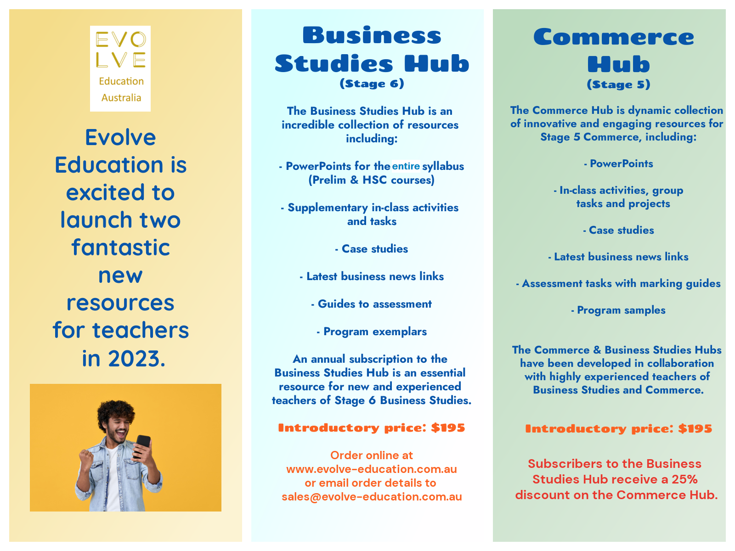
Evolve Education is excited to launch these fantastic resources for teachers of Commerce & Business Studies

