Guided Notes for Module 6
Marine Science at Florida Virtual School

Lesson 6.01
Page 1
- Describe some of the problems that organisms on this page “are discussing”.
- What is the big complaint of the sea turtle?

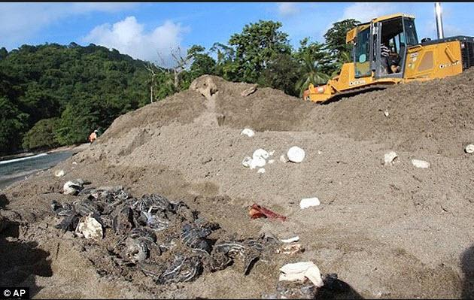
Sea Turtle Hatchlings

Page 2
- Do most plastics biodegrade?
- What are microplastics?
- What is the Great Pacific Garbage Patch?
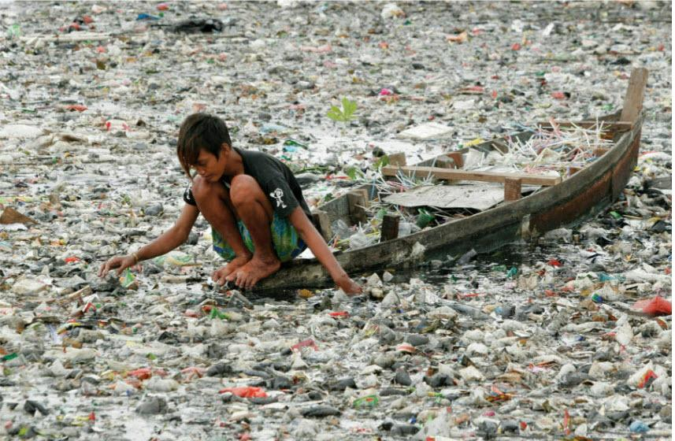
- Are Garbage Patches small or large?
- What is the best way to prevent garbage patches?

Page 3
- How do trash and plastics enter the ocean?
- Describe ways that debris harms organisms.
- What are ways to prevent trash from entering the oceans?
- What are microbeads and why should we avoid them?
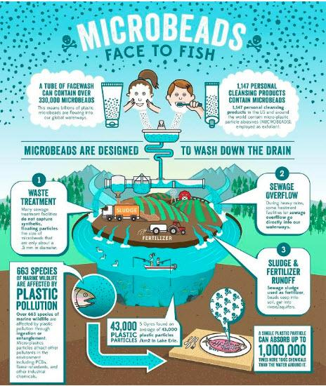

Page 4
- Describe 6 different impacts of marine debris.

Page 5
- The text says: "Invasive species threaten food chains ". What is an invasive species?
- How can invasive species cause harm to ecosystems?
- Why has the number of invasive species increased so much since World War 2?

Page 6
- How are non-native species different from invasive species? How are they the same?
- Do invasive species typically have predators? Explain.
- Explain why invasive species are so harmful to ecosystems?
- What happens to biodiversity when invasive species arrive?

Lesson 6.02 (Honors only)
Page 1
- What is environmental quality?
- What characteristics are used to measure the quality of an environment?
- How does the economy impact environmental quality?

Page 2
- Complete the “Evaluate Inventions” activity on page 2 and answer the following questions.
  - How does an ocean cleanup array remove plastic and debris from the ocean?
  - What are lobster casitas? “Casitas” is a Spanish word that translates to little houses in English.
  - Why are streamers being used on fishing boats?

Page 3
- How does the amount of resources that we use affect the environment?
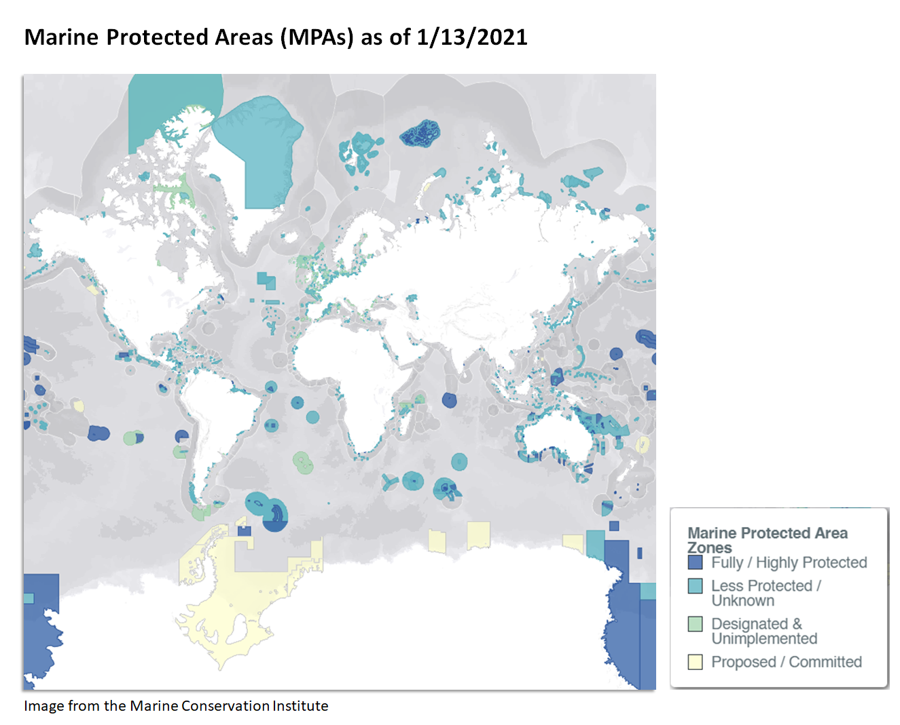
- What are marine protected areas (MPAs)?

Page 4
- How did the growth of the human population during the Industrial Revolution affect the environment?

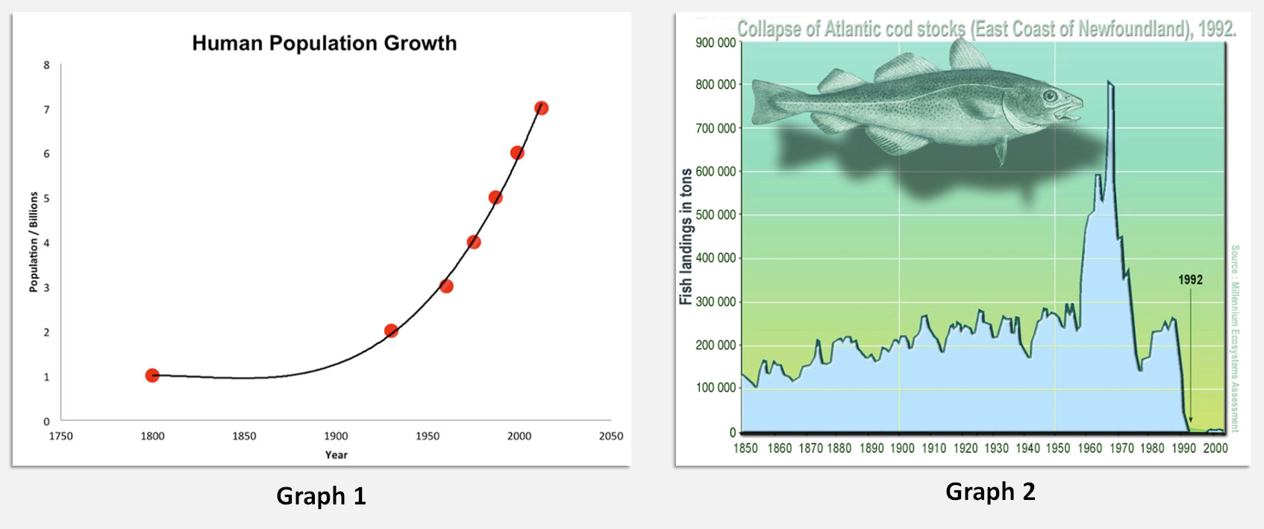

- Graph 1 (above) displays data on the growth of the human population from 1800 to present day. Graph 2 displays data about cod fish landings, which are the catches (number of fish) that have landed in foreign or domestic ports. Study the two graphs carefully and answer the following questions.
  - When does human population growth start to increase dramatically?
  - What is happening to the cod catch at the same time that the human population is increasing dramatically?
  - What is the relationship between the human population growth and the cod catch?

Page 5
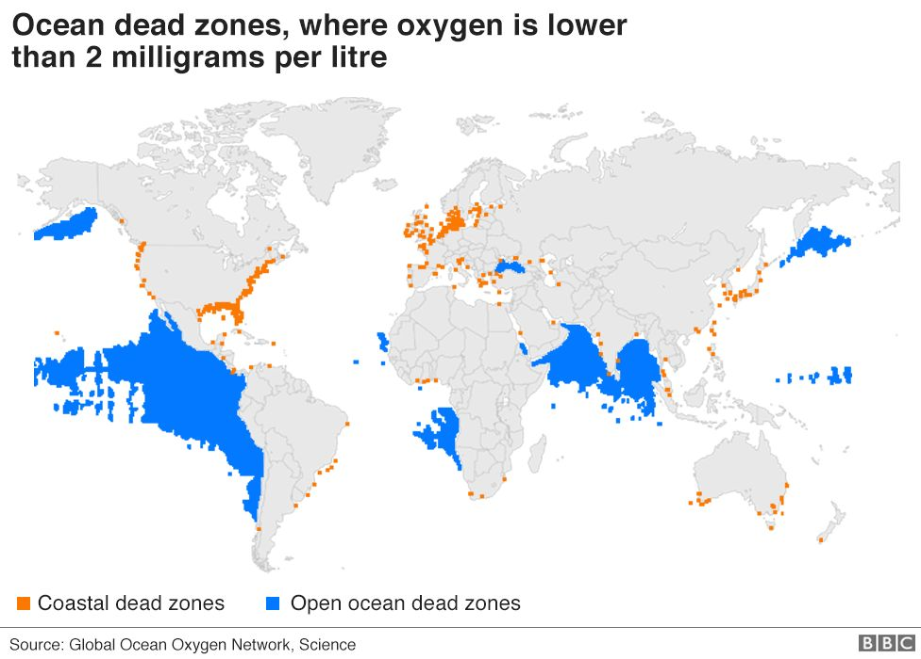
- How are dead zones created?

Lesson 6.03
Page 2
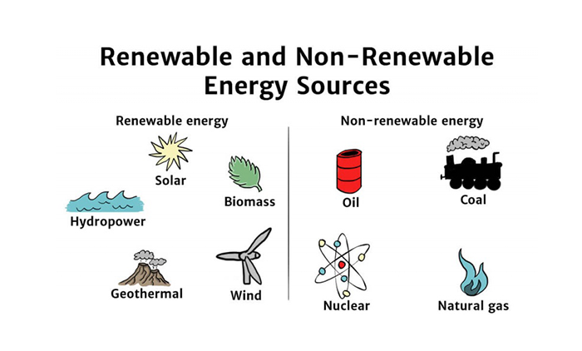
- What is a renewable resource?
- What is a non-renewable resource?
- Is oil a renewable or non-renewable resource?
- The text says: "although non-renewable resources might be available and cheap, extracting them can be messy and not so great for ecosystems." Give examples of the "messy and not so great for the ecosystem".

Page 3
- How does the rate of replenishment affect whether we label something renewable or non-renewable?
- Explain why the Alaskan King Crab is a potentially renewable resource.

Page 4
- Why are miners looking to the oceans for minerals now?
- Do scientists know and understand all the impacts that could result from mining the ocean depths?
- Why does the release of methane hydrates scare some scientists?

Lesson 6.04
Page 1
- What is the Tragedy of the Commons?
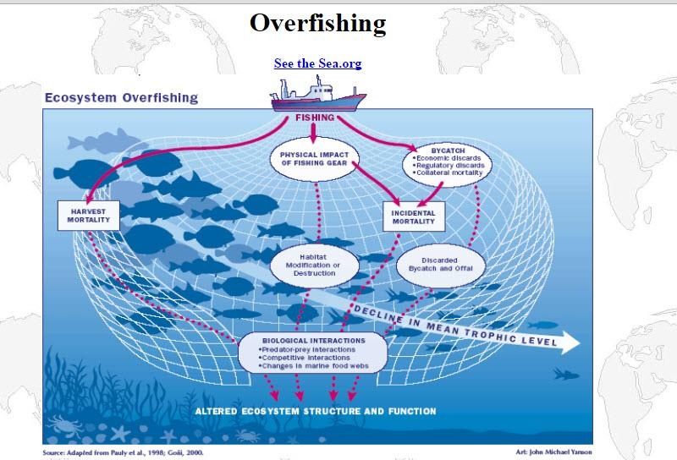
- How do you feel about ocean resources that are shared equally if some people cheat and take more than their share?

Page 2
- List 3 renewable resources.
- List 5 non-renewable resources.
- What is the benefit of renewable resources?
- What is the primary benefit of continuing to use non-renewable oil, as opposed to using renewable sources of energy instead?
- What are the major benefits to replacing fossil fuels with solar panels and wind turbines to meet our energy needs?

Page 3
- According to the text, non-renewable resources only seem cheaper at first. What are some of the hidden costs?
- Could a desert provide energy for the entire world? How?
- What are smart grids?

Page 4
- Explain how Hawaii is turning trash into energy?

