LJ Institute of Media & Communications
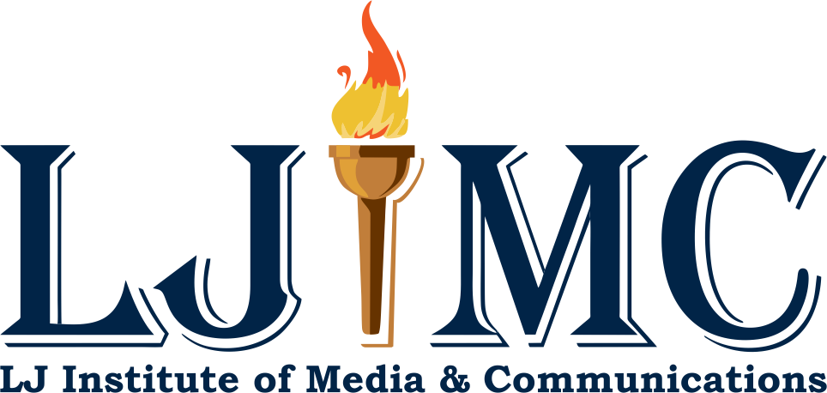
Event Report: Sensitisation Seminars - Media Studies and Opportunities

Dates: January 18, 2024, January 19, 2024, and January 29, 2024
Venues: New LJ Commerce College, LJ Institute of Applied Science, and LJ Institute of Business Administration in Vastrapur.

Introduction
A series of Sensitisation Seminars were organised by LJ Institute of Media & Communication followed by visits across various campuses of LJ University on 18th, 19th and 29th of January 2024 respectively, covering various colleges of LJ University, including New LJ Commerce College, LJ Institute of Applied Science, and LJ Institute of Business Administration in Vastrapur. The seminars were organised to introduce students to the field of media studies and the diverse career opportunities it offers

Objectives:
- Introduce students to concepts and disciplines within media studies.
- To highlight career opportunities in the media industry.
- Create an engaging and inspiring environment to encourage students to explore media-related career opportunities.
- Foster awareness of the importance and impact of media studies.
- Provide students with insights into the practical applications of media studies in real-world scenarios.

Event Details:
The Sensitisation Seminars on Media Studies and Opportunities were conducted by Dr. Divya Soni, Director of LJIMC, along with Assistant Professors Hardik Solanki and Rishank Joshi. These seminars, held on January 18, 19, and 29, 2024, aimed to provide students with valuable insights into the field of media and its career prospects.

Seminars Highlights:
The program highlights a range of activities aimed at providing students with valuable insights into media studies and its associated career pathways.
Program highlights included:

Overview of Media Studies:
A comprehensive presentation was conducted to provide students with an overview of media studies, highlighting its scope and significance in today's professional landscape. Through presentations and discussions, they gained insights into the various disciplines within media studies and their practical applications in real-world scenarios.

Interactive Session on Career Opportunities:
The moderators led engaging discussions with students after the sessions, exploring the myriad of career paths available in the field of media studies. Topics included journalism, broadcasting, advertising, digital marketing, and filmmaking, providing students with valuable insights into potential career options.

Tour of LJIMC Facilities (Radio Room and Studio Room):
Students were given a guided tour of LJ Institute of Media & Communications' state-of-the-art facilities, including the radio room and studio room. . They received hands-on experience with industry-standard equipment and technology used in radio broadcasting and audiovisual production. The tour provided students with practical exposure to the equipment and technology used in radio broadcasting and audiovisual production. The visits to the faculty after the seminars were managed by students of LJIMC itself to explain the media Infrastructure. The students of LJIMC themselves demonstrated the use of recording equipment, editing software, and broadcasting tools, allowing students to experience firsthand the process of creating media content in a professional studio environment..

Attendees:
100 plus students from New LJ Commerce College (NLJCC), LJ Institute of Applied Science (LJIAS), and LJ Institute of Business Administration (LJIBA), Vastrapur each visited LJIMC for exploring media as a career opportunity.

Enclosure:
Seminar 1: January 18, 2024
- Participation Attendance:
  - Students Present: 90

Seminar 2: January 19, 2024
- Participation Attendance:
  - Students Present: 120
Seminar 3: January 29, 2024
- Participation Attendance:
  - Students Present: 120

- Name of Colleges:
  - New L.J Commerce College
  - LJ Institute of Applied Science (LJIAS),
  - LJ Institute of Business Administration (LJIBA), Vastrapur

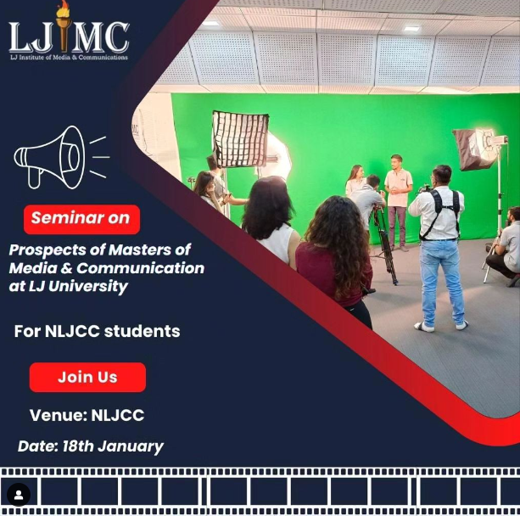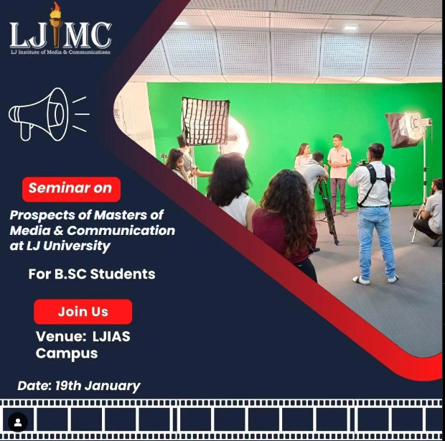

- The above creatives were floated on social media platforms for making students aware about the sessions.

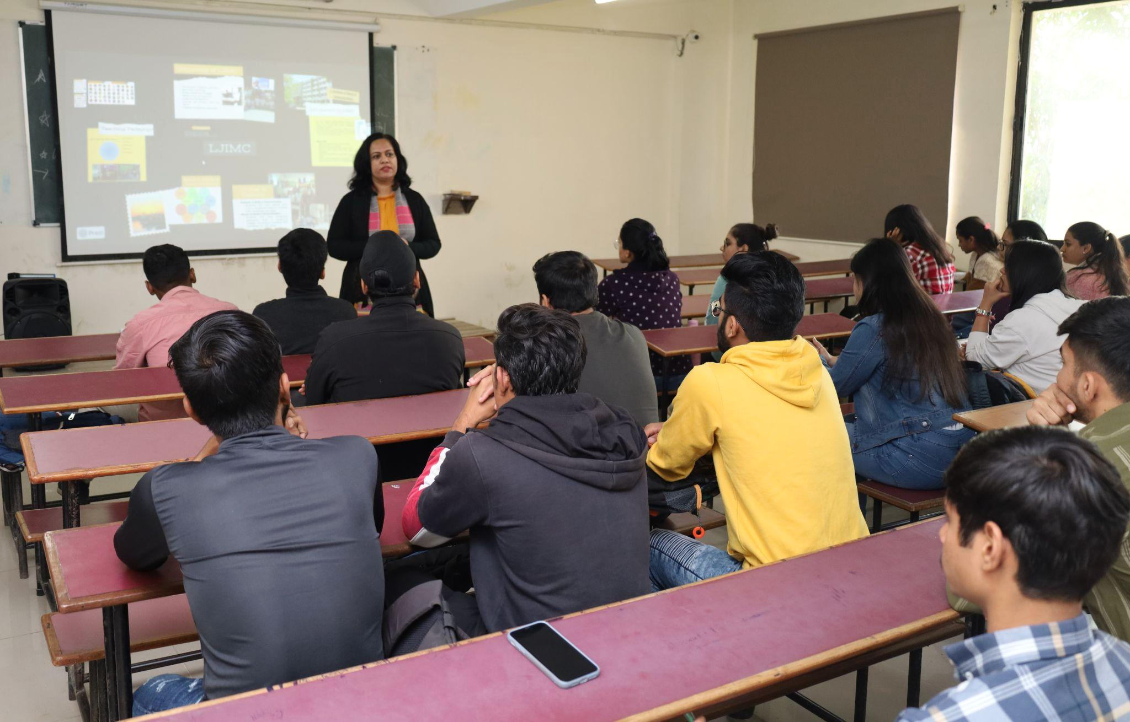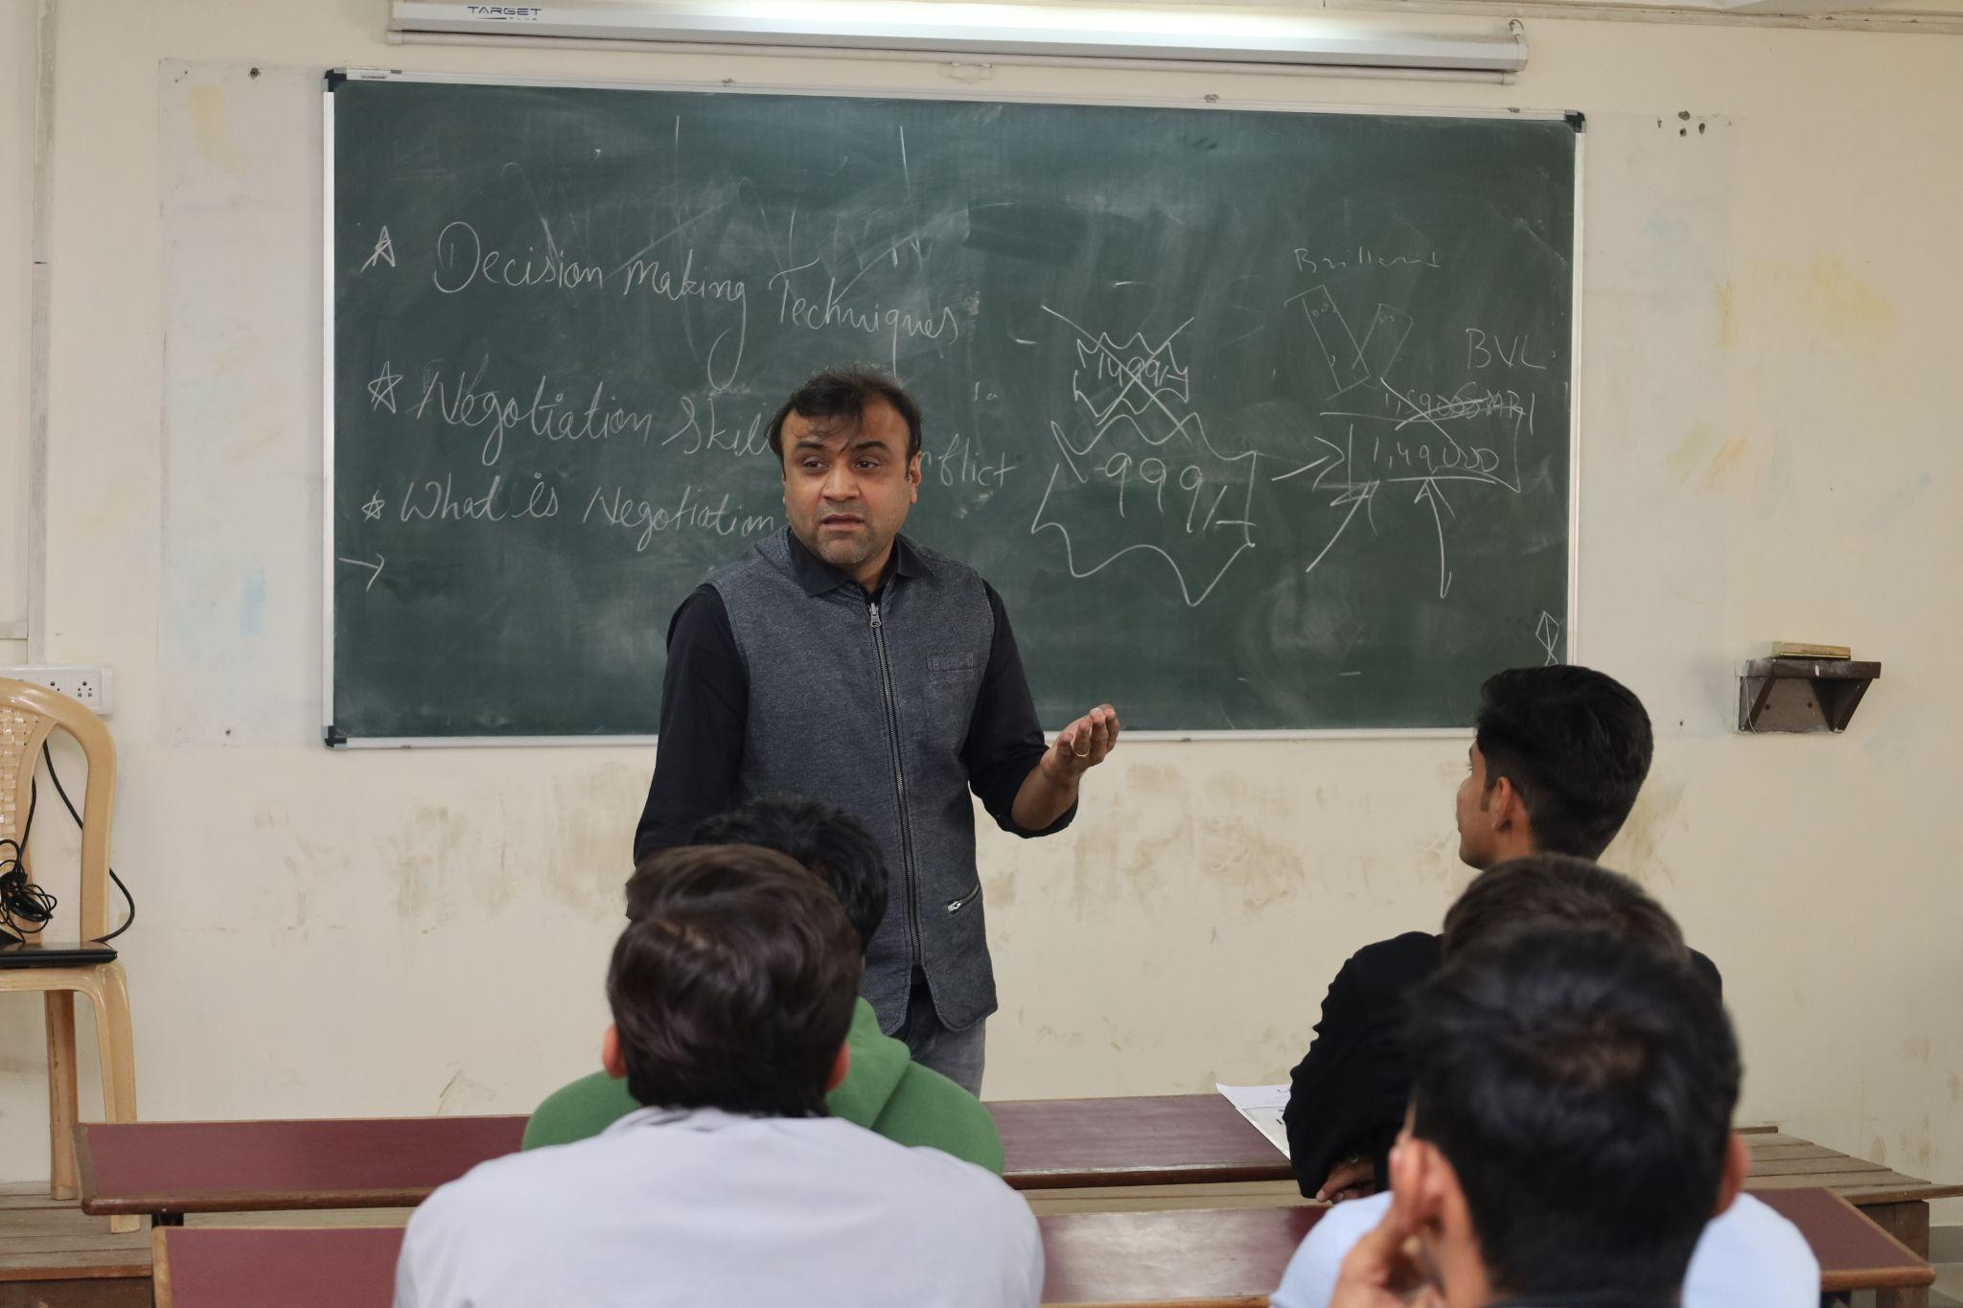
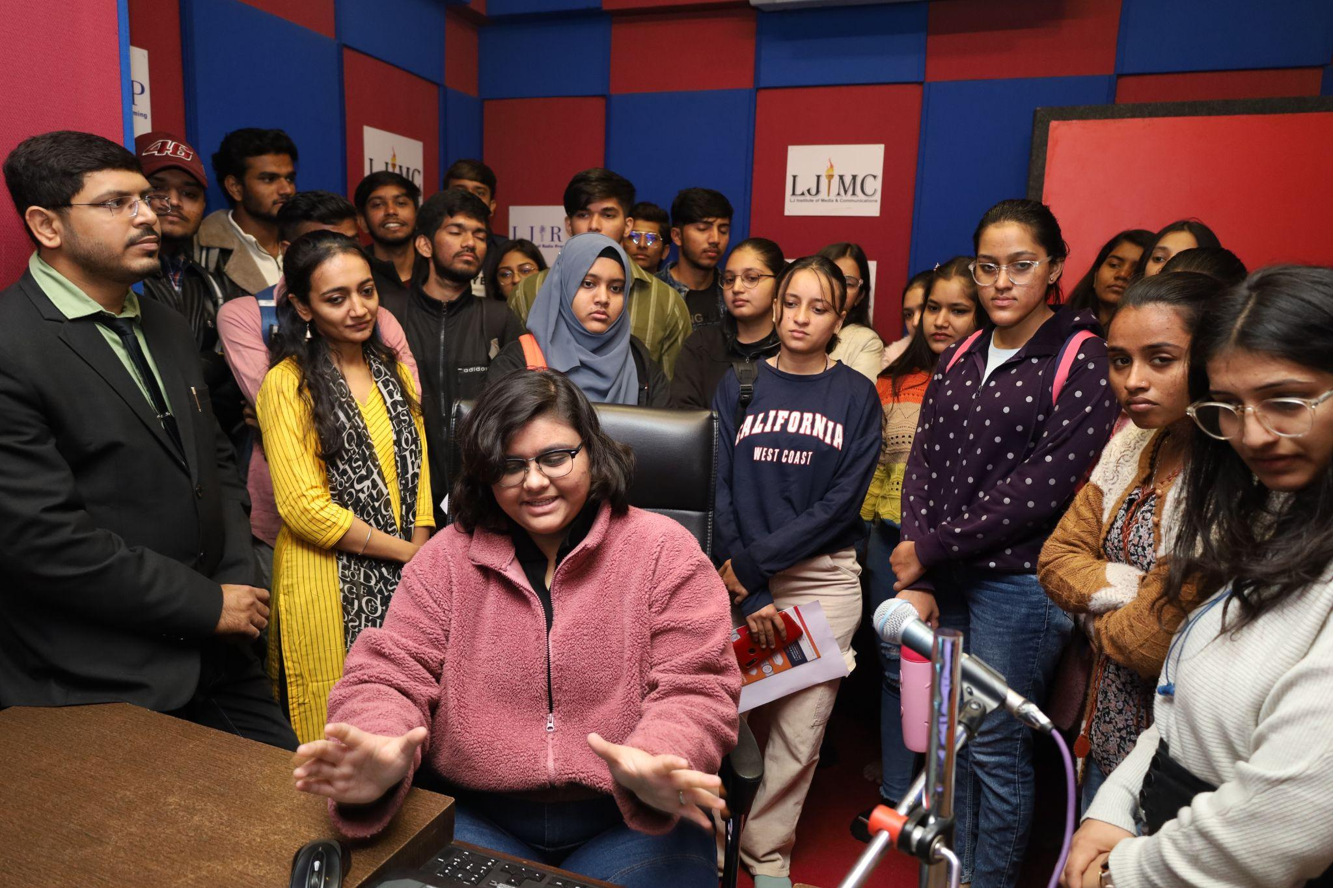

- The above are the pictures of media awareness sessions with NLJCC students.

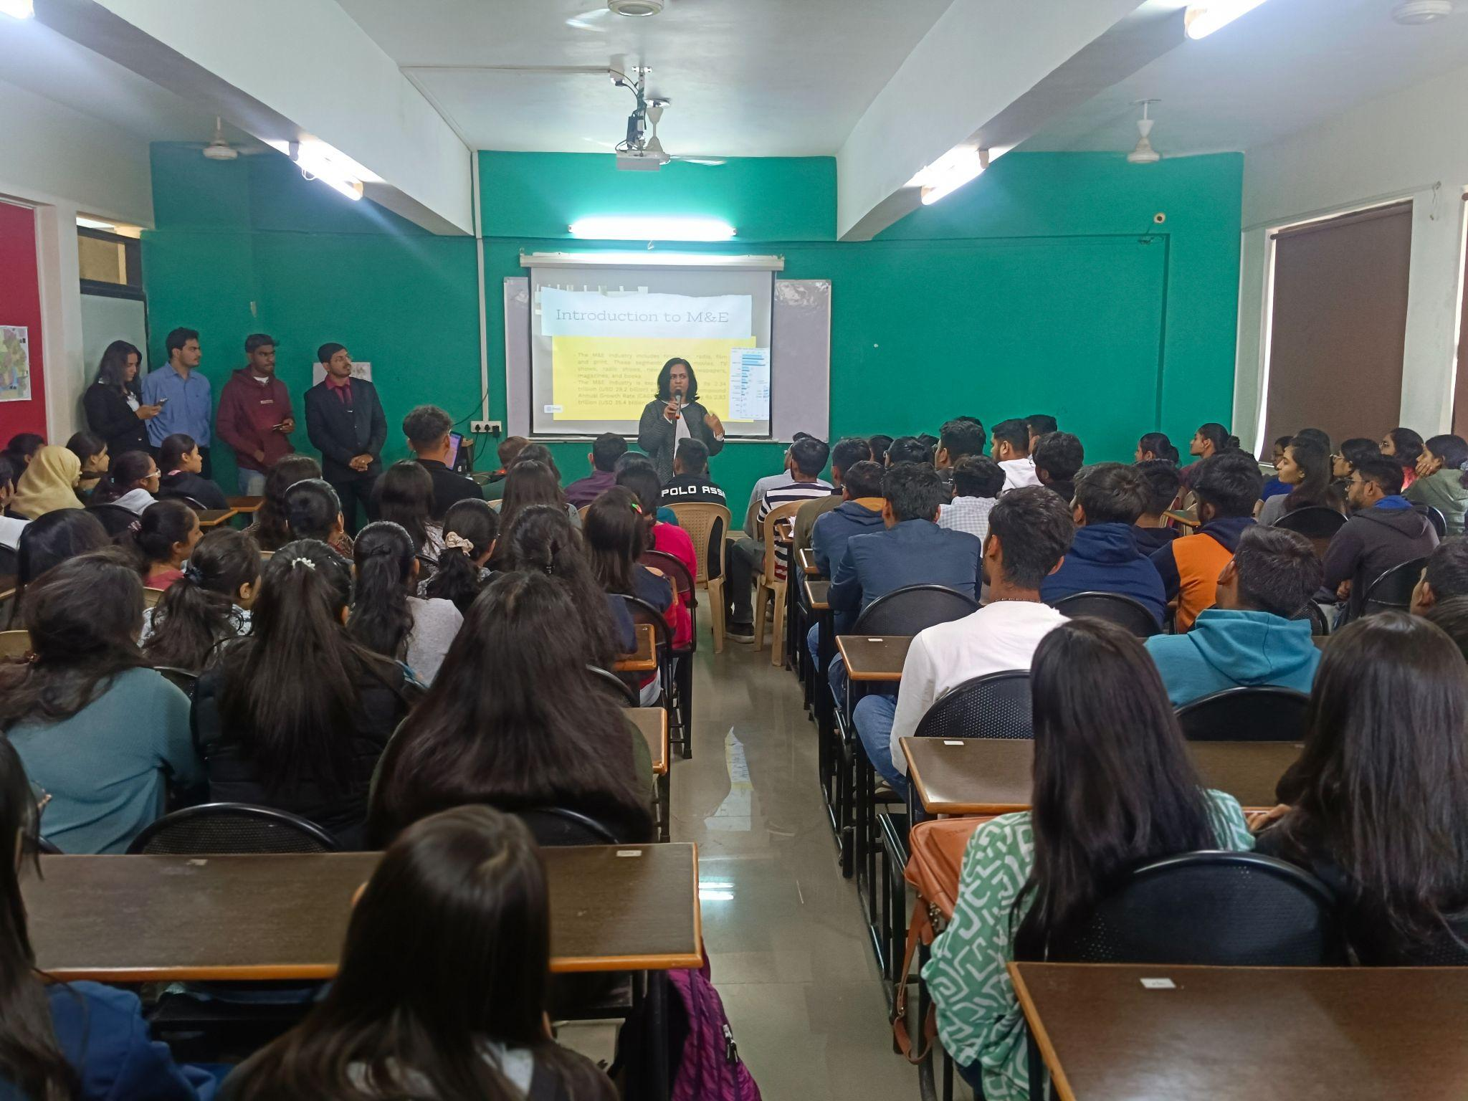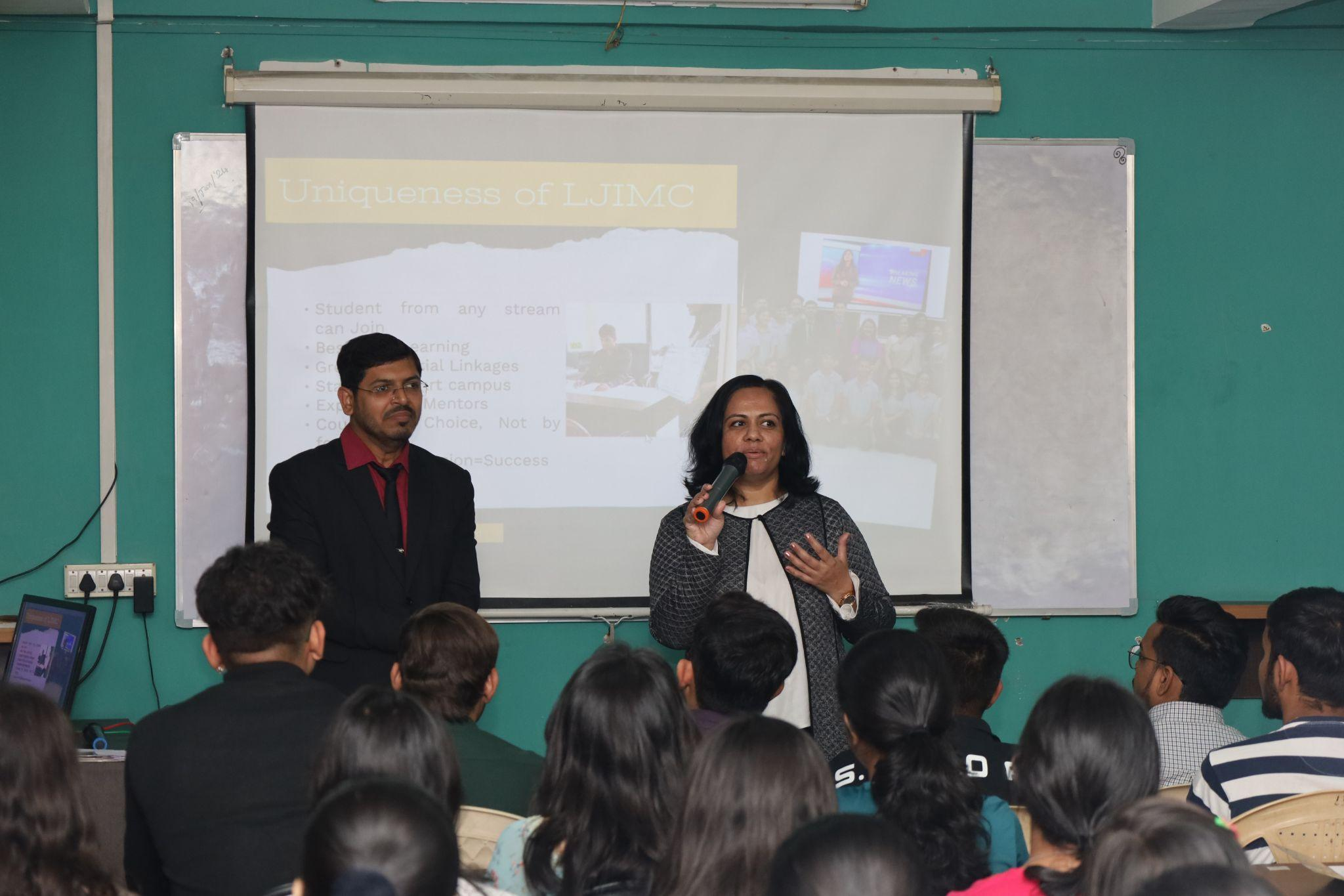
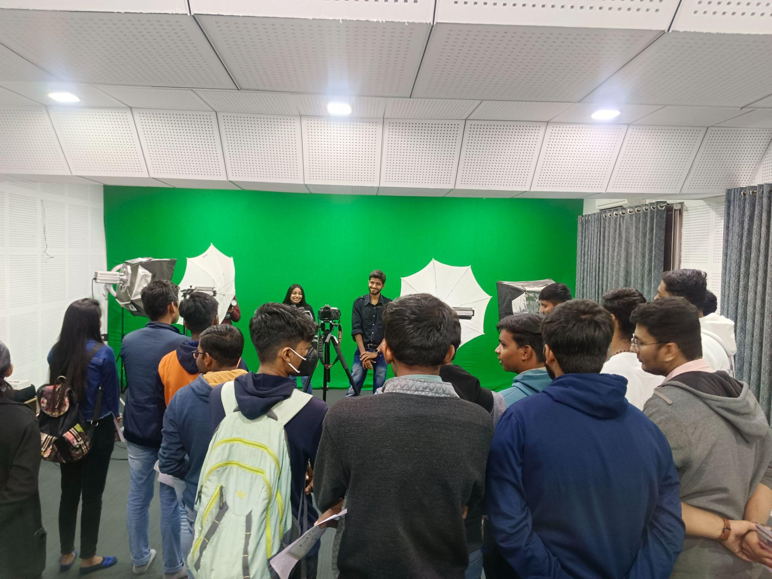
- The above are the pictures of media awareness sessions with LJIAS students.

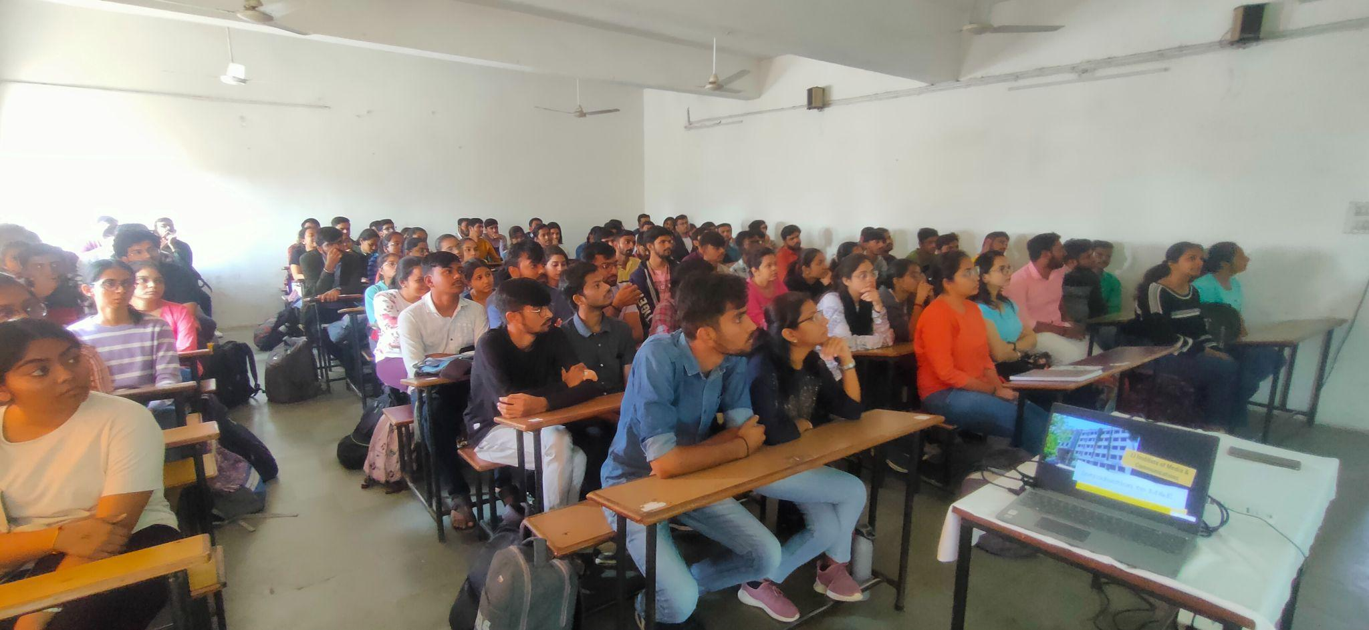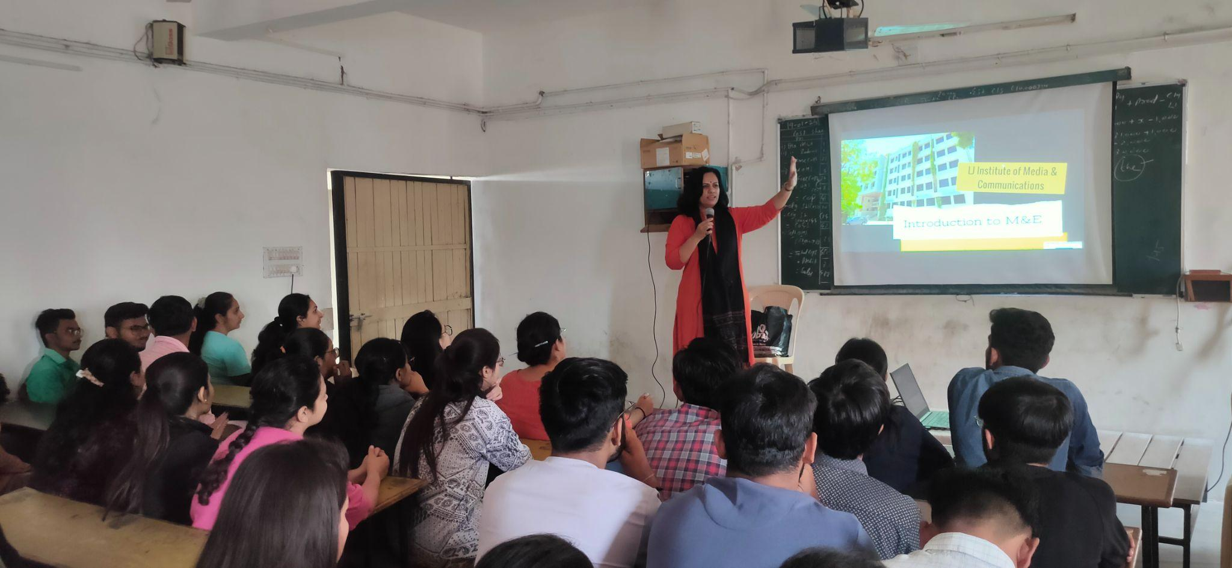
- The above are the pictures of media awareness sessions with LJIBA, Vastrapur’s students.

Conclusion:
The Sensitisation Seminars on Media Studies and Opportunities concluded successfully, with over 100 students from New LJ Commerce College (NLJCC), LJ Institute of Applied Science (LJIAS), and LJ Institute of Business Administration (LJIBA), Vastrapur, participating in each session. The seminars provided a platform for students to gain valuable insights into the dynamic field of media and sparked interest in potential career paths.

Outcome of the Event:
Feedback from students highlighted the informative and inspiring nature of the seminars. Many students expressed newfound interest in pursuing careers in media and appreciated the opportunity to interact with LJIMC mentors. The success of the seminars underscores LJIMC's commitment to providing valuable educational experiences and fostering student engagement.

