

B3Networks CPaaS
Product Specification for the CPaaS Auto Attendant Solution

Table of Contents
Product Summary 4
Product Features 5
Product License Requirements 6
Functional Spec 7
Typical Call Flow 7
Use Cases In Various Industries 8

Document control versioning

Document History
Date | Version | Applicable BMOs | Author | Comments
25 Aug 2022 | Version 1.0 | All | Ray | Document creation
27 Sept 2022 | Version 1.1 | All | Hallie | Amendment

Product Summary

CPaaS Auto Attendant is a flexible solution that enables users to set up a professional virtual hotline in an instant, complete with a personalized auto attendant and extensions.

Users are granted the ability to manage service requests in an effective manner and greet clients with unique messages through the creation of a multi-layered IVR (Interactive Voice Response) menu with specific call flows and conditions.



Product Features

Feature | Description
Unlimited layers of automated phone attendant | Able to create multiple layers of callflow
Visual call flow designer | The call flow of Auto Attendant can be created via visual flow
Supports TTS or MP3 file upload for IVR message | - Max MP3 File Size - 5mb  - 1 MP3 file is allowed per message block
Customizable language and speech settings | 34 different languages + multiple accent options
Call hunting - ring queue and ring group | A business phone system strategy that connects calls to multiple phone lines either simultaneously or one after the other
Call transfer | Ability to transfer the call from Auto Attendant to extension user, call group, or external number
Missed call notification with voicemail | Missed call notification via email
Missed call notification via SMS (purchased license) | Missed call notification via SMS
Gather caller’s input | - Play a message and gather the input from the caller to route the call accordingly  - Support exact matching, no matching, list matching or pattern matching
Forward | Forward the call to any previous blocks
Set conditions for your call flow | Define the matching condition and open different call flow branches depending on the result of it.  Available matching parameters:  - Pattern  - Caller's calling day in a week  - Caller's calling time  - Day of the week  - Upload numbers  - Validate Expression
Number blacklist management | With this being activated, the number, either anonymous or inserted number, will be blocked from accessing the Auto Attendant number
Office hour, After Office hour and Holiday customization | Ability to customize different flows for working hours, after working hours, and holidays
Show multiple version histories for reverting purposes | Fallback features which allow the previous flow to be re-activated
Backup and restore flows | - Export the call flow to a JSON file to backup  - Import the JSON file to restore
Integration | Allow integration to Phone System and Contact Center
Custom third-party software integration | Custom Third-Party Software (CRM/Ticketing System) Integration [e.g. Freshdesk, Zendesk, AgileCRM] via Webhook for Data Push /HTTPS integration only
Comprehensive call history with a customer journey | Call history can be retrieved for up to 1 year from the Portal
Schedule / Real-time deployment | Deploy a specific flow at specific time or opt to deploy it real time
Holiday settings | Set public holidays so that inbound call will react based on the setting of public holidays

Product License Requirements
(CPaaS Auto Attendant SKU List Requirements)
SKU Name | SKU Type | Unit of measure | Free/Paid
Auto Attendant | Base License | per organization per month | Free
Concurrent Call | Add-on License | per concurrent call per month | Paid
Number | Addon License | per organization per month | Paid
*SMS (For missed call notification via SMS) | Addon License | per organization per month | Paid

(*): optional

Functional Spec

Personalizes customer journeys and offers self-service voice options with a graphic, flexible IVR solution. No coding or IT skills are needed!

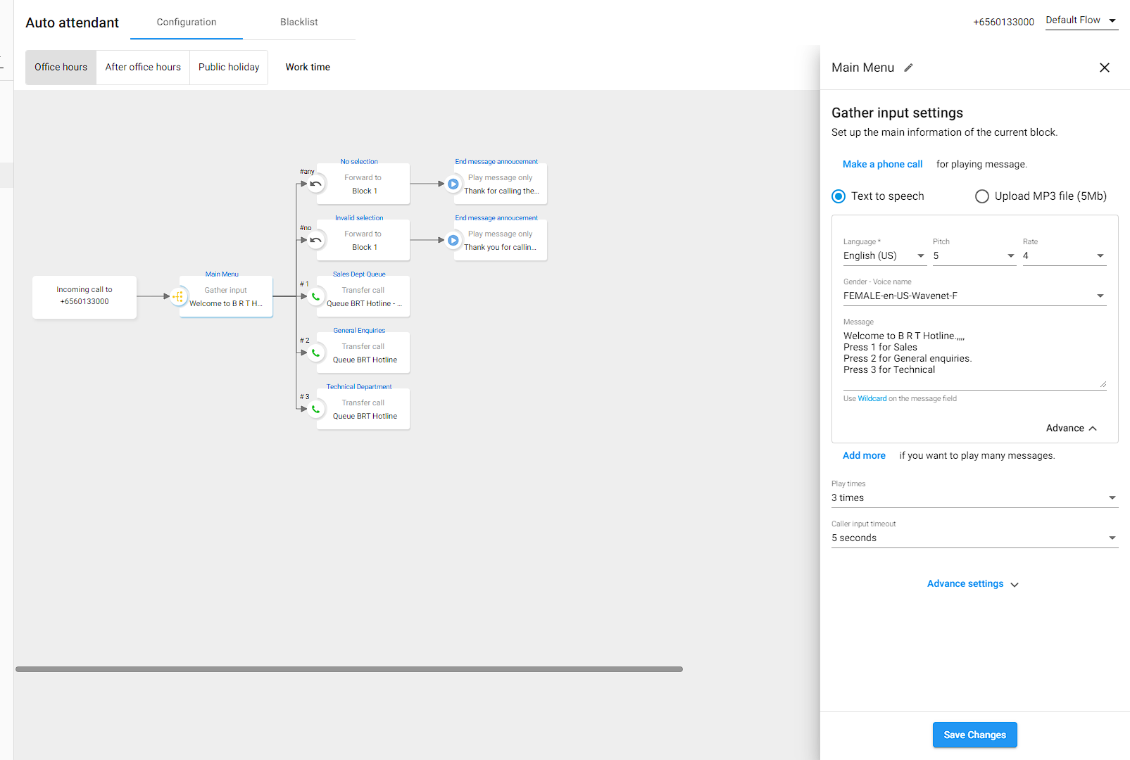

Typical Call Flow

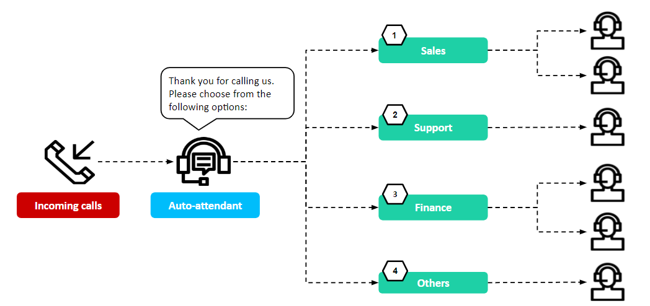

Use Cases In Various Industries
CPaaS Auto Attendant Solution can meet your communication requirements with flexible and scalable solutions across all industries.
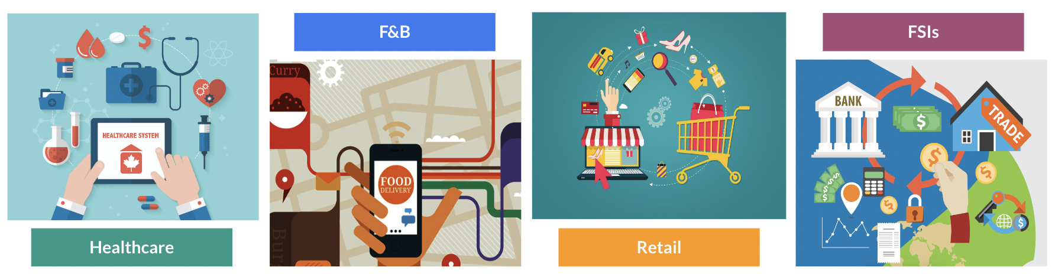
- Hospital & Clinic: Doctors’ offices rely on Auto Attendant to funnel callers to the right department (e.g., office staff for appointment booking and nurses for medical inquiries).
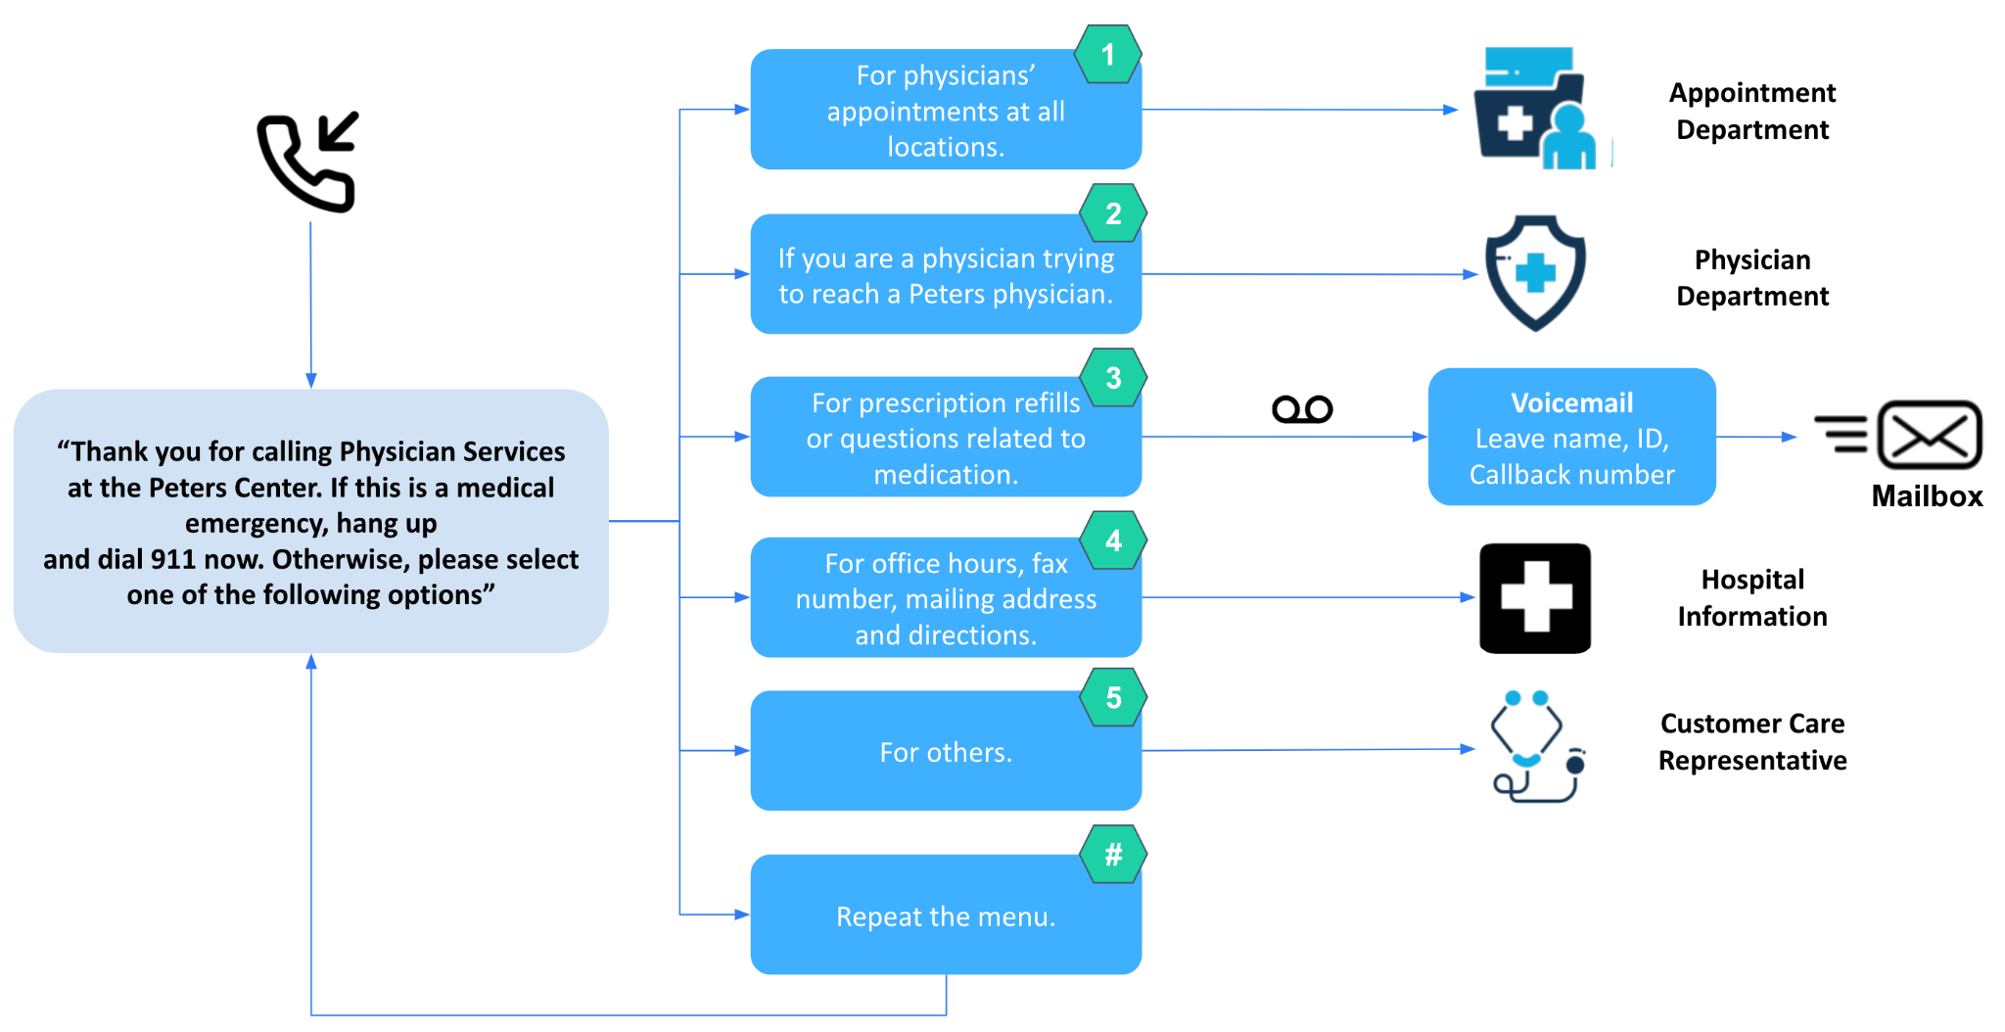
- Restaurant Reservation Group: Use the Auto Attendant to make/cancel an appointment. Auto Attendant sends reservation links via SMS to callers, which directs them to the online booking software.
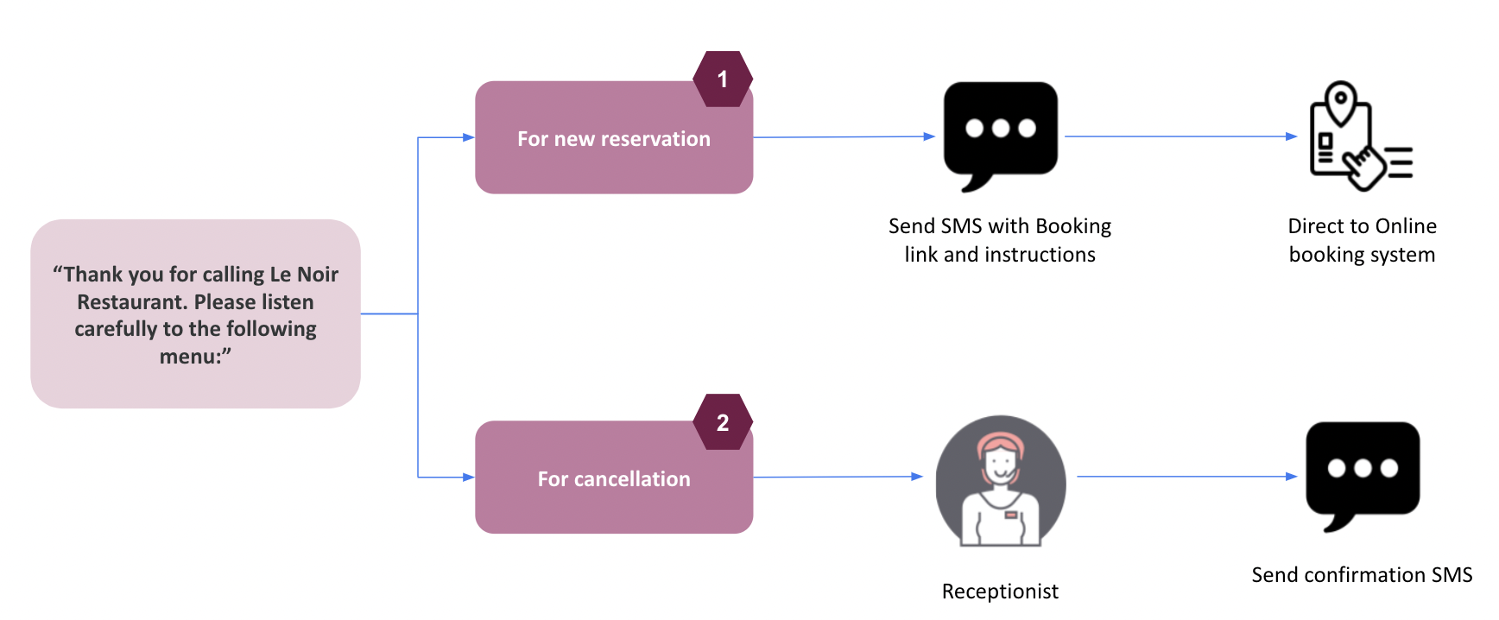
- E-Commerce Stores: Auto Attendant is used as a dedicated line with alternate greetings specific to seasonal products, services, or marketing promotions. For example, during the holidays, stores can use the IVR to streamline sales questions and process orders over the phone.
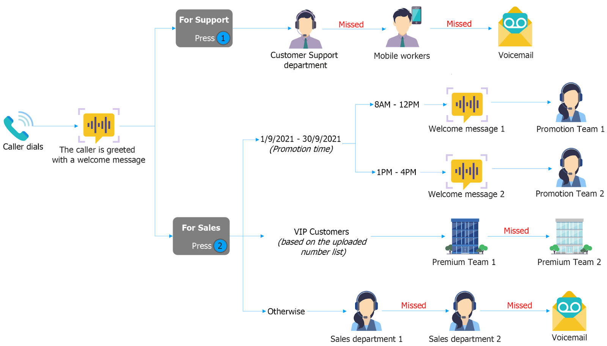
- Financial Institution: Auto Attendant integrated with the company’s database and CRM systems to handle all their hotline and corporate calls. Get policy information over the phone by securely authenticating their information via the IVR.
