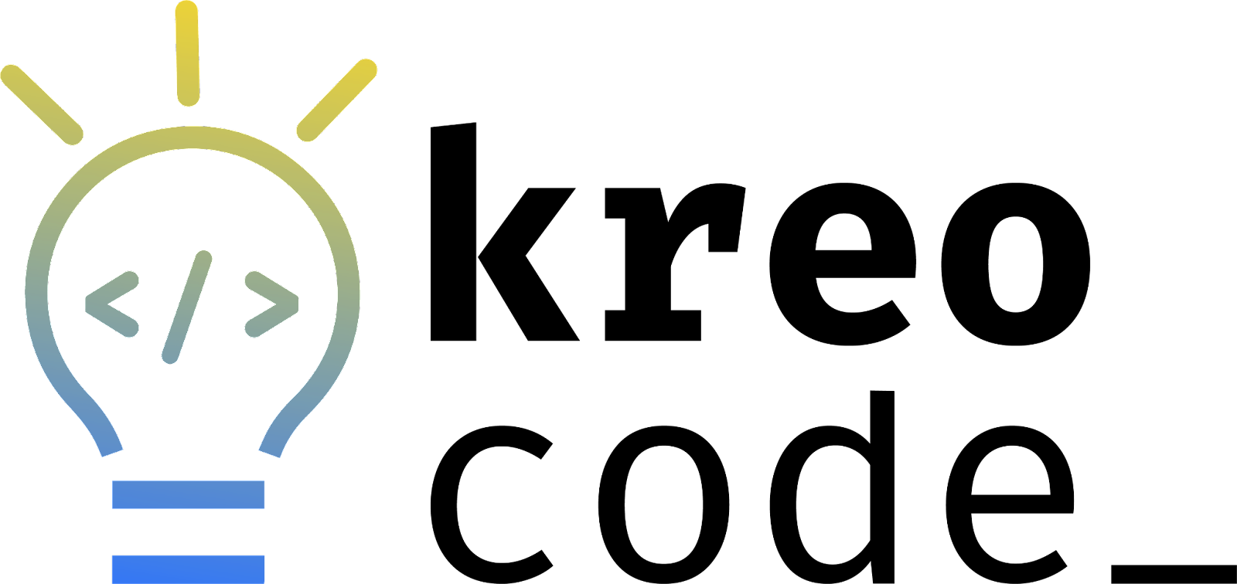
Teacher’s Guide
Scratch
Beginner and Advanced Challenges

Sustainable Development Goals (SDG): 11 - Sustainable Cities and Communities

Welcome to the Kreocode Challenge!

1. Introduction and Target Audience 2
2. Challenge Description 3
Pedagogical Intention 3
Links with the Quebec Education Program (PFEQ) 3
Terms and Conditions 3
Estimated Time 3
3. Getting Started 4
Create your teacher’s account 4
Create accounts for your students 4
4. Sequence of Project 5
Getting Started: An Introduction to Sustainable Development 5
The Kreocode Challenge and Sustainable Development Goal #11 6
Presentation of the Kreocode Challenges 8
Carrying Out the Challenges 8
Review and Validate Before Publishing 9
Going Further 9
5. Project Selection and Participation in the Event 9
6. Conclusion 10
Appendix A : Links to the Québec Education Program (PFEQ) and the Digital Competences 11
Appendix B: Criteria for Beginner and Advanced Kreocode Challenges 27

Challenge 2025 : Kreo imagines a sustainable city!

1. Introduction and Target Audience

Coding events are amazing opportunities for students to learn to code in a fun, engaging way! As an educator, you don’t need to be an expert in the field of coding or have prior experience coding: guides, tutorials and resources will be available to you, as well as support from a team of pedagogical consultants. During a coding event, students are generally presented with a challenge to code and share with their community.
The Kreocode event was created by a group of RÉCIT consultants with the aim of offering a provincial coding event for all levels (preschool, youth sector and adult general education) and all subject areas. For this year’s edition, students will be asked to use block programming (Scratch) to illustrate a solution to a real-life global challenge. To inspire students, we decided to use one of the United Nations Sustainable Development Goals (SDGs) as a prompt. Throughout the coding challenge, students will have the opportunity to make pedagogical use of programming and they will be able to inform themselves, exchange, and take a stance in relation to the SDGs. The Kreocode.ca website offers a wide range of resources to support you throughout this challenge including this video.
Scratch, one of the two tools proposed for the Kreocode event, is an ideal coding tool for students from cycle two elementary school onwards. This guide proposes a variety of challenges, from beginner to advanced levels, for students of all levels.
(For preschool, elementary cycle one students or students with special needs, we recommend using ScratchJr. The Teacher’s Guide for ScratchJr can be found here.)

2. Challenge Description

Pedagogical Intention
Illustrate a solution aimed at achieving a sustainable development goal using the Scratch programming tool.

Links with the Quebec Education Program (PFEQ)
The Kreocode Challenge fosters the development of the digital competency as well as competencies in various subject areas. It is up to you, the teacher, to choose the subject-specific content you wish to explore while participating in this challenge. Many links to the PFEQ and the Digital Competency Framework are presented in Appendix A, for various subject areas.

Terms and Conditions
The challenge can be completed as a large group, in teams, or individually. However, only one to five projects per class may be submitted to the Kreocode website each year.

Estimated Time
The time required for the challenge may vary from one group to another and depends greatly on the level of difficulty of the challenge chosen. Nevertheless, we recommend planning at least 5 hours for the completion of the challenge.

Additionally, allow approximately 15 minutes for preparing and submitting each project on the Kreocode website as well as filling out the form and adding links to each of them.

3. Getting Started

In preparation for the Scratch adventure with your students, we suggest completing a few tasks.

Create your teacher’s account

The Scratch teacher account makes it easier to manage the projects created by your students. To create your teacher account, click on this link. Please allow 24 hours for the validation process to be completed.

Create accounts for your students
There are several ways to create your class. You can:
- Create accounts for your students
  - Procedure for creating accounts by the teacher
  - Procedure for the students’ first login
  - Procedure for adding a project to the studio

- Share a sign-up link with your students via email or using your educational platform(s) such as Classroom or Teams.
- Create accounts using a .csv file. This method is recommended if you need to create accounts for multiple groups.
Notes:
- On their first login, students will need to fill in some information. After that, they will be ready to start creating.
- A class can only be linked to one teacher account. Therefore, it is not possible to invite a co-teacher to your class.
- It is not possible to use the same account in multiple classes. Therefore, if students already have an account from a previous year, new accounts will need to be created for them in order to add them to your class.

4. Sequence of Project
This section proposes a sequence that you can adapt to the needs of your students.

Getting Started: An Introduction to Sustainable Development
🖥️Slideshow: Presentation of the Kreocode Challenge, slides 1 to 8 (beginner - advanced)

Explain to students that you are offering them the opportunity to participate in an event open to all students across Québec, where they will have the chance to learn more about the SDGs (Sustainable Development Goals).
In fact, the organizers of Kreocode have decided to add a "green" touch to their ScratchJr and Scratch challenges in order to highlight the sustainable development goals proposed by the United Nations member states.
At the beginning of the project, it may be both useful and necessary to discuss sustainable development and the SDGs developed by the United Nations (UN) with students. To foster a discussion, you may want to start by: watching video clips, reading texts, exploring posters or logos that display the SDG targets. If necessary, students can take notes from these discussions in their student booklet.
Here are some resources that may help understand the topic.

📑 Sustainable Development
- Video: What is Sustainable Development ?
- UNESCO: Student Resources

📑 Sustainable Development Goals
- Presentation of the Sustainable Development Goals (UN)
- Illustration of the Sustainable Development Goals
- Video 17 Sustainable Development Goals

📑 Other resources on Sustainable Development Goals
- Edutopia: Hands-On Learning and the SDGs
- Video: Sustainable Development Goals explained with 3 useful tips
- Books on the Constellations website
Did you know?
- By 2030, UN member countries intend to
  - eradicate poverty
  - protect the planet
  - ensure prosperity for all

- From these three general goals, 17 targets emerge :
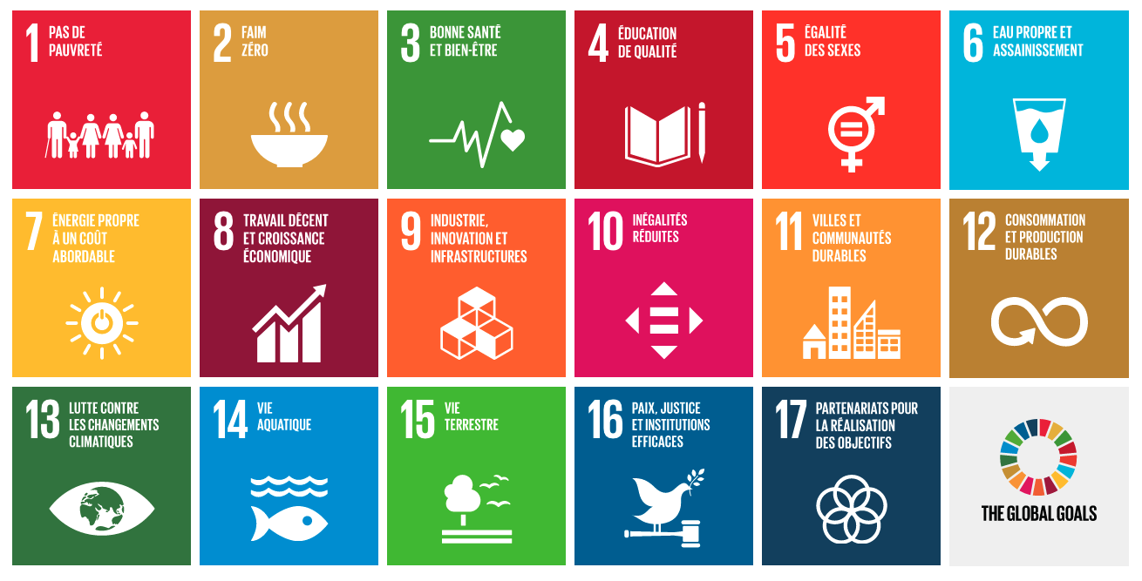

Source : Wikipedia

The Kreocode Challenge and Sustainable Development Goal #11
🖥️Slideshow: Presentation of the Kreocode challenge, slides 9 to 17 (beginner - advanced)
Introduce the Kreocode Challenge to your students. This year's edition is set within the context of SDG #11 (Sustainable Cities and Communities) which is about making cities and human settlements inclusive, safe, resilient and sustainable. Using the slideshow as a support, we recommend that you have students explore and discuss the following three sub-goals and discuss them:
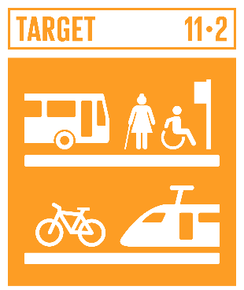 | 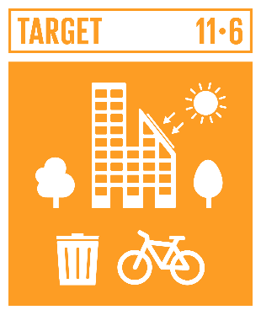 | 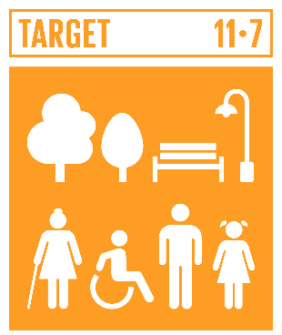
Target 11-2: Affordable, accessible and sustainable transport systems for all. | Target 11.6: Reduce the environmental impact of cities. | Target 11.7: Access to safe, inclusive and accessible, green and public spaces
Resources that can be explored in class:

Sustainable cities
- SDG Board Game
- Carbon City Zero
- Redesigning Cities to Fight Climate Change
- SDG 11 Sustainable Cities & Communities - DEEP DIVE
- What is sustainable development?
- Sustainable Cities and Communities
- Creating Sustainable Cities
- Paper City
- Sustainable Cities (Crash Course)

Some topics related to sustainable cities (books and websites)
Transportation
- City Streets Are for People
- Rush Hour
- Green Transportation
- Pedal It!
- Getting to School the Green Way (Lesson Plan)
Buildings
- The Impact of Buildings and Cities
- Sustainable Structures
- The Cities We Live In
- Why Humans Build Up
Parks and Green Spaces
- A Forest in the City
- Urban Gardening
- Keep Our World Green
- Green Spaces Lesson
- Green Spaces

Presentation of the Kreocode Challenges
🖥️ Presentation: The Kreocode Challenge, slides 18 to 21 (beginner - advanced)
📑 Document: Presentation of criteria (beginner or advanced)
📑 Document: Kreocode - Student booklet (beginner or advanced)
📑 Document: Kreocode - Planning My Scratch animation (doc) if needed*.
*Note - Using the “wait until” block is not the most efficient method, but it is a solution that can be used by beginners in Scratch.

Two challenges are available for the event: the beginner version and the advanced version. In Appendix B, you will find a table comparing the criteria for these two versions. Each challenge focuses on the same theme, but has different criteria. We suggest that you present these criteria to the students. A student booklet is also provided.

If your students have different levels of proficiency with Scratch, you can offer the advanced challenge to only certain students.

Carrying Out the Challenges
🖥️ Slideshow: Introduction to Scratch (beginner to advanced)
📑 Document: Presentation of criteria (beginner or advanced)
📑 Document: Kreocode - Student booklet (beginner or advanced)
📑 Document: Kreocode - My Scratch animation (doc) if needed*
Depending on your preference, you may choose to carry out initiation activities prior to tackling the Kreocode challenge. These activities allow students to acquire the basic skills necessary to successfully create an animation in Scratch. You may also choose to skip these activities and begin the challenge straight away. A short presentation of the interface and basic blocks is nevertheless suggested.

During the challenge, you may support your students as they :
- brainstorm individually and in groups;
- gather information;
- plan the animation, and write sentences to include;
- create the animation in Scratch.

Review and Validate Before Publishing
🖥️Slideshow: Presentation of the Kreocode Challenge, slides 22 to 23 (beginner - advanced)
📑 Document: Presentation of criteria (beginner or advanced)
📑 Document: Kreocode - Student Booklet (beginner or advanced)
Invite students to review and validate their work by going over the criteria and any feedback you may have provided. Pay close attention to the last section concerning the publication, as it has not yet been presented to students.

Going Further
Here are some suggestions to go further with this project:
- Consider sharing all of your students’ projects with parents. To do this, you can send the links through educational platform(s) such as Classroom or Teams.
- Initiate another project with Scratch.
- Organize an exhibition (like a “science fair”) and invite other students or groups from the school.

5. Project Selection and Participation in the Event

Once completed, up to five projects per class can be submitted to the Kreocode website. Preferably, students participate in selecting the projects.

To submit one or more projects, teachers must use the form on the “Challenges” page of the Kreocode website. Projects are submitted by providing links to the students' Scratch programs. Instructions for finding these links can be found here.

As stated in the participation guidelines, projects that include a student’s photo or any personal information (name, group, school, etc.) will not be published.

Once the videos are posted on the Kreocode website, we encourage you to share the link with students and their families so that they can enjoy their projects and explore the projects of other students.

6. Conclusion
The entire Kreocode team is looking forward to seeing your students’ projects regarding the targeted sustainable development goal this year!
Pedagogical Consultants, including those from the RÉCIT team, are available to support you, answer any questions you may have, and guide you through the entire process of this event for students from across Québec.
For more information, please feel free to contact us at kreocode@recit.qc.ca.
We look forward to seeing you again next year!

Appendix A : Links to the Québec Education Program (PFEQ) and the Digital Competences
1. General Education in the Youth Sector
- Arts Education
- Physical Education and Health
- English Language Arts
- English as a Second Language
- Culture and Citizenship in Québec
- Français, Langue Seconde
- Mathematics
- Science and Technology
- Social Sciences

2. Adult General Education (AGE)
- English Language Arts
- Français, Langue Seconde
- Computer Science
- Mathematics
- Contemporary World
- Science and Technology

3. Francisation

4. Digital Competency

1. General Education in the Youth Sector

Arts Education
While creating, students will explore the creative process/dynamics (modèle au primaire, modèle au secondaire (in French) in order to research and inventory ideas, experiment and make choices, and reflect on the final result while making necessary adjustments.
Students will, within the competency of creating media works, regardless of the artistic discipline, be connected to producing content related to sustainable development. It should contain a message and be addressed to one or more recipients. The visual, sound, dramatic and physical elements (sprites) should support the project's message according to the intended target audience.
Physical Education and Health
Adopting a healthy and active lifestyle can be an interesting background to the Kreocode Challenge. Here are some suggestions that can mobilize this skill.
- Name healthy or harmful lifestyle habits for health and well-being. Example: walking or cycling to school
- Discuss strategies to have healthier eating habits according to our level or physical activity.

English Language Arts
In Kreocode, there are many opportunities to develop ELA subject specific competencies. Students will read information, talk in small groups about the Sustainable Development Goals and propose solutions and finally, produce a text (words and images) that communicates with an authentic audience.

- Read and discuss the different Sustainable Development Goals (SDGs) in small groups.
- Learn about one of the 17 Sustainable Development Goals using stories, information, posters and short videos. In small groups talk about each goal and come up with ideas to support each goal.
- Write/draw a draft text and images that will communicate your ideas clearly. Get feedback from peers and then revise the text to make it great!
- Follow the Kreocode process. Plan your interactive story with your audience in mind. Is the message for children or adults?
- Write or code your story, get feedback, revise it and share it with your audience.

Elementary C1 | Read and listen to literary, popular and information-based texts
Elementary C2 | To write self-expressive, narrative and information-based texts
Elementary C3 | To represent their literacy in different media
Elementary C4 | To use language to communicate and learn
Secondary C1 | Uses language/talk to communicate and to learn
Secondary C2 | Represents their literacy in different media
Secondary C3 | Produces texts for personal and social purposes

English as a second language
All three competencies are mobilized with this challenge.
Some suggestions to develop the ESL competencies:

C1: Interact Orally
- Students use conversational prompts to discuss solutions to the issues in the challenge.
- Students discuss personal connections to the global goal issue.

C2: Reinvest Understanding
- Students read about global goals and discuss issues (constructing the meaning)
- After constructing the meaning of various texts, students use information from them to create a personalized dialogue or story that represents a solution to the challenge.

C3: Write Texts
- Students write tips or advice using modals.
- Students write a dialogue between two people discussing the selected global goal issue.
- Students write a narrative story that includes a description of the issue and a solution.

Many strategies can be developed or integrated while working on the Kreocode challenge. Here are a few examples relevant to the ESL program:
- Using resources, planning, comparing, predicting, taking notes, cooperating, and taking risks.
These strategies can help enhance language development and support students in various learning situations.

Culture and Citizenship in Québec
The United Nations' sustainable development goals targeted in the Kreocode Challenge offer opportunities to take a critical look at the cultural realities that shape collective life. For this reason, they represent contexts conducive to the development of disciplinary competencies from the Quebec Culture and Citizenship (CCQ) program. For example, students could :
- Make observations about the layout of their city (for instance, students could observe public transportation, therefore targeting the competency Examine cultural realities (Elementary Cycle 2) ;
- Question the link between social order and city planning by questioning and gathering information (e.g. in connection with Secondary 2 contents and the competency Examine cultural realities) ;
- Contextualize a situation presenting ethical issues (e.g. the Quebec City tramway) and formulate an ethical question to reflect on it, then propose possible actions to address them, measure their effects and select those that promote the common good (For example, in connection with Secondary 4 contents and the competency Reflect on ethical issues) ;
At the primary level, the theme of “Relationships between humans and the environment” is taught each year and provides an ideal opportunity to address the issue of territory management.
- Reflection contexts become increasingly complex over the cycles, making certain themes possible for achieving the goals of the Kreocode Challenge. For example, the student could reflect on:
    - Urban cohabitation between humans and other living beings (Cycle 1) ;
- Ways of inhabiting the territory (Grade 3) ;
- Examine ecological practices implemented in your community (Grade 4r) ;
- Reflect critically on collective choices about the future of transportation in Quebec Grade 5) ;
- Think critically about young people's environmental involvement in citizen discussion spaces (Grade 6) ;

In secondary 1, the theme Collective Life and Public Space provides an opportunity to take a look at eco responsibility and civic participation. Students could take a look at individual, collective and institutional responsibilities with regard to the use of public spaces, and identify tensions.
At the senior high school level, the theme of Relationships and Caring provides an opportunity to reflect on the inclusiveness of public spaces, in particular access to green spaces by people with limited mobility.
- In senior high school, the theme Technologies and Future Challenges includes the concept of environmental technology. Students could explore different technological advances that enable municipalities to reduce their environmental impact, and think critically about which ones should be favored. Students could share their thoughts with their municipality via e-mail.
Finally, the Act as an ethical citizen dimension of the Digital competency calls for reflection on issues related to digital uses. In this sense, the Kreocode challenge provides learning opportunities that are likely to contribute to a better future for individuals and the community. For example, students could reflect on the environmental effects of different technological choices on themselves, others and society.

Français, langue seconde (de base, immersion et enrichi)
FLS Primaire - Programmes base et immersion

Dans le cadre de ce défi, les compétences suivantes peuvent être exploitées:
- C1 - Interagir en français (communiquer, comprendre et lire)
- C2 - Produire des textes variés

Voici quelques pistes pour mobiliser ses compétences:
- Se familiariser avec les Objectifs de développement durable en lisant différents albums et exprimer ses réactions lors d’interactions
- S’informer sur un des 17 Objectifs de développement durable à l’aide de textes lus, vus ou entendus et partager sa compréhension avec les autres élèves selon le média choisi
- Discuter en français des différents Objectifs de développement durable et proposer des solutions aux différentes problématiques
- Planifier son histoire interactive en tenant compte de l’intention de communication
- Écrire son histoire, la retravailler, la réviser et la diffuser
- Utiliser des stratégies et des connaissances appropriées au type de texte et à son intention
- Utilisation d’un vocabulaire lié au sujet

FLS Secondaire, cycle 1 - Programmes base et enrichi

Dans le cadre de ce défi, les compétences suivantes peuvent être exploitées:
- C1- Interagir en français
- C2- Produire des textes variés en français
- C3- Lire des textes variés en français

FLS Secondaire, cycle 2 - Programmes base et enrichi

Dans le cadre de ce défi, les compétences suivantes peuvent être exploitées:
- C1- Interagir en français
- C2- Lire des textes variés en français (base)/ Lire des textes courants, spécialisés et littéraires en français (enrichi)
- C3- Produire des textes variés en français

Voici quelques pistes pour mobiliser ses compétences:
- Écouter, lire et regarder une variété de textes oraux, écrits, visuels ou mixtes, à caractère médiatique ou non, pour se familiariser avec les Objectifs de développement durable
- Discuter en français de sa compréhension des différents Objectifs de développement durable et proposer des solutions aux différentes problématiques
- Adopter une démarche de production (identifier les caractéristiques des éléments de la situation de communication, respecter son intention de communication )
- Préparer une première version de l’histoire, la retravailler, la réviser, faire une version finale et la diffuser

Mathematics
The Kreocode Challenge offers an opportunity for students to explore mathematical concepts and problem-solving through programming. This includes analyzing and resolving issues such as sprite movement and speech synchronization. Through discussions, students will learn to improve their programming efficiency.
Here are other ways that students can use their essential mathematical knowledge:
- Positioning their character on a Cartesian plane using coordinates (geometry).
- Including a translation when moving a sprite (geometry).
- Perform various calculations based on sustainable development goals data.
- Interpret a chart or diagram related to sustainable development goals (statistics).

Science and Technology
The Kreocode Challenge is situated in a Science and Technology (SCT) context. There are many skills, both in elementary and secondary education, that can be mobilized by this challenge. The approach of scientific popularization is at the heart of this project.
Here are a few ways that students can incorporate Science and Technology skills (SCT):
- Describing the impacts of human activities on the environment, such as resource exploitation, pollution, waste management, land development, urbanization, and agriculture (cycle two and three of elementary education).
- Explaining scientific and technological concepts related to recycling and composting, such as the properties of matter, changes of state, physical changes, chemical changes, food chains, and energy (cycle two and three of elementary education).
- Describing and recognizing diverse types of physical and chemical changes (SCT, cycle one of secondary education).
- Describing the main relationships between the lithosphere and human activities, such as maintaining life, agriculture, and land development (SCT cycle one secondary education).
- Explaining the concept of ecological footprint (Environmental Science and Technology, SCT, secondary four education).
In addition, several strategies can be encouraged. Some examples are:
- Approaching a problem or phenomenon from various frames of reference (e.g., social, environmental, historical, economical).
- Using various sources of information (e.g., book, newspaper, website, magazine, field or source expert.
- Validating sources of information.
- Using various forms of communication to propose explanations or solutions.
- Comparing different explanations or solutions to a problem in order to evaluate their relevance.
Social Sciences
In social studies, both in elementary and secondary education, the research approach can be used to answer a question that allows working on one of the program's skills. In this sense, different intellectual and technical operations are likely to be mobilized.
At the elementary level, students could:
- Interpret changes over time (for example between 1905 and today) related to means of transportation. They could discuss the following questions: How have transportation methods changed between 1905 and today? What is the role of alternative transport?
- Reflect on the organization of a society on its territory and the place reserved for green spaces over time. With industrialization and urbanization, the need to create green spaces is becoming increasingly obvious, to preserve a balanced environment and provide places for people to relax and enjoy themselves.
- Map the area around your school, distinguishing between human and natural elements, and thinking specifically about access to green spaces.
In geography, at the secondary cycle one level, the inquiry process can be used to develop interpreting and planetary citizenship skills. Here are examples of topics related to territories and SDG 11:
- Getting around in a metropolitan area
- Managing water in a metropolitan area
- Protected Areas: How can we reconcile public visits and nature park protection?
It would also be possible for students in the contemporary world to participate in the event by working on the competency of interpreting a problem of the contemporary world or taking a position on an issue of the contemporary world.
👉 Return to the table of contents for Appendix A

2. Adult General Education (AGE)
English Language Arts
Three competencies can be tackled with this challenge. Subject-specific content examples for secondary level learners: Analyzing, comparing and evaluating information on an issue, phenomenon, problematic situation or series of events, Asking for and summarizing information about an issue, phenomenon, problematic situation or series of events, Identifying main ideas, supporting details and contradictory information in texts, understanding, explaining, and discussing the steps, actions, procedures, and conditions for resolving a social issue, problem, or situation, inquiring about, explaining, discussing, and comparing factual information related to personal matters. Some suggestions to develop the ESL competencies:
C1: Interact Orally
- Students use conversational prompts to discuss solutions to the issues in the challenge.
- Students discuss personal connections to the global goal issue.
C2: Reinvest Understanding
- Students read about Global Goals and discuss issues. (demonstration of understanding).
- Students use information from different texts to create a personalized dialog or story that represents a solution to the challenge.
- Students learn how to use the online information while doing research about the issue presented in the challenge.
C3: Write Texts
- Students write tips or advice using modals.
- Students write a dialog between two people discussing the selected global goal issue.
- Students write a narrative story that includes a description of the issue and a solution.

French as a Second Language
Dans le cadre des cours du premier cycle (FBC), les cours FRA-1103-4 « Vers une langue partagée » et FRA-2101-4 « Vers une communication citoyenne » s’avèrent intéressants à lier au défi Kreocode puisque les domaines généraux de formation ciblés que sont « Santé et mieux-être » ainsi que « Citoyenneté » (Vie sociale et politique) sont en relation directes avec les objectifs de développement durable de l’ONU. De plus, puisque les compétences polyvalentes de ces cours sont « communiquer » et « exercer son sens critique et éthique », les ODD peuvent être proposés à travers la lecture d’une série de genre de textes suggérés par le programme : rubrique, chronique, reportage, témoignage, entrevue, documents d’organismes publics, article documentaire, dossier de presse, lettre d’opinion, éditorial. Pour ce qui est de l’écriture, le texte descriptif, explicatif ou d’opinion peut être intégré en tout ou en partie à l’intérieur même du programme informatique créé.
Dans le cadre des cours de la FBD, il est également possible d’établir des liens avec le défi Kreocode que ce soit avec les familles de situations d’apprentissage liées à l’information et à la pensée critique. Par exemple, en 4e secondaire, dans les cours FRA-4103-1 « S’initier à l’analyse de l’information » et FRA-4104-2 « Recourir à l’analyse pour traiter un sujet » , la lecture de reportages, de résultats d’enquête et d’articles analytiques se prêtent bien au sujet des ODD. D’autre part, en 5e secondaire dans les cours FRA-5201-2 « Défendre des idées » et FRA-5202-1 « Construire une argumentation » la lecture d’éditoriaux, de commentaires, de billets et de lettres ouvertes sont également convenus. L’écoute de reportages et de documentaires ou encore d’entrevues et de débats sont de surcroît à propos pour développer la communication orale.
Voici quelques pistes pouvant mobiliser les compétences en français langue d’enseignement :
- Lire un dossier de presse sur le développement durable et discuter en classe de la problématique du défi Kreocode.
- Travailler explicitement les compétences informationnelles avant d’effectuer une recherche afin de trouver des informations sur le sujet.
- Écouter un débat sur un enjeu de développement durable et prendre position.
- Exprimer adéquatement un message écrit clair et cohérent.
- Utiliser ses stratégies liées au processus d’écriture (planification, révision et correction).

Computer Sciences:
In adult general education, computer classes are found at Common Core Basic and Diversified Basic Éducation . However, only the courses of DBE are listed in this document. This choice is due to the low use of courses at Common Core Basic. In the courses of the diversified basic Education (DBE), we find three disciplinary competencies.
Competency 1: Interacting in a computer environment;
Competency 2: Producing computerized documents;
Competency 3: Adopting ethical, critical, and secure behaviors.
Several computer courses can be affected by the Kreocode Challenge. Three are particularly affected.
INF-5082-2 Introduction to Programming: In its course presentation, the ministry wants to provide the student with "the means to solve problem situations using a structured programming language." The Kreocode Challenge therefore greatly meets the objectives of the course, whether it is a question of flowchart, types of variables, logical operators, or loops in a program.
INF-5083-2 Emerging Application in Computer Science:
This course allows those who teach it to offer students the opportunity to mobilize their skills in exploring and understanding an emerging application or new technological discovery. The disciplinary competencies affected are interacting in a computer environment and producing computerized documents.
INF-5084-1 Supplementary Computer Science Training:
The course is similar to the two previous courses and can also be completed in part with the Kreocode Challenge. The course offers two possibilities for students. Firstly, the ability to develop new skills related to computer science learning initiated in a previous course. The student enrolled in the course could also be expected to develop skills in a new, more hands-on manner.
Other Computer Science courses may also have learning opportunities related to the Kreocode Challenge. The challenge can be a fantastic way for students to apply the skills and knowledge they have learned in a real-world scenario, and to further develop their problem-solving and critical thinking abilities
INF-5078-2 Assisted Presentation:
The three skills are affected by this course, whose goal is to "provide adults with the means to increase their communication ability and to allow them to produce multimedia documents capable of effectively presenting their ideas." (Computer Sciences Program, p. 181). As the students implement the production process (two steps: planning and production), they will be able to apply these learnings to the Kreocode Challenge.
INF-5079-3 Creating Web Documents:
Certain concepts from the course can be applied to the Kreocode Challenge. The production process is also presented here. In addition, the student will learn different web languages, which will help them solve problems that may arise during the challenge. Elements related to the use of images in different formats (PNG, JPG, GIF) can also be used, particularly for the creation or management of sprites and backgrounds
INF-5080-2 Multimedia Production:
In this course, the graphic design aspect could help students to successfully take on the challenge. Although vector graphics may have been covered in a previous course, the concepts related to it are also present in INF-5080-2. The student will add to their skills the ability to "adopt ethical, critical and secure behavior." They will also have to create a scenario image. The concept of layout could easily be used in the challenge.

Mathematics:
The field of mathematics is eminently well-suited to the Kreocode Challenge. Here are, classified according to mathematical concepts, the elements that can be transposed. These elements blend with the field of mathematics and its three competencies:
- Competence 1: Use strategies to solve problem situations.
- Competence 2: Deploy mathematical reasoning.
- Competence 3: Communicate using mathematical language.
Arithmetic and Personal Finance:
In these courses, students learn the mathematical elements related to personal finance. Here are the elements of the course that can be worked on with Scratch:
MAT-P-101 Applied arithmetic to personal finance:
- Perform operations on integers.
- Calculate taxes on a purchase.
- Calculate the weekly rate of rent.
- Program basic calculations.

MAT-1101: Arithmetic and Personal Finance:
In addition to the material seen in MAT-P-101, students will continue their learning with this course.
- Calculate the difference between two whole numbers.
- Calculating percentages of taxes or discounts.
- Calculating profits on an investment.
- Calculating a tip percentage.

Probability:
Many of the lessons students have learned in their probability courses can be reinvested in the Kreocode Challenge.

MAT-P-103: Sets and Statistics
Interpreting and producing data rankings are the core elements of the following courses. They can easily be used in the Kreocode Challenges.
- Perform an average of numbers.
- Program a roll of the dice by examining the results.
- Calculate an average.
- Apply the concept of axes (x/y), which is essential to the proper movement of Scratch sprites.

MAT-1102: Statistical Studies and Probability:
- Take an average of several numbers.
- Calculate the frequency of one side of one or two dice in a draw.
MAT-3052: Data Collection:
- Order a given list in ascending order.
- Develop the student's concept of median.
- To have the student use operations in Scratch to determine the mode of a distribution.
- Calculate a mean.
Geometry:
Like many elements of the mathematics courses in AGE, learning about geometry can easily be applied to the Kreocode Challenge. Since Scratch operates on a Cartesian plane, the links between geometry and the application are seamless.
MAT-P-104: Geometric Representations:
- Draw a sketch of their house.
- Compare the dimensions of two buildings.
- Build quadrilaterals and triangles.
- Calculate the perimeter of a plot of land to be fenced.
- Converting measurements.
MAT-2102: Geometric Transformation and Representations:
- Determine measurements and ratios;
- Calculate the volume of your pool.

Determining points, finding measurements on geometric shapes or on a Cartesian plane, all these elements can be reinvested in the Kreocode Challenge.
MAT-3051: Algebraic and Graphical Modeling:
- Calculate the area of various figures.
- Calculate rates of change.
- Using and knowing the Cartesian plane.
MAT-3053: Geometrical Representation:
- Find the measure of the hypotenuse.
- Find the measure of a cathetus.
- Convert various units of measurement.
MAT-4151: Algebraic and Graphical Modeling in General Context:
- Solve a simple exponential equation.
- Represent a situation using lines.
MAT-4153: Geometric Representation in General Context:
- Develop an understanding of the formula for the distance between two points.
- Determine the coordinates of the midpoint of a segment.
- Determine the coordinates of the midpoint with a Cartesian plane.

Contemporary World:
In the Contemporary World curriculum, learning situations are grouped into two families: interpreting a contemporary world problem; and taking a position on a contemporary world issue. Therefore, the UN's Sustainable Development Goals can be very relevant objects of interpretation. In SCH 5101-2, focus on issues related to the environment, population, and wealth, while in SCH 5102-2, focus on power, tension, and conflict.
- Analyze a map to illustrate a problem and evaluate its importance.
- Write a summary sheet to establish a portrait of the different types of actors involved in the problem and its causes.
- Analyze the social effects of the issue to assess the impact in developing countries.
- Write a fact sheet on the media treatment of the issue to recognize the choices made by certain media.

Science and Technology:
The Kreocode Challenge is in itself a science and technology (SCT) context. Several skills can be mobilized by this challenge. The scientific popularization approach is at the heart of this project.
Here are a few avenues that can be explored in Science and Technology in relation to the Kreocode Challenge:
- Describe the impacts of human activities on the environment, e.g., resource exploitation, pollution, waste management, land use, urbanization, agriculture.
- Explain scientific and technological concepts associated with recycling and composting, e.g., properties of matter, changes of state, physical changes, chemical changes, food chain, energy.
- Describe the major relationships between the lithosphere and human activities, e.g., life support, agriculture, land use.
- Explain the concept of ecological footprint.
In addition, several strategies can be applied. Here are a few examples:
- Approach a problem or phenomenon from a variety of perspectives or lens (e.g., social, environmental, historical, economic).
- Use different sources of information (e.g., book, newspaper, website, magazine, field expert).
- Validate information sources.
- Use a variety of communication methods to propose explanations or solutions.
- Confront different possible explanations or solutions to a problem to evaluate their relevance.
👉 Return to the index of Appendix A

3. Francisation
Compte tenu de la nature des enjeux abordés par les objectifs de développement durable de l’ONU, le niveau 8 « Des communications complexes » est probablement le plus pertinent pour faire vivre le défi Kreocode aux élèves. En effet, dans le domaine général de formation Culture et médias, la situation « suivi de l’actualité » permet de développer les compétences langagières en compréhension et en production écrite qui sont adaptées.
Voici quelques pistes pouvant mobiliser les compétences :
- Lire pour comprendre un article d’opinion, une chronique, un éditorial ou un blogue lié au développement durable;
- Résumer un texte d’opinion lié à un ODD;
- Rédiger son opinion sur l’importance de s’adresser à un enjeu des ODD.

👉 Return to the index of Appendix A

4. Digital Competency Framework
Dimension | Elements of the dimensions
2- Developing and mobilizing technological skills | - Learning to use new technologies to keep one’s digital skills up to date.
2- Developing and mobilizing technological skills | - Developing computational thinking, particularly through the improvement of one’s programming skills and enhancement of one’s understanding of computer programming.
3- Harnessing the potential of digital resources for learning | - Using digital technology to develop or co-develop subject-specific, teaching and techno-pedagogical competencies.
 | - Using the opportunities digital technology provides to whet one’s curiosity and expand one’s horizons, as well as to learn or help others learn.
10 - Solving diverse problems via digital technology | - Mobilizing a variety of resources and solving a problem creatively
12- Adopting an innovative and creative approach to the use of digital technology | - Developing the ability to make innovative use of digital technology for creative projects in an artistic, personal or professional context
Source: Digital Competency Framework
👉 Return to the index of Appendix A

Appendix B: Criteria for Beginner and Advanced Kreocode Challenges

 | Beginner | Advanced
Content of the animation | - at least one action or idea to improve city planning;  - at least one backdrop;  - at least one sprite;  - at least one sound or audio recording. | - at least one action or idea to improve city planning;  - at least two backdrops;  - at least two sprites;  - at least one sound or audio recording;  - at least one dialogue between two sprites;  - at least one interaction (e.g., a question) with the user.
Content of the Scratch program | - motion blocks for animating sprites;  - at least three blocks to express text or ideas;  - at least one programming loop. | - motion blocks for animating sprites;  - at least one interactive block (e.g., ask the user a question);  - at least one conditional block;  - at least one programming loop;  - at least two starting blocks.
Elements relating to the publication | - a meaningful title followed by Kreocode 20XX (e.g., My Sustainable City - Kreocode 20XX);  - only copyright-free images, photos or sounds; (no photo or personal information of students);  - particular attention should be given to the use of language.  - instructions on how to start the program if the start is not activated with the green flag (in the instruction box of the project page);  - sharing of the project once it is completed. | - meaningful title followed by Kreocode 20XX (e.g., My Sustainable City - Kreocode 20XX);  - only copyright-free images, photos or sounds; (no photo or personal information of students);  - particular attention should be given to the use of language.  - instructions on how to start the program if the start is not activated with the green flag (in the instruction box of the project page);  - sharing of the project once it is completed.
Maximum length of recording | - Maximum of 4 minutes. | - 2 to 4 minutes.

